Visible® Analyst
Tutorial

Visible Systems Corporation
24 School Street, 2nd floor
Boston, MA 02108
617-902-0767

www.visiblesystemscorp.com
https://twitter.com/VISIBLECorp

Email: contact@visiblesystemscorp.com



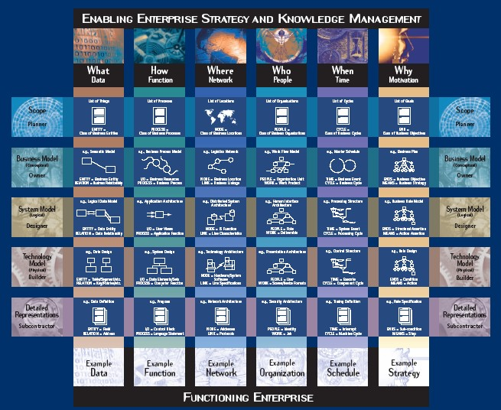
Enterprise-wide Analysis, Design and Planning for Improvement.

Information in this document is subject to change without notice and does not represent a commitment on the part of Visible Systems Corporation. The software described in this document is furnished under a license agreement or non-disclosure agreement. The software may be used or copied only in accordance with the terms of this agreement. It is against the law to copy the software onto any medium except as specifically allowed in the license or non- disclosure agreement.

No part of this manual may be reproduced or transmitted in any form or by any means, electronic or otherwise, including photocopying, reprinting, or recording, for any purpose without the express written permission of Visible Systems Corporation. Visible Systems Corporation makes no representations or warranties with respect to the contents or use of this manual, and specifically disclaims any express or implied warranties of merchantability or fitness for any particular purpose. Names, dates, and information used in examples in this manual are fictitious and only for examples.

Copyright 2008 – 2020 by Visible Systems Corporation, All rights reserved. Printed and bound in the United States of America.
This manual was prepared using Microsoft Word for Windows.

Visible Analyst
Tutorial on Structured Methods, Repository Management and The Zachman Framework Visible Analyst® is a registered trademark of Visible Systems Corporation.
The Zachman Framework illustration on the cover page of this tutorial was printed and used with the permission of the Intervista Institute © 2004 (www.intervista-institute.com). Microsoft and Windows are registered trademarks of Microsoft Corporation. Other product and company names are either trademarks or registered trademarks of their respective owners.

Dear Colleagues:

Thank you for your time in selecting our product, the Visible Analyst. At Visible, we take your time and effort seriously. To that end, we pride ourselves on delivering the most appropriate, value-oriented solutions. And, we feel that we offer the very best in product support that often differentiates us from our competitors.
As you read though the tutorial, please take the time to understand that our approach to software development is one of a model driven approach. Within the framework of this approach, Visible, in part, supports the Model Driven Architecture (MDA) as defined by the Object Management Group (OMG). This group, commonly referred to as the OMG, is an open membership, not-for-profit consortium that produces and maintains computer industry specifications for interoperable enterprise wide applications. For more information about the OMG and in particular their MDA specification, please reference their web site at http://www.omg.org/mda/.

In conjunction with a model driven approach, Visible has incorporated a framework to enable you to better plan and manage your Enterprise Architecture effort. In this edition, The Zachman Framework, is the framework of choice. However, you can customize the Visible Analyst to implement other frameworks like, for example, the US Federal Enterprise Architecture Framework (FEAF).

Visible Systems Corporation. Visible Analyst, Visible Developer, Visible Data Governance, Visible Web Portal, Visible Self Service Data Discovery, Visible Sight (Context-driven business insights), Razor SCM, Polaris (Task Management).

Table of Contents

A Model Driven Approach to Enterprise Architecture 3
Planning, Analysis, Design and Development 3
Table of Contents 7
Lesson 1 Getting to Know Visible Analyst 16
INTRODUCTION 16
FAST TRACK USERS 2
OVERVIEW OF MDA CONCEPTS 3
The Basic MDA Models 3
Visible Analyst Choices 5
VISIBLE ANALYST OVERVIEW 5
Visible Analyst Architecture 5
Figure 1-1 Visible Analyst Workspace 6
Windows Version Features 6
The Application Workspace 6
Windows Configuration 8
Multiple Document Interface 8
Figure 1-2 Visible Analyst Multiple Document Interface 8
Selecting a Diagram Object 9
Left Mouse Button 9
Right Mouse Button 9
Double-Click 9
TAB Key 9
Selecting a Block 10
Deselecting Objects 10
Shortcut Keys 10
Control Bar 11
Figure 1-3 The Control Bar for Entity Relationship Diagrams with All Tool Bars Displayed 12
Figure 1-4: The Symbol Cursor 12
Figure 1-5: The Line Cursor 12
Figure 1-6: The Text Cursor 12
Figure 1-7: The Couple Cursor 12
Help Bar 12
Object Browser 12
Menus 13
File Menu 13
Edit Menu 13
View Menu 13
Options Menu 13
Repository Menu 14
Diagram Menu 14
Tools Menu 14
Window Menu 14
Figure 1-8 Cascaded Multiple Diagram Windows 15
Help Menu 15
Lesson 2 The Zachman Framework 16
INTRODUCTION 16
Figure 2-1 Zachman Framework 18
THE ZACHMAN FRAMEWORK PROJECT AND CELL DEFINITIONS 19
Framework Rules 20
Accessing the Visible Analyst Project Artifacts 20
Accessing the diagrams 21
Accessing the repository 21
Accessing the strategic planning statements 21
Column 1: The “Data” or “What” column 22
Row 1, Column 1 - “List of Things Important to the Business” 22
Row 2, Column 1 - “Semantic Model” 23
Row 3, Column 1 - “Logical Data Model” 24
Row 4, Column 1 - “Physical Data Model” 25
Row 5, Column 1 - “Data Definition” 26
Column 2: The “Function” or “How” column 27
Row 1, Column 2 - “List of Processes the Business Performs” 27
Row 2, Column 2 - “Business Process Model” 27
Row 3, Column 2 - “Application Architecture” 28
Row 4, Column 2 - “System Design” 29
Row 5, Column 2 - “Program” 30
Column 3: The “Network” or “Where” column 31
Row 1, Column 3 - “List of Locations in Which the Business Operates” 31
Row 2 Column 3 “Logistics Network” 31
Row 3, Column 3 - “Distributed System Architecture” 32
Row 4, Column 3 - “Technology Architecture” 33
Row 5 Column 3 “Network Architecture” 34
Column 4: The “People” or “Who” column 35
Row 1, Column 4 - “List of Organizations Important to the Business” 35
Row 2, Column 4 - “The WorkFlow Model” 36
Row 3, Column 4 - “Human Interface Architecture” 36
Row 4, Column 4 - “Presentation Architecture” 37
Row 5, Column 4 - “Security Architecture” 38
Column 5: The “Time” or “When” column 39
Row 1, Column 5 - “List of Events Significant to the Business” 39
Row 2, Column 5 - “Master Schedule” 39
Row 3, Column 5 - “Processing Structure” 40
Row 4, Column 5 - “Control Structure” 40
Row 5, Column 5 - “Timing Definition” 41
Column 6: The “Motivation” or “Why” column 42
Row 1, Column 6 - “List of Business Goals/Strategies” 42
Row 2, Column 6 - “Business Plan” 42
Row 3, Column 6 - “Business Rule Model” 43
Row 4, Column 6 - “Rule Design” 44
Row 5, Column 6 - “Rule Specification” 45
Lesson 3 Business Planning Techniques 46
INTRODUCTION 46
VISIBLE BUSINESS RULES 47
BUSINESS RULES IN BUSINESS MODELS 47
Figure 3-1 Business Rules 48
STRATEGIC PLANNING OVERVIEW 49
Figure 3-2 Defining Planning Statement Types 50
Figure 3-3 Planning Statement Outline Windows 51
Figure 3-4 Creating a Planning Statement 53
Figure 3-5 Planning Statement Links 55
Lesson 4 Structured Modeling Techniques 56
OVERVIEW 56
STRUCTURED PLANNING 56
ENTITY RELATIONSHIP MODELING 57
PROCESS MODELING 58
WORKING WITH BOTH DATA AND PROCESS MODELS 61
STRUCTURED DESIGN 61
OBJECT-ORIENTED MODELING 62
OBJECT CONCEPTS 62
STATE TRANSITION (DYNAMIC) MODELING 63
OBJECT MODELING AND PROCESS MODELING 63
DATA AND OBJECT RELATIONSHIPS 64
LIBRARY MODEL 64
Lesson 5 Diagramming and Repository Basics 65
INTRODUCTION 65
CREATING A NEW PROJECT 65
Figure 5-1 New Project Dialog Box 66
Figure 5-2 New Diagram Dialog Box 68
CREATING A NEW DIAGRAM 68
EDITING A DIAGRAM 69
Figure 5-3 New Diagram with Symbols Added 71
Figure 5-4 Stylize Symbol Dialog Box 72
Figure 5-5 A Line With Its Handles 74
Figure 5-6 Text Settings Dialog Box 76
Figure 5-7 The Completed Diagram 77
OTHER DIAGRAMMING FUNCTIONS 77
CLOSING A DIAGRAM 79
THE TUTORIAL PROJECT 80
CONCLUSION 80
Lesson 6 81
Planning and Using Functional Decomposition Diagrams 81
OVERVIEW 81
Figure 6-1 DFDs Created by an FDD Using Spawn 82
DEFINITIONS 83
Figure 6-2 FDD Symbols 84
CREATING AN FDD 84
Figure 6-3 Function and Process Symbols Drawn on FDD 86
Lesson 7 Entity Relationship Diagrams 95
OVERVIEW 95
THE EVOLUTION OF DATA MODELING 99
BUSINESS RULES NOTATION 102
Table 7-1: Using Relationship Symbols for Data-Oriented, Business-Driven Business Rules 102
Table 7-2: Using Relationship Symbols for Process-Oriented, IT-Driven Business Rules 103
Cluster Analysis and Cluster Report 104
Milestone Clusters 105
Moving Clusters into a Different Functional Area 105
Data Model Display Orientation 106
Potential Export Capability to Microsoft Project 106
BUSINESS NORMALIZATION 106
DEVELOPING YOUR DATA MODEL 108
Figure 7-2 New Entities 110
Figure 7-3 Changed Entity Type 111
Figure 7-4 Label Relationship Dialog Box 113
Figure 7-5 Normalized Diagram 102
Figure 7-6 Process View Dialog Box 104
Figure 7-7 The Generated Process View 105
Lesson 8 Data Flow Diagrams 107
OVERVIEW 107
CREATING AND POPULATING A TOP-LEVEL DIAGRAM 112
NESTING A PROCESS 112
CREATING A NEW DIAGRAM 116
ANALYZING FOR BALANCE AND COMPLETENESS 122
GENERATING A PROCESS DECOMPOSITION MODEL 124
Lesson 9 Structured Design and Structure Charts 127
OVERVIEW 127
DRAWING A STRUCTURE CHART 131
Lesson 10 The Class Diagrams 137
OVERVIEW 137
DEVELOPING YOUR CLASS MODEL 139
ATTRIBUTES OF AN OBJECT 144
METHODS FOR AN OBJECT 147
ANALYZING THE CLASS DIAGRAM 151
Lesson 11 State Transition Diagramming 153
OVERVIEW 153
DEVELOPING YOUR STATE TRANSITION MODEL 154
Lesson 12 Activity Diagramming 157
OVERVIEW 157
DEFINITIONS 157
RELATIONSHIPS 158
DEVELOPING YOUR ACTIVITY DIAGRAM 159
Lesson 13 Use Case Diagramming 167
OVERVIEW 167
DEFINITIONS 167
RELATIONSHIPS 169
DEVELOPING YOUR USE CASE DIAGRAM 171
BUSINESS SCENARIO 171
Lesson 14 Sequence Diagramming 175
OVERVIEW 175
DEFINITIONS 175
DEVELOPING YOUR SEQUENCE DIAGRAM 177
Lesson 15 Collaboration Diagramming 189
OVERVIEW 189
DEFINITIONS 189
DEVELOPING YOUR COLLABORATION DIAGRAM 190
DEPARTMENT OF MOTOR VEHICLES SCENARIO 192
Lesson 16 Business Process Diagramming with BPMN 195
OVERVIEW 195
BPMN MODEL TYPES 195
DEFINITIONS 196
BUSINESS PROCESS DIAGRAM ATTRIBUTES 204
DEVELOPING BPMN DIAGRAMS 204
Lesson 17 Working with the Repository Functions 213
OVERVIEW 213
REPOSITORY BASICS 214
ADVANCED REPOSITORY FEATURES 230
Lesson 18 Where To Go From Here 243
OVERVIEW 243
REAL WORLD APPLICATION 243
WHAT TO DO NEXT? 244
CONCLUSION 245
# 247
, 247
: 247
A 247
B 248
C 249
D 251
E 252
F 253
G 253
H 254
I 254
J 254
K 255
L 255
M 255
O 257
P 257
Q 258
R 258
T 261
U 262
V 262
W 262
X 262
Y 262
Z 262

Lesson 1 Getting to Know Visible Analyst

INTRODUCTION
The Visible Analyst Zachman Edition provides a Model Driven approach for defining, designing, building, testing, documenting and supporting Enterprise Architecture (EA), information systems and software products. Model Driven Architecture (MDA) tools are based on logical dissection of the real world into understandable models, processes and components. MDA tools provide mechanisms for evaluating current information activities, defining proposed changes, producing and validating new information processes and focusing on changes that will enhance the performance and operation of the organization. The successful use of MDA tools requires an understanding of the underlying concepts and logic and a comfortable knowledge of the operation and use of the MDA tool.

Visible Analyst has been created to make the implementation of MDA techniques a logical, flexible, natural and easy-to-perform process. Visible Analyst is a seamless MDA tool that integrates all phases of planning, analysis, design, code generation, and reverse engineering. Visible Analyst provides facilities for the development of function, object/class, state transition, data, data flow (process), activity, Use Case, sequence, collaboration, and structure chart (product) models for an information system. With the introduction of the Business Process Modeling Notation (BPMN) the Visible Analyst provides a modeling notation that can be communicated to and understood by all business users, from the business analysts developing the models, to the technical analysts implementing the model processes, to the business people who manage and monitor the processes. An integrated repository containing all defined model elements, extensive additional component definitions and free-form notes and definition fields provides a continuous life-cycle library of the design and development process. The Visible Analyst repository is used for reports of project content and to generate various forms of schema and application software code.

These lessons have been designed to lead you through the Visible Analyst mechanics and to demonstrate how easy Visible Analyst is to use. These lessons cover the entire development process, from drawing functional diagrams to generating program code. You can follow the lessons in sequence or you can select just the ones of interest to you. Like Visible Analyst itself, you have the flexibility to use any piece of the tool in any order that is reasonable within the project.

The tutorial also provides you with some insight into MDA concepts and underlying logic. These concepts are basically simple and logical. They allow you to break the complex real world into smaller and more manageable chunks that can be defined quickly and then be used to build operational pieces that work in the complex real world. Each of the MDA models provides a different view of the real world. Visible Analyst ties these models together and provides a vehicle for using them to define and evaluate current information operations.
Proposed changes in the information processes, procedures and sequences are reflected into the MDA models and then are used to build a new set for the proposed change operations. The analysts, designers, developers and users interact with the Visible Analyst models and data repository to verify and validate the information steps and procedures for their organization and operations.

Once the architecture of the new information system is considered sound and solid, the software designer moves to defining and building the new product components and the software code. Visible Analyst supports the development of physical programming modules through the structure chart model. It also supports the definition and recording of pseudo code in the Visible Analyst repository. From these definitions and the data model, Visible Analyst generates database schema, SQL code and application shell code. Test plans, sequences, test cases and scenarios can also be generated in the repository notes fields.

One new feature of the Visible Analyst has been the additional support for the Business Process Modeling Notation based on the Business Process Modeling Initiative developed by the Object Management Group (omg.org). The complete specification can be downloaded from the OMG website, www.omg.org. The primary goal of BPMN is to provide a modeling notation that can be communicated to and understood by all business users, from the business analysts developing the models, to the technical analysts implementing the model processes, to the business people who manage and monitor the processes. The BPMN models describe the sequence of business processes with support for parallel and conditional behavior.

FAST TRACK USERS
Those who like to work on the Fast Track should read Lesson 5 - Diagramming Basics and follow the steps for creating a project, creating a diagram, and some optional settings that are available with Visible Analyst. Lesson 5 gives you the basic skills for working with Visible Analyst. We recommend that you work through the other lessons to discover the more advanced features that make Visible Analyst a powerful tool. Throughout the tutorial are references to features that are not demonstrated in the tutorial but that may be of interest to you. You can find more information about these features in the Operation Manual, which can be downloaded from our Web site using this link http://www.visiblesystemscorp.com/Products/Analyst/manual.pdf. The online help feature in Visible Analyst, accessed from the Help menu or by pressing F1, also provides you with more information on the referenced subjects.

Note
 Since Visible Analyst is available in multiple configurations, the software you purchased may not include all of the diagram types or advanced features described in these lessons. The basic drawing techniques apply to all diagram types, and you are encouraged to work through the brief exercise in Lesson 5 - Diagramming Basics. Thereafter, you can skip chapters that do not apply to your Visible Analyst package.

OVERVIEW OF MDA CONCEPTS
MDA concepts involve creating and defining different models or views of the real world and then using these models to analyze and develop changes and modifications to the information processes of the organization. Some of the models provide definitions of factual items such as business functions, objects and data entities; others show how things flow, connect or relate to one another. Some of the models evolve and expand to match reality and others are done as snapshots, showing as-is and then as-proposed operations. The views are composed graphically using symbolic objects, line connectors and some rules of logic and structure. The objects are given names called labels that populate the data repository with entries that can be retrieved, expanded, detailed and used to define and document the contents of the project.
There are logic rules for many parts of the models. The models can be tested and evaluated for completeness, consistency, rule compliance and other factors. All of the models and the repository are interrelated, and many share common components such as databases, objects and/or actions. The development of the models is iterative, often requiring several sessions before the models are complete and realistic. The ability to move from one model to another and to work on different ones at different times is critical to a successful MDA tool.

The rules of MDA deal with the checking of consistency and logical structures such as naming and complete linkages. Errors found in models are reported during the Visible Analyst analyze process. These errors should be corrected to maintain consistency and accuracy of the models. However, Visible Analyst, unlike software compilers, allows you to continue with any reasonable MDA operation without waiting until you have corrected all errors. This allows you to continue progress on the project and its components. However, it also leaves you responsible for returning and correcting your errors.

The Basic MDA Models
The basic MDA models include:

Functional Decomposition Model (also known as a Business Model) - Shows the business functions and the processes they support drawn in a hierarchical structure.

Entity Relationship Model (also known as a Data Model) - Shows the data entities of the application and the relationships between the entities. The entities are things and the relationships are actions. The data attributes can be defined for the entities via the repository and then shown on the diagram. Entities and relationships can be selected in subsets to produce views of the data model.

Object Model (also known as an Object Class Model) - Shows classes of objects, subclasses, aggregations and inheritance. Defines structures and packaging of data for an application.

State Transition Model (also known as the Real Time Model) - Shows how objects transition to and from various states or conditions and the events or triggers that cause them to change between the different states.

Process Model (also known as the Data Flow Diagram) - Shows how things occur in the organization via a sequence of processes, actions, stores, inputs and outputs. Processes are decomposed into more detail, producing a layered hierarchical structure.

Product Model (also known as a Structure Chart) - Shows a hierarchical, top-down design map of how the application will be programmed, built, integrated and tested.

Use Case Model – Shows the relationship between a user and a computer system.

Activity Model – Is a special form of state diagram where states represent the performance of actions or sub-activities. Transitions are triggered by the completion of the actions or sub- activities.

Sequence Model – Shows how objects collaborate in some behavior.

Collaboration Model – Shows an interaction organized around the objects in the interaction and their links to each other.

Business Process Modeling Notation- Provides a modeling notation that can be communicated to and understood by all business users, from the business analysts developing the models, to the technical analysts implementing the model processes, to the business people who manage and monitor the processes.

Repository or Library Model (also known as the Project Database) - Keeps the records of all recorded objects and relationships from the diagrams and allows for the definition of detailed specifics and extensions of the individual items. Used for evaluation, reporting and generation of details about the project and its products.

Visible Analyst Choices
Today systems designers have multiple choices. They can follow the Structured Analysis and Structured Design (SA/SD) approach and build on functions/processes, data models and product concepts; or they can follow the object-oriented approach and build class hierarchies, dynamic states and functional/process models. Both approaches can build better information systems and both cover similar aspects of information systems definition. However, both use different sequences of effort and focus on different aspects of the project. Visible Analyst allows you to choose either approach or to combine the approaches to develop a comprehensive product definition, design and development mechanism.

There are five keys to using Visible Analyst, or any MDA tool. The first key is to develop the discipline to apply and follow the steps and procedures of the technique. The second key is to develop skills in conceptualizing the MDA models to represent the real world requirements. The third key is to be consistent in how you define and describe the real world. The fourth key is to strive to be complete in the definition of all of the major parts of a real world application. The fifth key is to progress from the conceptual to the operational specifications and construction of a working information systems process.

VISIBLE ANALYST OVERVIEW
Visible Analyst is a Microsoft® Windows® application. Versions 7.1 and higher of Visible Analyst work with Windows NT, 2000, 2003 Server and XP while VA2008 is also VISTA compatible. This section defines the overall structure of Visible Analyst and identifies some of its key operational characteristics.

Visible Analyst Architecture
The basic components of Visible Analyst are: a set of diagramming tools, a rules module, and a repository module. Diagramming tools are used to construct the ―blueprints of your target system. These lessons guide you in the creation of diagrams and provide you with basic information on the uses of the diagrams.

A system is designed and constructed according to rules, and the rules module manages the methodologies of Visible Analyst tools for you. Visible Analyst allows you to choose the rule set you prefer to use as a guideline for the development of your system. These rules are important in determining the appearance of your diagrams, as well as the entire structure of your system. For the purposes of the tutorial, you are introduced to the supported techniques and learn how to designate the rule set to use and the different symbol types used for each rules methodology.

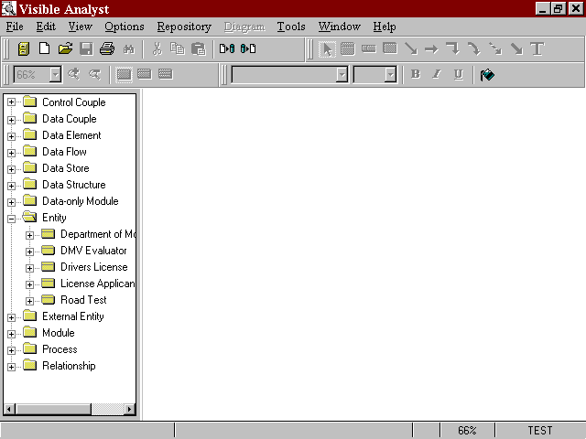Standard Tool Bar

View Tool Bar

Diagram Tool Bar

Font Tool Bar

Control Bar

Object Browser

Diagram Workspace

Help Bar

Project Root

Figure 1-1 Visible Analyst Workspace

The repository module controls the individual repositories of each of your projects. A project‘s repository stores detailed information about objects that are used in developing a system. An object in the repository includes processes, entities, relationship lines, classes, etc. The type of information contained in the repository for each object includes description, composition, values and meanings, location references, and other very specific detail information (see Lesson 17 – Working with The Repository Functions for details). The repository makes Visible Analyst a very powerful systems development tool. Visible Analyst is much more than just a diagramming tool; its repository and rules set provide definition, documentation, and consistency capabilities for the entire system. Visible Analyst has advanced features enabling you to generate reports and code for your target system, using the information contained in a project repository.

Windows Version Features
This section highlights some of the Windows-specific features of Visible Analyst.

The Application Workspace
All work in Visible Analyst is done either in the main application workspace, shown in Figure 1-1, or in the repository, described in Lesson 16 - Repository Functions.

Windows Configuration
Visible Analyst configuration features controlled through Windows include the hardware configurations, desktop colors, available printer drivers, and available fonts. Changes or additions to these features can be made through Windows and are reflected in Visible Analyst.

Multiple Document Interface
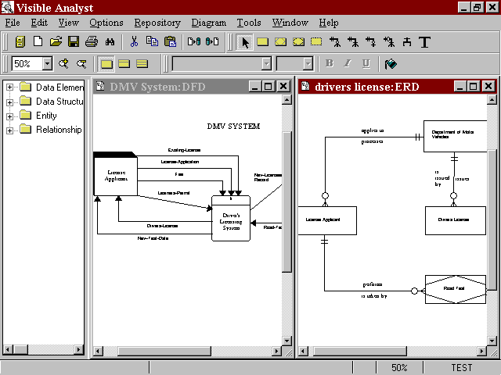The Windows Multiple Document Interface (MDI) allows multiple diagrams to be open at one time. Open diagrams can be of the same or different diagram types (data flow diagrams, entity relationship diagrams, etc.). Diagrams may be maximized, taking up the entire workspace, sized so that several diagram windows are visible, or minimized to icons appearing at the bottom of the application workspace. Any window larger than an icon is editable. You can cut, copy, and paste to and from the Windows Clipboard to move objects between diagrams and even between other Clipboard-aware applications. (See Figure 1-2.)

Figure 1-2 Visible Analyst Multiple Document Interface

Note
 Users not familiar with MDI Windows programs should take note: there is a difference between the diagram Control menu button and the Visible Analyst Control menu button. The former is in the top left corner of the diagram window, or to the left of the File menu if the diagram is maximized. This Control menu contains functions that affect the diagram only, such Maximize, Close, etc. The latter is in the top left corner of the Visible Analyst window. The Visible Analyst Control menu affects the whole Visible Analyst window and program.

Selecting a Diagram Object
A diagram object is anything that appears on a diagram: symbol, line, text, or block. When you click on an object with a mouse button, it becomes the current or selected object and you can perform various operations on it. There are five different ways to select an object. The following paragraphs describe the effect of selecting an object with the left mouse button, the right mouse button, a double-click with the left mouse button, the TAB key and selecting a Block.

Left Mouse Button
Clicking on an object with the left mouse button selects it. The object changes color to show that it has been selected allowing you to make changes to the object or to move the object. When a symbol or line is selected, text labels for that object are automatically highlighted.

Right Mouse Button
Clicking on an object with the right mouse button also selects it. In addition, the Object menu appears containing all of the functions that can be performed on that object.

Notes
 Unless stated to the contrary, instructions to click a mouse button refer to the left
button. Instructions for the right button are explicitly mentioned.

 Left-handed mouse users: if you use a mouse with the buttons reversed, you should reverse references to left and right mouse buttons in this text.

Double-Click
If you double-click on an object with the left mouse button, the repository entry for that object appears. If the object is unlabeled, a dialog box for labeling the object is displayed. Double- clicking is also used to indicate the end of a line.

TAB Key

To highlight only the text label for a selected symbol or line, press the TAB key until the appropriate item is highlighted. (If the label is located outside the symbol, you can click on it directly.) Continuing to press the TAB key sequentially selects each object on the diagram.

Selecting a Block
To select a block, meaning a group of objects, on a diagram, click and hold the left mouse button and drag the mouse to draw a box around the objects. All objects completely contained within that box change colors to show that they are selected. Once a block is selected, you can perform various functions on the block such as cut, paste, move, change text settings for contained objects, and other actions.

Deselecting Objects
To deselect any object or block, simply click the left mouse button on an empty area anywhere on the diagram workspace outside of the object or block. The items that had been selected return to their usual color. You can also use the Clear function on the Edit menu.

Shortcut Keys
Shortcut keys provide fast access to functions without using the menus. Some of the active shortcut keys used in Visible Analyst are standard Windows shortcut control key sequences, such as CTRL+P, which is the command for Print; others are specific to Visible Analyst. All available shortcut keys are listed here.

CTRL+A | Analyze | Analyzes a diagram or entire project.
CTRL+C | Copy | Copies to clipboard.
CTRL+D | Define | Accesses the repository.
CTRL+E | Connect | Draws lines between selected symbols.
CTRL+F | Find | Accesses the search mode.
CTRL+L | Lines | Sets the cursor to line drawing mode.
CTRL+N | New Diagram | Creates a new diagram.
CTRL+O | Open Diagram | Opens an existing diagram.
CTRL+P | Print | Prints the current diagram or queue contents.
CTRL+Q | Report Query | Generates a custom repository report.
CTRL+R | Reports | Generates a standard repository report.
CTRL+S | Save | Saves the current diagram.
CTRL+T | Text | Sets the cursor to text adding mode.
CTRL+U | Clear | Deselects diagram object or block.
CTRL+V | Paste | Pastes from Clipboard.
CTRL+T | Snap Symbols | Aligns selected symbols in a row.
CTRL+X | Cut | Cuts to Clipboard.
CTRL+Z | Undo | Erases partially drawn or undoes moved line.
DEL | Delete | Deletes object from diagram.
F1 | Help | Displays context-sensitive help.
ALT+R | Delete Project | Deletes a project with no project files.

SHIFT+F1 | Menu Help | Enters Help mode for menu items.
SHIFT+F10 | Object Menu | Displays repository object menu.
Another standard Windows shortcut method for accessing a menu item without using the mouse is to press the ALT key followed by the underlined letter of the menu title or menu item that you would like to access. For example, to access the File menu, press the ALT key followed by the F key. It is not necessary to hold down the ALT key while pressing the F key.

Control Bar
The control bar, shown in Figure 1- 3, is located above the diagram workspace and gives you quick access to commonly used functions and types of objects that can be added to a diagram. The control bar can contain up to four tool bars.
  - The standard tool bar contains basic buttons, such as Select Project, Open Diagram, etc., common to most Windows applications.
  - The diagram tools tool bar contains the symbol, line, and text buttons appropriate for the current diagram.
  - The view tool bar contains controls that change the zoom level and entity/class view level.
  - The font tool bar contains controls that allow changing the current font characteristics, such as font type, font size, etc.

You can customize the control bar by selecting Control Bar from the Options menu to display the Customize Control Bar dialog box. Using this dialog box, you can select the tool bars to be displayed and select control bar options such as Show Tooltips, Large Buttons, Flat Buttons, and Hot Buttons. You can also right-click the control bar itself to display a properties menu that allows you to toggle the individual tool bars on or off or to select the Customize option. To change the size and position of the tool bars, click the left mouse button on the ―gripper (the two vertical bars ‖ at the beginning of each tool bar) and drag the tool bar to the desired position. From the Customize Control Bar dialog box, you can also
―undock ‖ the diagram tools tool bar so that it appears in its own floating window.

The  button (shown in Figure 1-3) is used to change into selection mode (also called editing mode). In selection mode, objects can be selected on the diagram to be changed or moved, or a box can be drawn around many objects on a diagram, for moving, cutting and pasting, or changing text settings for groups of objects. Click one of the drawing mode buttons, and you can add that type of item to the diagram. The object types include symbols, lines, couples, and caption text. When you choose one of the drawing mode items from the control bar to add to your diagram, the cursor automatically changes to indicate that you are either in symbol, line or couple adding mode, or caption text adding mode. Specifically, this means that while the cursor is positioned inside the diagram workspace and it is something other than an arrow, which indicates selection mode, clicking on the mouse adds an object to the diagram.

Figure 1-3 The Control Bar for Entity Relationship Diagrams with All Tool Bars Displayed

For example, when the diagram tools tool bar is displayed on the control bar, you can easily select the particular symbol you want to add to the diagram. A symbol is added to your diagram centered at the cursor location anytime you click on the diagram workspace while the cursor indicates symbol drawing mode.

Figure 1-4: The Symbol Cursor

Figure 1-5: The Line Cursor

Figure 1-6: The Text Cursor

Figure 1-7: The Couple Cursor

Help Bar
As you move through the Visible Analyst menus, a line of text appears on the help bar at the bottom of the application workspace that briefly explains what that menu item does. The current zoom level, current project and current object are also displayed. You can toggle this feature off and on from the Options menu.

Object Browser
From the Options menu, you can choose to have the Visible Analyst object browser displayed on your screen. The object browser displays a list of all the objects in the repository in a resizable window. When there are no diagrams open, or the current window is the diagram list, all objects are displayed. When a diagram is open, only those objects that are valid for that diagram type are displayed. If an object appears on the open diagram, it is displayed in

bold. Double-click on a folder in the list to expand or collapse it; double-click on an object in the list to display the Define dialog box. You can also click on an object in the list and drag it onto your diagram. To resize the object browser, click on the right margin of the browser and drag to the desired size.

Menus
The menus are arranged in nine groups for browsing and selecting the various features of Visible Analyst. (Refer to Figure 1-1.)

File Menu
The File menu contains the functions for accessing and creating projects and diagrams. This includes all of the functions that cause the opening of another diagram, such as Nest, Spawn, and Page. (These functions are explained under the specific diagram type where each is used.) It also includes a list of Recent Diagrams and Recent Projects. The Save, Print, and Exit functions are also found in the File menu. If you are using a network version, information about network activity and modifying the user list is contained in the File menu. If you purchased a copy of the Zachman Framework Edition, the framework can be opened and closed using the Zachman Framework option.

Edit Menu
The Edit menu contains the standard Windows editing functions including Cut, Copy, Paste, Find and Delete. There is also an Undo function for removing partially drawn lines and undoing a move line operation. The Strategic Planning options allow you to add a New Statement, Promote, Demote, Move Up, or Move Down, a strategic planning statement.

View Menu
The functions contained in the View menu allow you to change the appearance of the active diagram. There are functions to change the zoom level and to give you the ability to change the items displayed on a diagram, including Show Line Names, Show Symbol Names, Show Discriminators, Show Statement Types, Show Priority, Show Description, Class and Entity Display Options, Physical Schema, Events, and Messages. Also on the View menu are Grid and Ruler, functions that make it easier to position objects accurately on a diagram.

Options Menu
The Options menu contains functions that allow you to change default settings for Visible Analyst. For diagram drawing and manipulation settings, the functions include automatic labeling of symbols and lines, Line Settings defaults, Text Settings defaults and diagram Colors, as well as on/off settings for Security, the Help Bar, the Object Browser, and the Control Bar. The Options menu also includes settings for interaction diagrams, model balancing rules, SQL schema and shell code generation, DDS name translation, user-defined

attribute and object definition, planning statement types, Zachman Framework cell settings and symbol template settings.

Repository Menu
All of the selections included in the Repository menu are functions performed on the information contained in a project’s repository. These include Define, which allows repository access, schema and shell code generation, schema / model comparison, Key Analysis and Key Synchronization, Model Balancing, and repository Reports. The Divisions function is used with the Enterprise Copy feature and is explained in the on-line Help. The Divisions and Enterprise Copy feature are not available in the Visible Analyst Student edition.

Diagram Menu
The Diagram menu contains functions for selecting, manipulating, and analyzing diagram objects. These include functions for selecting Symbols, Lines, or Text to add to a diagram, as well as functions for changing or stylizing a selected item on a diagram. The function for analyzing the diagrams according to the selected rules methodology, modifying the diagram settings and the function for modifying an existing view are also contained in the Diagram menu.

Tools Menu
The Tools menu contains the various functions that can be performed on a project. These include Backup, Restore, Copy Project, Delete Project, Rename/Move, Import, Export, and copying information between projects. The utility for assigning user access to the multi- user version of Visible Analyst is also found in the Tools menu. The Enterprise Copy and Enterprise Tag Maintenance features are not available in the Visible Analyst Student Edition but are explained in the on-line Help.

Window Menu
The Window menu allows you to change the arrangement of the open diagrams. Diagrams can be automatically arranged in a Tile, Cascade, or minimized (icon) format. You can also switch between open and minimized diagrams.

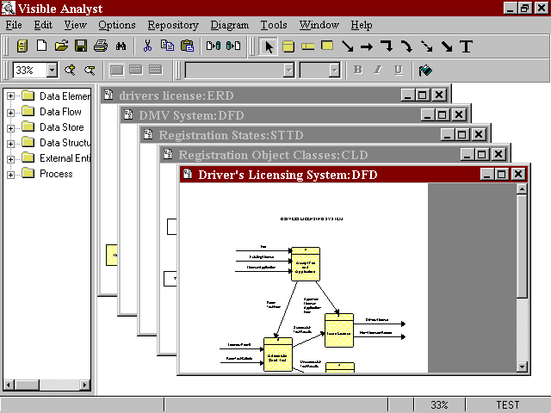Figure 1-8 Cascaded Multiple Diagram Windows

Help Menu
The Help menu allows you to access the Help features, product and user information, and Visible Analyst on the Internet.

Note
 Detailed information about each of the menu options can be found in the Visible Analyst Operation Manual and the online help system (accessed by pressing F1).

Lesson 2 The Zachman Framework

INTRODUCTION
It has been Visible Systems Corporation’s experience that no matter where you start in your application development activities, you will soon find yourself making certain ―assumptions‖ about things not under your control or outside of your scope. To confirm or validate these assumptions, you find yourself addressing the artifacts up and down the Zachman Framework rows and/or across the columns to capture the true drivers for the system: who? what? where? when? why? and how?1 This means coordinating with the affected or interested business experts, system users, and management.

In 1987 John Zachman wrote, ―To keep the business from disintegrating, the concept of an information systems architecture is becoming less of an option and more of a necessity.2‖ From that assertion over a decade ago, the Zachman Framework for Enterprise Architecture has evolved and become the model around which major organizations view and communicate their enterprise information infrastructure. The Zachman Framework draws upon the discipline of classical architecture to establish a common vocabulary and set perspectives--a framework--for defining and describing today‘s complex enterprise systems. Enterprise Architecture provides the blueprint--or architecture--for the organization‘s information infrastructure and provides a framework for managing information complexity and managing change.

Today the Zachman Framework has become a standard for Enterprise Architecture used by many of the most successful organizations in the world. Evidence of the acceptance of the Framework has been apparent at the annual forums conducted by the Zachman Institute for Framework Advancement (ZIFA, www.zifa.com). At each forum, attendees hear presentations on the many different aspects and practical uses of the Framework. Visible fully supports both the concept and philosophy of the Zachman Framework. Visible helps clients gain greater control of their information systems and technology requirements through development of an enterprise-wide architecture.

1 ―Visible and the Zachman Framework for Enterprise Architecture‖ by Alan Perkins p. 2. Copyright © 1997-2001, Visible Systems Corporation.
2 ―A framework for information system architecture‖ by J.A. Zachman p. 454 IBM Systems Journal, Vol. 26, Nos. 3,
1987, ©1987, 1999 IBM.

Visible takes an engineering approach to developing an enterprise architecture. We use a combination of forward and reverse engineering to establish the enterprise architecture. Forward engineering tasks include business planning and data and process modeling. Reverse engineering tasks include analysis and documentation of all existing structures for the organization. The result is a model that represents an integrated view of the enterprise architecture framework, with redundancies and discrepancies resolved and documented. All conceptual and logical architecture components can all be maintained in Visible‘s proprietary modeling tool, Visible Analyst®.

The Visible Analyst supports the tasks and techniques involved in the creation and management of an enterprise architecture, with sufficient flexibility to integrate and support other approaches to software engineering. Visible Analyst captures business plans of multiple organization levels and maintains the hierarchy of planning components (mission, goals, strategies, measures, business rules, etc.).

Unlike many other modeling tools, Visible Analyst has the capability of directly linking each business plan component to the entities and attributes of a data model that support/implement the planning elements. This feature is used to control quality and completeness, and to ensure that process and system designs meet business requirements. Visible Analyst can also be used to specify physical information system designs based on the data model or import physical designs of existing data structures into the repository, and then link them back to the business plan component.

The following sections provide an overview of the Visible Analyst‘s repository and modeling capabilities, followed by an explanation of the Visible Analyst framework project. Each cell in the Zachman framework project is detailed in a cell-by-cell review including an explanation of the artifacts created for the cell in the Visible Analyst. A backup copy of the Zachman project is located in the VA\Zachman folder on the product CD. If you do not have a product CD, contact Visible Systems support at support@visiblesystemscorp.com for a copy of the document and backup file set. To access the project, see the Restore instructions at the beginning of this tutorial.

It is important to remember that the Visible Analyst Enterprise Project using the Zachman Framework is not a static one-time snapshot view of the enterprise. As mentioned in the cell explanations, the artifacts such as the business plan, physical data model, security architecture, strategic goals, etc. will change as the enterprise changes. Using the Visible Analyst and its repository to model the enterprise provides a one-stop location where all information about the enterprise is located. External documents may be changed, but the hyperlinks to the artifacts are maintained within the enterprise project, allowing for both a birds eye and physical implementation perspective of the enterprise.

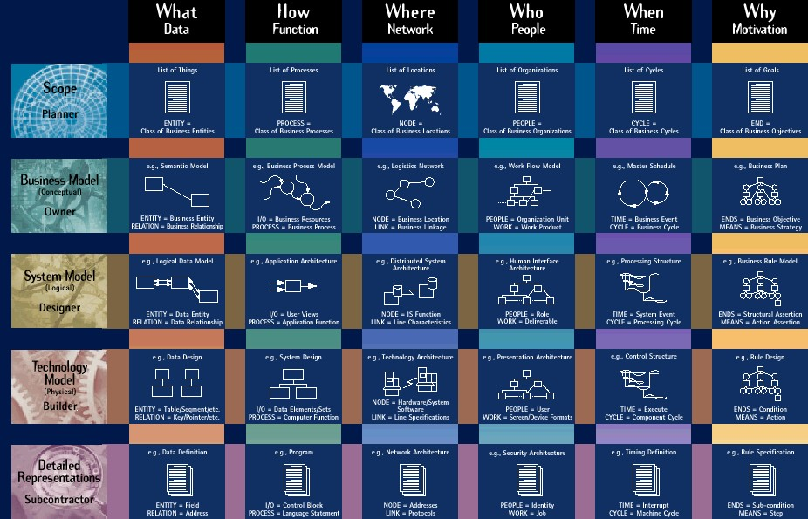

Figure 2-1 Zachman Framework

Image provided courtesy of the Intervista Institute, Copyright © Intervista Institute (www.intervist-institute.com)

THE ZACHMAN FRAMEWORK PROJECT AND CELL DEFINITIONS

When implementing an Enterprise Architecture Framework, it is important where you begin. In our white paper, ―Enterprise Architecture Engineering‖3 by Alan Perkins and Clive Finkelstein, available on our web site at www.visiblesystemscorp.com, they state, ―A well documented Enterprise Architecture is a logical organization of information pertaining to the following multi-level, multi-dimensional, enterprise wide elements.

    - Strategic goals, objectives, strategies
    - Business rules and measures
    - Information requirements
    - Processes, systems and applications
    - Relationships between architecture elements
    - Technology infrastructure‖

They emphasize that the most important starting point is that establishing the right sponsorship helps to insure successful development and deployment. Alan also explains,
―…all potential users of the applications and systems based upon the architecture must be involved in the process. Without both management sponsorship and near universal involvement, enterprise-wide architecture engineering projects usually fail.‖4 Additional white papers are available on our web site at www.visiblesystemscorp.com that help explain the ―Critical Success Factors for Enterprise Architecture Engineering‖, ―Business Rules ARE Metadata‖, etc.

Each cell of the framework is described using the following format beginning with the ―What column Planner perspective‖ and proceeding down the column in a top-to-bottom left-to-right order.

    - Cell location, label, perspective and descriptive type
    - An explanation of the cell definition
    - The artifact created in the project to implement the cell. The name and location of the cell is included in the artifact label where appropriate, such as "Row 4 Column 1 Physical Data Model".
    - A detailed explanation of the project artifact
    - Alternative artifacts that could be created in the project to implement the cell

3 ―Enterprise Architecture Engineering‖ by Alan Perkins and Clive Finkelstein p.3. Copyright © 2000, Visible Systems Corporation.
4 ―Critical Success Factors for Enterprise Architecture Engineering‖ by Alan Perkins p. 4. Copyright © 2000 Visible Systems Corporation.

This project contains many different types of artifacts, consisting of diagrams, strategic planning statements, lists, user defined objects, etc., and each was created to document a specific cell of the framework. Only one artifact was created for each cell, and additional artifact option types are included in this document and the cells’ repository definition when appropriate. An actual enterprise project will have multiple artifacts representing a particular cell. When using the Visible Analyst in a real-world implementation of the framework, users should consider using the Enterprise Modeling feature (described in the online help system) to eliminate any naming conflicts, to maintain logical and physical data model separation, program specification, etc. The Enterprise Modeling feature will maintain the linkage between the artifacts in the projects, promoting object re-use.

Note
 Appendix A in the ―Visible Analyst Framework Document‖, located in the VA\Zachman folder on the product CD, contains additional resources and modeling capabilities available in the Visible Analyst when creating artifacts for the various cells. If you do not have a product CD, contact Visible Systems support at support@visiblesystemscorp.com for a copy of the document.

Framework Rules

Before beginning the enterprise project and creating the cell artifacts, it is important that users know and understand the rules of the framework as described by John Zachman and John Sowa.5

- The columns have no order.
- Each column has a simple, basic model.
- The basic model of each column must be unique.
- Each row represents a distinct, unique perspective.
- Each cell is unique.
- The composite or integration of all cell models in one row constitutes a complete model from the perspective of that row.
- The logic is recursive.

Accessing the Visible Analyst Project Artifacts

For users unfamiliar with the Visible Analyst we have included instructions to access the project artifacts maintained in the Visible Analyst Framework project.

- ―Extending and formalizing the framework for information systems architecture‖ by J. A. Sowa and J. A. Zachman, IBM Systems Journal, Vol. 31, No 3, 1992. Pages 599-603

Accessing the diagrams
Clicking the File | Open Diagram menu item displays a list of diagram types supported by the Visible Analyst in alphabetical order. If a diagram has been created a plus sign is displayed next to the diagram type and clicking the plus sign displays the diagram list. Double click on the diagram label to open the diagram.
When viewing the repository entry of a diagram symbol, double clicking on a diagram label listed in the Locations field on the Locations tab of the entry opens the diagram in the background and the selected item is highlighted on the diagram.

Accessing the repository
There are a number of ways to display the repository Define Item screen for an object even when a diagram is not displayed:

  - Select the Repository | Define menu item to directly access the repository. If no diagram object or planning statement was highlighted, a blank Define item screen is displayed. Clicking the Next button at the bottom of the screen displays all repository entries in alphabetical order. Entering a letter into the label field and clicking the Search button displays a list of all repository entries beginning with that letter. Click the Search button and then the F1 key on the keyboard to display the
―Repository Searches – Overview‖ help file.
  - Double click on the label of the item in the Object Browser.
  - For diagram symbols and strategic planning statements, double clicking on the diagram symbol or statement opens the item‘s Define Item screen.
  - Right click on the diagram object and select Define from the object menu, or left click on the object so it is highlighted and choose the Repository | Define menu item.
  - Non-diagram repository object entries, such as data elements, data structures, user defined objects, etc., can be accessed by double clicking on the label of the item in the Object Browser or using the Repository | Define and Search feature mentioned above. When viewing a parent object‘s Define Item screen, such as an entity, class, data flow, etc., double click on the attribute item or select the attribute in the Attributes field and click the Jump button located at the bottom of the Define Item screen.

Accessing the strategic planning statements
Select the File | Strategic Planning menu item or click the Strategic Planning icon which is the second icon on the first menu bar. Use the up and down, left and right arrows on the strategic planning icon bar to position the statements within the statement hierarchy. The other strategic planning icons allow you to display the levels, branches, priority, type and description of the statements on the screen.

Column 1: The “Data” or “What” column
Provides an understanding of the data important to the business with finer amounts of detail shown at each succeeding perspective.

Row 1, Column 1 - “List of Things Important to the Business”
Objectives/Scope (Contextual) Data column, Planner role
Entity = Class of Business Thing

Cell explanation6
A list of items, objects, assets, etc. important to the business and defined at a high level of aggregation. The list is dependent on the enterprise modeled, and ―…defines the scope, or boundaries, of Rows 2 – 5 models of things significant to the Enterprise‖7. A software or manufacturing company would include Vendors, Products, Clients, Product Facilities, etc. A law firm would include specific knowledge areas, trial experience, etc., while educators would include a curriculum, educational levels, specific teaching disciplines, etc.

Project implementation
Implemented as an Strategic Planning Statement

Artifact explanation
The strategic planning statement’s Detailed Description repository field contains the list of items important to the business. This list includes Employees, Financial Resources, Accounting Procedures, Equipment and Technology, Profits etc. Using the Links tab of the statement’s repository entry, this statement was linked to the Row 1 Column 1 ―List of things important to the business‖ cell.

Each item in the list could have been be added as a separate sub-statement, and the repository fields of the individual statements populated with the discrete explanation of the items.
Hyperlinks to external documents, which further describe this high-level aggregation of the business, can be created if necessary.

- The cell definitions are based on the cell explanations as described in the following documents:
"The Framework for Enterprise Architecture Cell Definitions" ZIFA 03.doc Copyright © Zachman Institute for Framework Advancement www.zifa.com
and
"A different Kind of Life Cycle: The Zachman Framework" by David C. Hay, Essential Strategies Copyright © 2000, Essential Strategies, Inc www.essentialstrategies.com
- "The Framework for Enterprise Architecture Cell Definitions" ZIFA 03.doc Copyright © Zachman Institute for
Framework Advancement www.zifa.com

Alternative project implementations
  - A User Defined Object of type ―Business Object‖ can be created and implemented as an item in the list, with each item maintaining separate repository entries that can be linked to other cell artifacts.
  - The list can be maintained in any word processing application and a hyperlink to the file created in any one of the cells descriptive-type fields (notes, detailed description, etc.) in the repository.

Row 2, Column 1 - “Semantic Model”
Enterprise Model (Conceptual) Data column, Owner role Entity = Business Entity
Relation = Business Relationship

Cell explanation:
Contains a model of the things8 important to the business, as seen by the participants in the business, and is modeled as a high-level entity relationship diagram. These relationships are later implemented as business rules.9

Project implementation:
Implemented as an Entity Relationship diagram.

Artifact explanation:
This conceptual data model diagram contains a model of the high-level business objects and the relationships maintained between the objects. Entities include Company Employees, Company Management, Company Business Relationships, Products, etc. The relationships model the business concepts between the entities, such as Employees - design - Products; Employees – produce – Products; Company Management – acquires – Capital Resources, etc.

Alternative project artifact implementations:
A class diagram could be used to model this cell with the classes identifying the business objects and the relationships between these objects defining the business concepts.

- "A different Kind of Life Cycle: The Zachman Framework" by David C. Hay, Essential Strategies Copyright ©
2000, Essential Strategies, Inc. www.essentialstrategies.com
- "The Framework for Enterprise Architecture Cell Definitions" ZIFA 03.doc Copyright © Zachman Institute for
Framework Advancement www.zifa.com

Row 3, Column 1 - “Logical Data Model”
System Model (Logical) Data column, Designer role Entity = Data Entity Relation = Data Relationship

Cell explanation
The Technology neutral fully normalized logical data model with attributes and unique identifiers defined to record information important to the business.

Project implementation
Implemented as an Entity Relationship diagram

Artifact explanation
The entities involved in the logical data model can be modeled on one global diagram, and then separate subset entity relationship diagrams created if desirable. Note that key relationships between entities in the Visible Analyst extend across the diagrams for purposes of model analysis to provide additional analysis / and verification of the models.

The subset area diagrams can be copied to satellite projects using the Enterprise Copy feature and implemented as physical data models while maintaining the relationships to the logical data model.

Note
 A physical data model can be reverse engineered from any ODBC compliant RDBMS, and the physical model used as the basis for creating a new logical data model.

Alternative project artifact implementation
A class diagram can also be used to model this cell.

Row 4, Column 1 - “Physical Data Model”
Technology Model (Physical) Data column, Builder role Entity = Segment/Table Relation = Pointer/Key

Cell explanation
The entities in the subject areas are converted into table definitions of a technology constrained fully attributed entity relationship model. All keys, indexes, table and column check constraints, database storage information, database views, stored procedures, etc., are defined for implementation into a specific RDBMS.

Project implementation
Implemented as an Entity Relationship diagram

Artifact explanation
The fully attributed entities and relationships are added to entity relationship diagram(s) with corresponding Visible Analyst repository entries. All physical information about the entities and elements is defined, including primary, foreign and alternate keys; unique and non-unique indexes; table and column check constraints; database storage information; database views; stored procedures; triggers; etc. Each diagram can be modeled to correspond to specific business subject areas, such as Accounting, Shipping, Sales, etc. and these individual diagrams used as the basis of the generated SQL DDL.

Note
 The RDBMS tables, attributes, keys, index, trigger, stored procedure, tablespace information, database views etc., can be reverse engineered from the existing RDBMS and used to populate a Visible Analyst project. Diagrams can automatically be generated to display the imported tables, views and relationships, and data elements. Foreign keys can be inferred during the reverse engineering procedure to auto generate relationships if none are defined.

Alternative project artifact implementation
A class diagram can be used to model the physical information, and once the classes are copied to an entity diagram, SQL DDL can be generated.

Row 5, Column 1 - “Data Definition”
Detailed Representations (Out-of-Context) Data column, Sub-Contractor role
Entity = Field Relation = Address

Cell explanation
The artifact is the implementation and data definition of the tables and column in the specific RDBMS, as well as the SQL DDL script.

Project implementation
A User Defined Object of type ―Database‖ was created and implemented as the repository object ―SQL Server Database‖.

Artifact explanation
This ―SQL Server Database‖ user-defined object functions in 2 ways:

- As a container object to list all of the entities associated with a business area implemented in a specific database(s). Entities can be listed in many of these user defined ‗database objects.
- As the Visible Analyst repository entry linked to the implemented code, which can be stored in a source control application or stored in an external file. When a source code control application is used, the objects Links To field on the Links tab lists the connection to the source code control application. Otherwise, a hyperlink is created to connect the object to the external file containing the SQL DDL script.

The generated SQL DDL code could be pasted into the objects Notes field or a user-defined attribute could be created to store the SQL DDL code as part of this object‘s repository entry.

Alternative project artifact implementation(s)
A pre-defined Visible Analyst ―Cluster‖ repository object is used to maintain a listing of entities that can be displayed as one symbol on a diagram. Its purpose is to reduce the amount of displayed detail. The cluster object would be used to define the entities implemented in a specific database based on a specific diagram. The External Link to the source code control application would be entered in the ―Links To‖ field on the cluster‘s Links tab. Note that entities can only exist within one cluster.

Column 2: The “Function” or “How” column
Describes the process and functions performed by the business. Additional detail is displayed for each succeeding perspective.

Row 1, Column 2 - “List of Processes the Business Performs”
Objectives/Scope (Contextual) How column, Planner role
Function = Class of Business Processes

Cell explanation
This cell lists the processes /activities the business performs.

Project implementation
Implemented as a Functional Decomposition diagram.

Artifact explanation
The Functional Decomposition Diagram was chosen because the symbols allow the user to display the high-level business functions and processes in a hierarchical relationship. Each methodology symbol maintains a separate repository entry allowing the user to fully describe the function/process, and include hyperlinks to external documents if necessary. Through the use of off-page connectors, each function and its sub-processes can be modeled on separate multi page diagrams and copied to a satellite project if necessary for further decomposition. The Functional Decomposition Diagrams also can be used to spawn a high-level data flow diagram that segues into the next cell in the column, Business Process Modeling.

Alternative project artifact implementation(s)
  - The Strategic Planning Statements can be used to define the business functions and high-level child processes in the statement hierarchy.
  - A hyperlink from this cell to an external document listing the functions and processes can be used to link the cell to the document.

Row 2, Column 2 - “Business Process Model”
Enterprise Model (Conceptual) How column, Owner role Process = Business Process I/O = Business Resource

Cell explanation
The activities of the business function and processes are described independent of system implementation. The inputs and outputs describe the business resources.

Project implementation
Implemented as the Data Flow diagram "Row 2 Column 2 Business Process Model"

Artifact explanation
The data flow diagram is specifically suited for modeling the business processes, external influences and the input and outputs of the processes. Nest relationships are created when a process is exploded to a child diagram where more detailed information is defined. The split data flow feature is useful for decomposing the high-level inputs and outputs to show granular details on the lower level diagrams. The repository entries for the diagram symbols capture the process and data details in excruciating detail. The model balancing analysis confirms the integration of the lower level processes with the parent processes.

Alternative project artifact implementation(s)
- The Business Process Model (BPMN) diagram can also be used to model the business processes.
- The functional decomposition diagram can be used to model the business processes
- The activity diagram can be used to model the business processes.

Row 3, Column 2 - “Application Architecture”
System Model (Logical) How column, Designer role
Process = Application Function I/O = User Views

Cell explanation
An information perspective of the business processes explaining the controls and mechanisms and conversion of input data to output data.

Project implementation
Implemented as a Business Process Model diagram.

Artifact explanation
The Business Process Model diagram, using the BPMN notation developed by the Business Process Management Initiative (www.bpmi.org) and the Object
Management Group (OMG www.omg.org) is specifically suited for modeling the business processes. These diagram models communicate the business processes including the business processes, the events (triggers) that begin, end or interrupt the processes, and the information

(artifacts) used and developed by the processes. The BPMN notation supports Private (internal), Abstract (public) and Collaboration (global processes).

The repository entries for the diagram symbols capture the processes, events and data details in excruciating detail. The model analysis confirms the integration of the lower level processes with the associated model items.

Alternative project artifact implementation(s)
  - The data flow diagram can be used as the artifact to define this cell.
  - An activity diagram can be used to show the high-level inputs, processes and synchronization of the application architecture.
  - A class diagram could also be used to define the business users, the methods of the business, and the relationships between the business users.
  - A Use Case diagram can also be used and then ―nested‖ to an Activity diagram, where the inputs and outputs can be shown interacting with the business processes.

Row 4, Column 2 - “System Design”
Technology Constrained Model (Physical) How column, Builder role
Process = Computer Function I/O = Data Element Sets

Cell explanation
This system design is converted into to the module definitions or class methods, or BPEL if a BPMN diagram is used. A high level of abstraction is necessary to model this cell. BPEL generation is not yet available in the Visible Analyst.

Project implementation
Implemented as a Business Process Model Diagram.

Artifact explanation
The Business Process model was selected for its ability to model the activities, decisions, roles, as well as events and states of the system design. Concurrency of actions to be completed before processing can continue can be modeled and BPEL could be generated based on the design. BPEL generation is not yet available in the Visible Analyst.

Alternative project artifact implementation(s)
  - Structure Chart diagrams could be used to model the programs architecture, i.e. calling structure and information passed from module to module.
  - A data flow diagram can be used as an alternative diagram artifact

- An activity diagram can also be used because of its capabilities to include the events and concurrency of the processes.
- A Sequence diagram could also be used to define the calling structure and methods.
- A class diagram can also be used.

Row 5, Column 2 - “Program”
Detailed Representations (Out-of-Context) How column, Sub-Contractor role
Process = Language Statement I/O = Control Block

Cell explanation
The programs designed in the above columns are converted / compiled into the actual running programs

Project implementation
The Visible Analyst repository has a predefined repository object type of "Program", which is used to link to the program code stored in a source code control application.

Artifact explanation
This "program" object can be linked to the external code maintained in a source code control application such as RAZOR or Visual Source Safe using the Links To field on the programs Links tab. All methods associated with classes are stored in the Visible Analyst repository with an entry type of "module". These modules can be added to the composition field of the program object, detailing which modules are used in the program. Additionally, structure chart diagrams or sequence diagrams can be used to model the modules and calling structure of the program.

Inclusion of a hyperlink to sections of the code such as header files or code files written in C, C++, C#, VB files, .Net .sln files, etc. can also be created.

Alternative project artifact implementation(s)
- Creation of a user defined object similar to the program repository object mentioned above to maintain a link to the source code control application storing the generated program code.
- Link to Visible Developer, which creates the 3-tier business object program as ASP, VB6 or .Net code.
- A structure chart diagram can also be used to model the program and be the sequence object linked to the code.

Column 3: The “Network” or “Where” column
Describes the geographical distribution of the enterprise‘s activities.

Row 1, Column 3 - “List of Locations in Which the Business Operates”
Objectives/Scope (Contextual) Where column, Planner role Node = Major Business Location

Cell explanation
A list of locations where the business operates.

Project implementation
Implemented as a Functional Decomposition diagram.

Artifact explanation
The functional decomposition diagram was chosen to create a hierarchy of the business architecture with the corresponding repository entries providing fields to maintain a detailed description of the location. Hyperlinks to external items for each location can also be included as part of the locations repository entry, to record contract information, rules and regulations specific to the location, etc.

Alternative project artifact implementation(s)
  - Strategic planning statements could be used to describe each location, with subsidiary locations defined as sub-statements.
  - A ‗locations‘ user defined object could be created in the repository, and hyperlinks created to reference the external contracts, rules and regulations, etc as noted above.

Row 2 Column 3 “Logistics Network”
Enterprise Model (Conceptual) Where column, Owner role Node = Business Location Link = Business Linkage

Cell explanation
The detailed communications chart, listing the communications network and the protocols used, such as voice, data, post, rail, shipping, etc. and how the locations interact.

Project implementation
Implemented as a Structure Chart diagram.

Artifact explanation

The structure chart diagram type was selected so that the nodes could be modeled as modules and the links signifying the individual communications between the modules defined as data couples. These couples as well as the modules maintain repository entries allowing for a detailed description of the communications nodes and links. Hyperlinks to external information can also be included in the repository definitions. Additional details of the diagram symbols and the objects they represent can be defined in the repository using user- defined attributes as necessary.

Each location can be modeled independently but connected to the main location diagram via on-page or off-page connections.

Alternative project artifact implementation(s)
- A planning statement or user-defined object can be created to reference this cell, and a hyperlink to an external application supporting a network diagram can be created.
- Hyperlinks to other documents or artifacts associated with this cell but modeled externally can be created.

Row 3, Column 3 - “Distributed System Architecture”
System Model (Logical) Where column, Designer role
Node = I/S Function (Processor, Storage, etc.) Link = Line Characteristics

Cell explanation:
The architecture of the data distribution, where it is created, and where used. Technology neutral, it would contain the descriptions of the system facilities, ―…controlling software at the nodes and lines (processors/operating systems, storage devices/DBMS‘, peripherals/drivers, lines/line operation systems, etc)‖.10

Project implementation:
Implemented as a Structure Chart diagram.

Artifact explanation
The structure chart diagram was used so that the data couples signifying the Links show the transfer of the information between the module symbols as Nodes on the diagram. Additional

- The cell definitions are based on the cell explanations as described in the following documents:
"The Framework for Enterprise Architecture Cell Definitions" ZIFA 03.doc Copyright © Zachman Institute for Framework Advancement www.zifa.com
and
"A different Kind of Life Cycle: The Zachman Framework" by David C. Hay, Essential Strategies Copyright © 2000, Essential Strategies, Inc www.essentialstrategies.com

details of the diagram symbols and the objects they represent can be defined in the repository using user-defined attributes.

Alternative project artifact implementation(s)
  - A planning statement or user-defined object can be created to reference this cell, and a hyperlink to an external application supporting a system architecture diagram can be created.
  - Hyperlinks to other documents or artifacts associated with this cell but modeled externally can be created.

Row 4, Column 3 - “Technology Architecture”
Technology Constrained Model (Physical) Where column, Builder role
Node = Hardware/System Software Link = Line Specification

Cell explanation
Shows the physical design of the computer facilities including the details of the hardware and software used at the business locations.

Project implementation
Implemented as a Structure Chart diagram.

Artifact explanation
The structure chart diagram was used so that the data couples signifying the Links show the transfer of the information between the module symbols as Nodes on the diagram. Additional details of the diagram symbols and the objects they represent can be defined in the repository using user-defined attributes.

Alternative project artifact implementation(s)
  - A planning statement or user-defined object can be created to reference this cell, and a hyperlink to an external application supporting a technology architecture diagram can be created.
  - Hyperlinks from the cell to other documents or artifacts associated with this cell but modeled externally can be created.

Row 5 Column 3 “Network Architecture”
Detailed Representations (Out-of-Context) Where column, Sub-Contractor role Node= Address
Link = Protocol

Cell explanation
The definitions of the node address and line specification, which are translated into specifications of particular protocols, communication facilities, etc., 8are defined in this cell.

Project implementation
Implemented as the User-Defined Object of type‖ Architecture‖ and the repository entry "Row 5 Column 3 Network Architecture Implementation".

Artifact explanation
This user defined objects‘ text fields are used to maintain the network architecture information. It can be hyperlinked to an external application that models network architecture, or hyperlinked to external documents describing the architecture.

Alternative project artifact implementation
A planning statement could be used as a ―container‖ object to maintain information about the network implementation.

8 "A different Kind of Life Cycle: The Zachman Framework" by David C. Hay, Essential Strategies Copyright ©
2000, Essential Strategies, Inc. www.essentialstrategies.com

Column 4: The “People” or “Who” column
Those involved in the business and their relationship to the technology.

Row 1, Column 4 - “List of Organizations Important to the Business”
Objectives/Scope (Contextual) Who column, Planner role People = Class of Agent

Cell explanation
A list of people and organizations important to the business, including organizational units and their scope and boundaries is the artifact created for this cell.

Project implementation
Implemented using a Strategic Planning Hierarchy statement.

Artifact explanation
Only one planning statement was used to identify the people and organizations important to the business. Practically, each person, organization and organizational unit should be entered as sub-statements in the statement hierarchy to maintain individual repository entries. This procedure facilitates the definition of the person / unit especially when hyperlinks are created to external documents describing the relationship. Contact information with vendors; venture capital contracts; rental agreements; technology contracts; shipping agreements are some simple examples of the additional documentation associated with the people and organizations important to the business.

Note
 Not all users should be granted access to the sensitive business documents. In some cases a listing of the documents may be sufficient to define the artifact rather than a hyperlink to the actual documents themselves.

Alternative project artifact implementation(s)
- A functional decomposition diagram could also be used to identify the business units and the individuals, organizations and organizational units in a hierarchical diagram.
- A user-defined object could also be used to identify the people and organizations important to the business.

Row 2, Column 4 - “The WorkFlow Model”
Enterprise Model (Conceptual) Who column, Owner role People = Organizational Unit Work = Work Product

Cell explanation
Allocation of responsibilities as described in an organizational chart with secondary documents defining the products. Security requirements are also included within this cell.

Project implementation
Implemented as a Business Process Model diagram.

Artifact explanation
The Business Process Model diagram type was chosen because it models concurrent actions to be completed before the next action begins along with the inputs and outputs. The model also includes the use of Swimlanes (Pools) to categorize the activities performed by the respective roles of the business users.

Alternative project artifact implementation(s)
- Data flow diagrams can be used to model the organizations, organizational units and processes performed.
- An Activity diagram can also be used to model the workflow.
- A functional decomposition diagram can be used to model the Organization Chart.
- A Use Case could also be used, with links to a nested activity or collaboration diagram modeling the work products.

Row 3, Column 4 - “Human Interface Architecture”
System Model (Logical) Who column, Designer role People = Role
Work = Deliverable

Cell explanation
Defines the people, their roles and responsibilities and interacting with the technology to create the deliverables.

Project implementation
Implemented as a Use Case diagram.

Artifact explanation
The Use Case diagram captures the interaction of the people and the work deliverables. Nested links to an activity diagram including the use of user-defined attributes and the use of hyperlinks to the deliverables can be modeled to show additional detail.

Alternative project artifact implementation(s)
  - Data flow diagrams can be used to model the processes performed by the organizations interacting with the technology and resulting deliverables.
  - A functional decomposition diagram can be used to model the interactions and the deliverables.

Row 4, Column 4 - “Presentation Architecture”
Technology Constrained Model (Physical) Who column, Builder role
People = User
Work = Screen Format

Cell explanation
The actual interface is modeled with presentation formats including screens, navigation paths, security rules, etc.

Project implementation
This cell was implemented as a Use Case diagram.

Artifact explanation
The Use Case diagram can also be nested to an activity diagram. Each of the repository entries can be tied to the implementation code, such as the screen design as shown in the user interface code generated by Visible Developer. The security considerations can be modeled as user-defined attributes, separate user defined objects, or as planning statements and each of these repository objects linked to the appropriate Use Case symbol artifact. Hyperlinks to some external tools can also be created as necessary.

Alternative project artifact implementation(s)
  - A database view object can be used to list the data elements used in the menu screens, and the Extended Attributes tab of the elements repository definition used to store the presentation information.
  - A hyperlink from this cell can be used to a human interface architecture diagram or the screen configuration files developed in an external application.

Row 5, Column 4 - “Security Architecture”
Detailed Representations (Out-of-Context) Who column, Sub-Contractor role
People = Identity Work = Job

Cell explanation
Individual‘s program access permissions and work they are authorized to perform.

Project implementation
Implemented as a Class diagram.

Artifact explanation
Implemented as a class diagram with the class representing the users, programs, and the elements defining the class data such as permissions, security mechanisms, etc. Methods can also be defined for classes as an additional level of detail. Hyperlinks to the code stored in a configuration management application can also be created.

Alternative project artifact implementation
An entity diagram can be used with a user-defined attribute or user-defined object substituting for the method‘s definition.

Column 5: The “Time” or “When” column
Used to describe the effects of time on the business, and interacts with column 2, the How column.

Row 1, Column 5 - “List of Events Significant to the Business”
Objectives/Scope (Contextual) When column, Planner role Time = Major Business Event

Cell explanation:
A description of the business cycle and when events significant to the business occur.

Project implementation:
Implemented as a Planning Statement.

Artifact explanation:
The events are modeled as subset planning statements allowing for further definition and linkage to other artifact items listed in subsequent How columns.

Alternative project artifact implementation(s):
  - A used-defined object could contain this list.
  - Hyperlinks from the cell‘s definition to external documents describing the event.

Row 2, Column 5 - “Master Schedule”
Enterprise Model (Conceptual) When column, Owner role Time = Business Event
Cycle = Business Cycle

Cell explanation
When the business functions occur, including the initiating event and the processing order.

Project implementation
Implemented as a Business Process Model diagram.

Artifact explanation
The Business Process Model diagram models the business events, processes and when functions are to happen and under what circumstances.

Alternative project artifact implementation(s)
- A state transition diagram can be used to model this cell.
- An Entity Life History diagram can be used to model this cell.
- An activity diagram can be used to model this cell.
- A list of events and time lines can be defined as a user defined object or as external documents hyperlinked to the cell.

Row 3, Column 5 - “Processing Structure”
System Model (Logical) When column, Designer role Time = System Event
Cycle = Processing Cycle

Cell explanation
Model of the system events and times to complete the data transformation processes and entity state changes.

Project implementation
Implemented as a State Transition diagram.

Artifact explanation
The state transition diagram works well to show the states of the system and the events causing the change in state. Detailed information is documented in the appropriate repository fields with additional user defined attributes added as necessary.

The Business Process Model diagram, if used, can display the business system processes and the events causing the change in state. Detailed information is documented in the appropriate repository fields with additional user defined attributes added as necessary.

Alternative project artifact implementation(s)
- A data flow diagram can be used to model this cell.
- A state transition diagram can be used to model this cell.
- The activity diagram can be used to model this cell.
- The collaboration diagram can be used to model this cell.
- The sequence diagram can be used to model this cell.

Row 4, Column 5 - “Control Structure”
Technology Constrained Model (Physical) When Column, Builder role
Time = Execute

Cycle = Component Cycle

Cell explanation
Triggers, messages, responses etc, described as system events with physical properties and processing cycles detailed.

Project implementation:
Implemented as a Sequence Diagram.

Artifact explanation:
The sequence diagram models the calling structure of the programs and the returns, etc. The details are stored in the appropriate repository fields with additional user defined attributes added as necessary.

Alternative project artifact implementation(s)
  - The state transition diagram can be used to model this cell.
  - A business process model can be used to model this cell.
  - The structure chart diagram can be used to model this cell.
  - The collaboration diagram can be used to model this cell.

Row 5, Column 5 - “Timing Definition”
Detailed Representations (Out-of-Context) When Column, Sub-Contractor role
Time = Interrupt
Cycle = Machine Cycle

Cell explanation
Schedule Online and Batch applications (Function Details), showing the interrupts and machine cycles.

Project implementation
Implemented as a Collaboration diagram.

Artifact explanation
The collaboration diagram shows the timing of the application through the use of the messages that implement the business scenario.

Alternative project artifact implementation
A sequence diagram can also be used to model this cell.

Column 6: The “Motivation” or “Why” column
Translation of the business goals and strategies into the ends and means of the business.

Row 1, Column 6 - “List of Business Goals/Strategies”
Objectives/Scope (Contextual) Why column, Planner role
Ends/Means = Major Business Goal / Critical Success Factor

Cell explanation
The goals and strategies of the business are identified.

Project implementation
Implemented as a Strategic Planning Statement.

Artifact explanation
The strategic planning statement hierarchy is specifically suited to create the artifacts necessary for this cell. The users can extend the statement types, and an editable priority field is available for assignment to each statement in addition to the predefined repository fields. Links to the other artifacts can be defined in the Links To field on the Links tab in the repository. Hyperlinks to external documents can be created as necessary.

Alternative project artifact implementation(s)
- The functional decomposition diagram can be used to define the hierarchy.
- Hyperlinks to an external document or another statement hierarchy application can be used.

Row 2, Column 6 - “Business Plan”
Enterprise Model (Conceptual) Why column, Owner role
End = Business Objective Means = Business Strategy

Cell explanation
The business plan contains the strategies, goals, financial considerations and motivation of the company. These artifacts can include both textual descriptions as well as financial documents.

Project implementation
Implemented as a Planning Statement hierarchy.

Artifact explanation
Individual strategic planning statements should be defined and can include references to external documents and artifacts hyperlinked to the statement. The ―Cost Structure‖, ―Capital Funding‖ statements might reference MS Excel spreadsheets, while the textual description of the ―Business Plan‖ statement contains a hyperlink(s) to MS Word document(s).
Note that these statements are linked to the functional decomposition diagram symbols repository entries as an example of the artifact integration available in the Visible Analyst.

Alternative project artifact implementation(s)
  - An alternative implementation is the functional decomposition diagram "Row 2 Column 6 Business Plan Hierarchy". The decomposition diagram allows the artifacts to be listed as a hierarchy and would include hyperlinks to the external documents the symbols represent. While each artifact can be represented within a symbols Notes field or as a user-defined attribute, maintaining them external to the application allows these artifacts to be updated and maintained in one place while still linking to the symbol in the enterprise project. Note that the decomposition diagram symbols are linked to the individual planning statements to demonstrate the cross artifact reference capability in the Visible Analyst.
  - A class diagram could be used to diagram the business plan and the methods used to detail the business constraints.

Row 3, Column 6 - “Business Rule Model”
System Model (Logical) Why column, Designer role End = Structural Assertion Means = Action Assertion

Cell explanation
Business rules can be considered as the metadata of the enterprise to include the intents and means of the business, and are part of the information implemented as checks on the database and enterprise information. Examples of these business rules as metadata include Definitions of Business Terms; Data integrity constraints; Mathematical and functional derivations; Logical inferences; Processing sequences; Relationships among facts about the business, etc.

Project implementation
Implemented as a Planning Statement hierarchy.

Artifact explanation
The strategic planning hierarchy provides the structured hierarchy allowing the metadata to be defined, and most importantly, to be linked to the implementation of these rules to the data.

The tables, columns, check constraints, business processes, database access security rules, etc. that implement the business rules are linked to the business rule statement.

Alternative project artifact implementation
Create a hyperlink from this cell to a User Defined Object created to store these business rules.

Row 4, Column 6 - “Rule Design”
Technology Constrained Model (Physical) Why column, Builder role
End = Condition Means = Action

Cell explanation
This cell describes the physical specifications of the Business Rules.

Project implementation
Implemented as a User Defined Object of type ―Rule Design‖ labeled ―Row 4 Column 6 Rule Design‖, linked to the repository entries that implement the rule design, such as the relationship cardinality between entities / classes, column or table check constraints, a business process that enforces these rules, etc.

Artifact explanation
Since this cell describes the physical specifications of the Business Rules, implementation of these rules can also be enforced as part of the relationship cardinality or as table or column check constraints on the Class | Entity in the repository. (Remember, entities can be used on class diagrams and methods, keys, constraints, etc., can be defined and the class/entity used for SQL DDL and code generation). Additional user-defined attributes can be added to the project as necessary to store specific textual descriptions of the specifications.

Note
 There is some agreement in the enterprise community that the UML OCL Language be used to represent the artifacts of this cell. Enter the following links into a web browser for an explanation of the OCL language. The artifacts referenced by the OCL can natively be created in the Visible Analyst using the supported diagram types or identified as a user defined attribute(s).

Alternative project artifact implementation(s)
- Program rule design can also be detailed in the methods associated with a class, either defined on the Class or Sequence diagram.

  - The cell‘s repository entry may also contain hyperlinks to appropriate external applications.

Row 5, Column 6 - “Rule Specification”
Detailed Representations (Out-of-Context) Why column, Sub-Contractor role
End = Sub-condition Means = Step

Cell explanation
Enforcement of the business rules in the programs are the artifacts.

Project implementation
Implemented as Application modules and Database tables, Data and Function Details. Hyperlinks from these repository entries to the implementation artifacts (programs) from the cell can be created.

Artifact explanation
The Rule Design artifacts as defined in the previous cell in this column are implemented in the code and applications as part of the Application modules, Database tables, Data and Function Details, etc. These programs or code should be hyperlinked to the Rule Design artifacts.

Alternative project artifact implementation
Application modules could be detailed as sequence or structure chart diagrams, but it is more appropriate to link to the code implementing the rules.

Lesson 3 Business Planning Techniques

INTRODUCTION
Business rules are used to capture and implement precise business logic in processes, procedures, and systems (manual or automated). They can also provide the basis for expert systems. One way these business rules are captured in the Visible Analyst is through the creation of Strategic Planning statements, as well as the triggers, check constraints, and element definitions as explained below.

Enterprises that take a model driven approach to software component development can use business rules to refine the models and create better designs. An enterprise that properly documents its business rules can also manage change better than one that ignores its rules. Business rules may be any of the following:

- Definitions of business terms
- Data integrity constraints
- Mathematical and functional derivations
- Logical inferences
- Processing sequences
- Relationships among facts about the business

These types of business rules are examples of metadata. They can be defined as metadata, modeled as metadata, and, most importantly, they can be implemented as metadata for an enterprise's operational and strategic information management systems.

Implementing business rules as metadata is the most rigorous and, at the same time, most flexible approach to business rule implementation. This is in contrast to other implementation approaches.

- Process-driven approaches can be rigorous, but they are by no means flexible. In any process-centric approach, implementing the business rules is fairly straightforward, but, because they are typically implemented in code, changing them can be difficult and labor intensive.

  - Procedure-driven approaches, characterized by manuals and checklists, are certainly flexible, but they are not rigorous. Procedures can be changed very easily. However, procedures are only as rigorous as their users choose them to be. People can and will ignore procedures.

VISIBLE BUSINESS RULES

Visible has pioneered a method and tools that allow business rules to be defined and implemented as metadata. Our approach captures rules as logical model elements and implements them as database tables, triggers, and object actions. The key to this is fully understanding the rules, documenting them consistently, and building conceptual information models and logical data models that accurately reflect the rules. Visible’s flagship modeling tool, Visible Analyst®, has the ability to store business rules in many formats in a single enterprise architecture model. This makes the rules visible. The rules can be modeled, including specific values for metadata. These migrate automatically to any database design generated from the models and, ultimately, are automatically inserted into the database tables when they are created or altered from the design.

This means that a business rule can be documented once in a logical model and still be part of multiple system designs and implemented databases. This one-logical, many-physical representation of business rules as metadata also allows a significant change in software component design. Components can be designed to access database tables for rules and do not have to include complex decision tables and rule-based processing logic.

There are several advantages that an enterprise can realize from using business rules as metadata:

  - Allows maximum flexibility
  - Reduces system maintenance
  - Simplifies system design, development and implementation
  - Rules can change without affecting implementation
  - Ensures that systems fully support business needs
  - MIS personnel don't need to learn the intricacies of the business

BUSINESS RULES IN BUSINESS MODELS
Business rules take several forms when documented in enterprise business models. There is one best representation that is appropriate for each particular type of business rule. For example, strategic business rules are best modeled as simple business statements, while operational business rules are best modeled as static data instances and derivations.

Business Statements
A business statement is a simple declaration. Business statements should be written in business language. They should be concise and clear. They should represent a single concept or idea. They should state business requirements, not system requirements. The kinds of strategic business rules that can be modeled using business statements are illustrated in Figure 3-1.
Enterprise Mission

Critical Success Factors
Critical Success Factors
Enterprise Mission

Events
Events

Critical Decision Set
Critical Decision Set

Goals
Goals

Strategies
Strategies

Value-Based Process
Value-Based Process

Objectives
Objectives

Critical Assumption Set
Critical Assumption Set

Business Rules
Business Rules

Performance Measure
Performance Measure

Information Needs
Information Needs

Functions
Functions

Figure 3-1 Business Rules

The Visible Analyst captures these business rules as Strategic Planning statements, which can be defined in the statement hierarchy then linked to other repository entries. This linkage provides both a validation of the rule as implemented by the object, such as a process, entity, element, check constraint, trigger, etc, and a graphical representation of the rules for communicating the business vision and rules that govern the organization. The hyperlink capability, available for any editable field in the Visible Analyst, can also be used to reference and link to external documents, web sites, applications, etc.

The next section explains the strategic planning capabilities within the Visible Analyst.

STRATEGIC PLANNING OVERVIEW
Planning and requirements identification is often the initial phase in an enterprise-engineering project. During the planning phase, you develop a comprehensive strategic business plan that meets the identified mission and purpose of the organization. Visible Analyst not only allows you to create these statements, but also allows you to link them to other objects in your repository. This allows you to track the software development process from the planning stages through analysis, design, and implementation. Linking planning statements to model objects helps you determine the significance of each object and ensures that each object is essential in supporting the organization's business plan.

As the product of the Planning phase, planning statements communicate the business vision and rules that govern the organization. Written in business language, the planning statements provide the framework to ensure that the data model developed in subsequent phases meets the information requirements of the business.

Each planning statement is assigned a statement type. Visible Analyst comes with many predefined statement types such as: Vision, Critical Success Factor, Assumption, Objective, Mission, Policy, Strength, Tactic, Weakness, Task, Opportunity, Business Event, Threat, Business Rule, Goal, System Event, Strategy, System Requirement, Issue for Resolution, System Design Objective, etc.

Your organization may use different terms for these types, so you may add different statement types using the Planning Statement Types feature located on the Options menu.

These new statement types can be specified for the current project or can be included when a new project is created.

Statements support each other in a hierarchical relationship according to their types (objectives support the mission, policies support objectives, etc.) You form this hierarchical structure in the Planning Outline window.

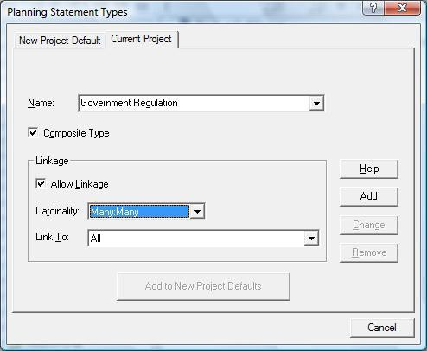

Figure 3-2 Defining Planning Statement Types

Planning Window
Planning statements are captured and refined in Visible Analyst through the Strategic Planning window. This window allows you to add statements to and delete statements from your repository, as well as edit and organize them. In addition, the planning windows let you link planning statements to other modeling objects (such as entities, attributes and classes) created during later phases of the software development process.

To open the Strategic Planning window, choose Strategic Planning from the File menu, or click the Strategic Planning icon on the control bar. Planning is only available in the Corporate and Zachman editions of Visible Analyst. If this option is grayed out, it means your version of Visible Analyst does not support planning statements.

The Strategic Planning window provides a hierarchical view of planning statements defined in the project repository.

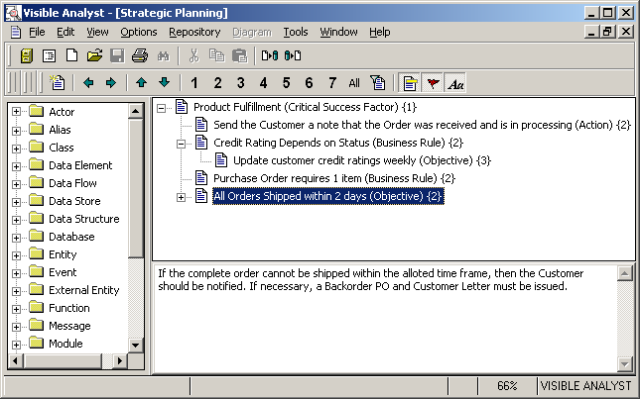

Figure 3-3 Planning Statement Outline Windows

Use the Planning Outline window to:

  - Add, edit and delete statements.
  - Move statements to other positions within the outline.
  - Link statements to other repository objects.
  - Assign priorities to statements.

Each planning statement defined in the repository is shown in a tree-like fashion in the planning window. For each statement, the following information can be displayed.

  - Statement Icon. A symbol showing if any levels are collapsed beneath the statement. A plus symbol (+) means that one or more levels are collapsed beneath the statement. A minus symbol (-) means that all levels beneath the statement have already been expanded. No symbol means that there are no levels below the statement.

- Statement Title. The title of the statement.
- Statement Type. The type of the statement. Shown in parentheses ( ) after the title.
- Statement Priority. The priority level assigned to the statement. Shown in curly brackets { } after the title and type.
- Statement Description. A description of the planning statement. Shown in a window below the statement hierarchy window.

The Planning Outline window displays planning statement titles in a tree arrangement similar to the directory tree in Windows Explorer. Like Explorer, you can expand and collapse branches of the outline to vary the level of detail displayed in the window.

The tree is hierarchical. Statements may have child (hierarchically subordinate) statements, which in turn may have their own child statements, if the statement type allows it. You may expand all hierarchy branches or collapse one or more of them to show only parent statement branches.

You can change the appearance of the statement window by using commands on the View menu, right-clicking on the window to display the Property menu, or by clicking on the appropriate buttons on the control bar.

Adding a New Statement
To add a new planning statement to the hierarchy:
Select the Parent: | 1 | Click the planning statement to which you want to add a child statement. If no statement is selected, the new statement is added to the top of the hierarchy.
Define the Statement | 2 | Click the New Statement icon on the control bar, right- click the parent and select New from the Properties menu, or click the Insert key on the keyboard to display the Add Planning Statement dialog box
 | 3 | Enter a name for the statement. Statement names must be unique.
 | 4 | Select the statement type from the list.
 | 5 | Set the priority. This is an optional field that can contain any value that you wish. Generally, a numeric value is used to set the relative priority against other statements.
 | 6 | Describe the statement.

Save the statement: 7 Click OK. The statement is now added to the hierarchy.

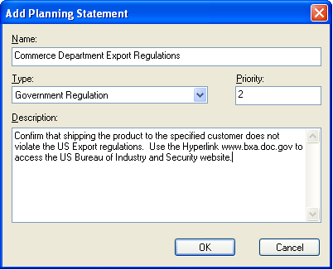

Figure 3-4 Creating a Planning Statement

Planning Statement Links
In order to track the software development process from the planning stages through analysis, design, and implementation, it is important to be able to link planning statements to model objects to help you determine the significance of each object and to ensure that each object is essential in supporting the organization's business plan. The Links To field on the Links tab of the Define dialog box allows you to maintain these relationships.

There are three methods for creating a link between a planning statement and any other object:

  - Right-click the Links To field and select Add from the Properties menu. A list of repository entries is presented and you can select the desired object. If the current object is not a planning statement, only planning statements are listed.

  - Drag a planning statement from the planning hierarchy window using the mouse.

- Set the focus in the Links To field and press the Insert key. A list of repository entries is presented and you can select the desired object. Once the link has been added, its name and type are displayed in the field. The link is visible from both directions. If you are looking at a planning statement, you see the linked object; and if you are defining any other type of object, the planning statement is displayed. The linkage rules for a statement type dictate how statements of that type can be linked to other objects.

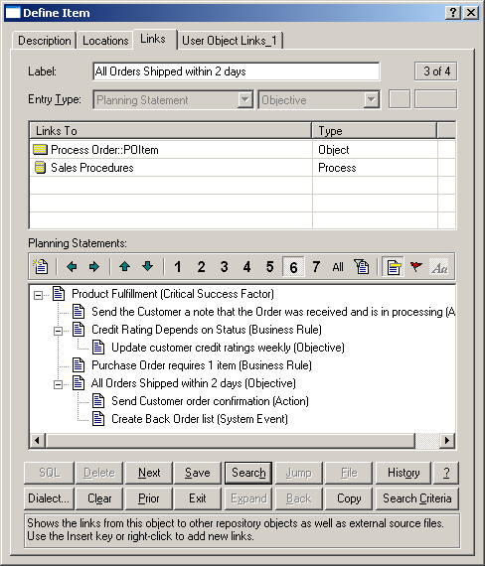

Figure 3-5 Planning Statement Links

Lesson 4 Structured Modeling Techniques

OVERVIEW
The techniques for planning, process modeling, data modeling, object modeling, state transition modeling and structured design assist in the creation of systematically correct and consistent diagrams and documentation. Using structured and object techniques forces a standardization of logic throughout the system under analysis. The benefits of this approach are obvious:
- Large systems can be partitioned into component subsystems or sub-functions for further analysis.
- Specifications for individual components are easier, faster, and more accurate to define than the total system.
- The interaction between the parts can be planned, designed, evaluated, and implemented to reflect improved information flows and controls.
- More than one person can work with the same system in the network edition.
- Standardized format and grammar enhance and simplify communication and maintenance.

STRUCTURED PLANNING
Planning uses a structured technique based on functional decomposition for describing interrelationships among broad organizational areas, specific organization functions, and the systems that support those functions. Structured planning establishes organization responsibilities at function levels and then defines the process responsibilities within functions.

The objective of structured planning is threefold:
- To identify the specific business or organization function, including roles, goals, and objectives, to be automated or reengineered.
- To identify the existing system processes that support that function.
- To provide a focus for requirements analysis in support of identified goals and objectives.

For example, functions or functional areas in an organization that could be decomposed could be Finance, Sales, and Research. A function is usually designated by a noun. These functional

areas could then be subdivided into processes that are groups of activities necessary in running the organization. The processes are usually defined in active state verbs. For example, the Sales function could be decomposed into the Customer Relations, Selling, and Management processes. These processes could then be further decomposed using a data flow diagram. If a process is labeled as a noun, it is a signal that the process should be further decomposed into more processes.

Because of the high-level functional nature of this type of modeling, the technique specifically applies to functions and not to the data that those functions use. Since functional decomposition modeling is viewed as the highest level of business planning, it is probably the place to begin when you wish to define the overall functioning of an enterprise. There is no rule that you must begin here, but other things are easier if you do. For designing individual projects, it may be just as effective to start with a process model or a data model (or both at once), for you might consider that the project does not have the breadth to warrant planning at the FDD level1. You might also choose to focus on the definition of objects, beginning with the object/class model.

ENTITY RELATIONSHIP MODELING
When designing, developing, restructuring, or maintaining a system, it is important to be able to model the interrelations of the data used in it. The technique used by Visible Analyst for representing data is known as entity relationship modeling or data modeling. The purpose of this technique is to graphically demonstrate how entities are related to one another. An entity represents a real or abstract thing that is important to an enterprise about which data needs to be stored. For example, an entity could be Customer, Product, Inventory, Supplier, Sale, Purchase Order, or some other label generally in the form of a singular noun. An entity would typically correspond to a table in a relational database.

The diagramming technique used to graphically depict the data model is the entity relationship diagram (ERD). It provides a clear and concise method for describing data through the use of entity symbols that are interconnected by relationship lines. Relationships between entities consist of specific associations that are described in terms of their cardinality and are generally labeled using action verbs. Cardinality refers to the numerical scope of associations between entities, such as a one-to-one association (one sale is associated with one customer); a one-to-many association (one supplier supplies many products); or a many-to-many association (many salesmen sell many products). The terms ―one-to-one,‖ ―one-to-many,‖ and ―many-to-many‖ are common statements used to describe the cardinality of a relationship. There are specific ERD symbols used to signify cardinality, the terminators on relationship lines.

1 Some of the theory behind functional decomposition diagrams can be found in Martin, J. and McClure, C., Structured Techniques for Computing, Prentice-Hall, Englewood Cliffs, NJ, 1985.

Relationships are also allowed to be optional instead of mandatory. It is sometimes the case that two entities are related, but not in all instances. For example, an employee can be assigned to zero, one, or many projects. The optional relationship is important when specifying a system in which the software is to enforce referential integrity; that is, to make sure that nothing is inserted into or deleted from the database that would make nonsense of some other entry. For instance, one sale is associated with one or many sale items, but it would be wrong to have one without the other. The optional-becoming-mandatory relationship enforces clear designation of what information can be omitted from or is optional within the database without disrupting other references. It often represents complex business rules that are often time-dependent. For example, PURCHASE ORDER --|-----O|-PRODUCT (a PURCHASE ORDER will eventually order at least one or many PRODUCTs.)

A relationship is intrinsically bi-directional and can be thought of as consisting of a relationship in one direction and a reverse relationship in the other. Generally, each direction in a relationship is given its own name or label. If you think of a relationship in one direction as a sentence, subject–verb–object, entity1–relationship–entity2, the picture becomes very clear.

Some feel that entity relationship modeling should be the starting point for designing a system because it is necessary to know the nature of the data in order to determine the processing done upon it. Others feel that the process model is the best starting place because the processing of the data is the system, and the data and its storage can be designed to fit the necessary processing. Visible Analyst accommodates either approach; it allows you to build upon what you have done before. You can then use the diagrams that you created and the repository information captured from them to refine the description of your model and to help you in properly normalize2 the data.3

PROCESS MODELING
Process modeling, otherwise known as structured analysis, is a technique for graphically depicting a system. The process modeling technique describes a system by focusing on the transformations of data inputs and outputs by processes. Whether examining an existing system or designing a new one (or both), this is a key step toward fully understanding the

2 Normalization is a means of eliminating redundancy in data. It is a complex topic and is beyond the scope of this tutorial. Since understanding normalization is key to effective database design, you should consult a text on the subject, such as one of those written by C. J. Date, or by Clive Finkelstein, “Enterprise Architecture for Integration: Rapid Delivery Methods and Technologies”, Third Edition (2015). Read Chapter 9: Business Normalization Concepts. Alternatively, you can view a narrated demonstration of Business Normalization by downloading the narrated PowerPoint presentation: “ARBC OERVIEW.pptx” from here.
3 Although many of the methodological details are different from how it is done in Visible Analyst, a good introduction to the concepts of data modeling can be found in Shlaer, S. and
Mellor, S. J., Object-Oriented Systems Analysis, Prentice-Hall, Englewood Cliffs, NJ, 1988. A practical, but more advanced, book is Fleming, C. C. and von Halle, B., Handbook of
Relational Database Design, Addison-Wesley, Reading, MA, 1989.

system. The diagrams you draw allow you to show, at levels of increasing detail, how data flows through your system and what is being done to it along the way.

Specifically, process modeling is used to identify the data flowing into a process, the business rules or logic used to transform the data, and the resulting output data flow. It demonstrates for a business area or a system where the data comes from, what processes transform it, and how processes interact with data stores.

The diagramming technique used for process modeling in structured analysis is the data flow diagram (DFD). The DFD consists of data flows, processes, data stores, and external entities. A data flow is data that is in motion in your system. It is represented by an arrow that indicates the direction of the flow of data. A data flow is labeled as a noun, indicating the particular data that is being transferred. A process is a procedural component, a transformation agent, in the system. It transforms inputs to outputs. A process is indicated by an action verb describing the sort of transformation that occurs. For example, Prepare Bank Deposits would designate a process. A data store, also called a file, represents a logical file, a database, or even a filing cabinet. In a system, it is data at rest within the scope of the system. An external entity, also called a source/sink, provides data to the system from outside the scope of the system, or receives data from the system. External entities are outside the system, so they are beyond the scope of analysis. A data store, a source, and a sink are all generally labeled as nouns.

A number of methodologies are available for process modeling. The most widely used are Yourdon/DeMarco, Gane & Sarson, SSADM, and Métrica. Visible Analyst implements these techniques. There are few differences among the techniques. The most noticeable is the slightly different appearance of the symbols used. The symbols are also named somewhat differently. For a detailed description of the differences, please refer to the Visible Analyst Operation Manual or to the online help system4.

The methodology you use is up to you. They are equally useful, and the results are the same. The data flow diagramming tutorial uses the Gane & Sarson methodology; but since they are so similar, it shows you the basics of how both are used.

4 For more detailed information on these analysis methodologies, you can refer to the following books:
DeMarco, Tom. Structured Analysis and System Specification. Englewood Cliffs: Prentice-Hall, 1978.
Gane, C. and Sarson, T. Structured Systems Analysis: Tools and Techniques.
Englewood Cliffs: Prentice-Hall, 1979.

WORKING WITH BOTH DATA AND PROCESS MODELS
All information you place in any diagram is, of course, captured by the repository and is available to both your process models (DFDs) and to your data models (ERDs) (where applicable) if you have an integrated tool set. The Analyze function can assist you in balancing a data model against a process model and in maintaining consistency.

There is some degree of correspondence between the entities in a data model and the data stores in a process model. The nature of this correspondence is not generally agreed upon. You may find that specifying such a correspondence helps you to ensure that all data is accounted for between your models. You can specify that every entity must correspond to a data store with the same composition; Analyze notifies you if this is not the case.

Similarly, you can configure Visible Analyst to notify you of any data elements that have been defined but are not used. In other words, is there an element listed as part of an entity but not used by at least one process on at least one data flow diagram? Refer to the manual or the online help system for details about both balancing options.

Another link between your process and data models is the ability to create a view of that portion of your data model affected by a particular process. Once you have at least a portion of each model built, you can request that Visible Analyst draw a process view of your data model for a particular process. This shows you on a process-by-process basis how your data is used and how a designated process affects other data. This technique is demonstrated in Lesson 7 – Entity Relationship Diagrams.

STRUCTURED DESIGN
Structured design is the partitioning of a system into a hierarchy of modules that performs the activities internal to your system. It is a technique used for representing the internal structure of a program or system and its components. Structured design is a discipline that is complementary to structured analysis and implements another stage in the software life cycle. If data flow diagramming is the ―what‖ of your system, structured design is the ―how.‖ To be most effective, it should be based upon specifications derived using structured analysis. The capability to integrate analysis and design verifies that your designs reflect the reality of your specifications.

The modeling technique used in structured design is the structure chart. It is a tree or hierarchical diagram that defines the overall architecture of a program or system by showing the program modules and their interrelationships. Visible Analyst uses the structural information contained in the system model in the code generation process to create the precise infrastructure of your system. This includes the passing of control and parameters between program modules, as well as the specific order in which the modules are arranged in your code.

A module represents a collection of program statements with four basic attributes: input and output, function, mechanics, and internal data. It could also be referred to as a program, a procedure, a function, a subroutine, or any other similar concept. A structure chart shows the interrelationships of the modules in a system by arranging the modules in hierarchical levels and connecting the levels by invocation arrows designating flow of control. Data couples and control couples, designated by arrows, show the passing of data or control flags from one module to the next. This is equivalent to passing parameters between functions or procedures in an actual program.

The Visible rules implementation of the Yourdon/Constantine structured design methodology is intended to maintain as much design freedom as possible for you, while guarding against known poor design practices. The error and warning messages generated are intended to be used as guidelines rather than rules.5

OBJECT-ORIENTED MODELING
Object-oriented modeling concentrates on developing a collection of discrete objects that incorporate both data structure and behavior. The objects perform or are impacted by operations that represent the action between objects. The focus is on building object definitions that can be organized into a class hierarchy with high-level abstractions of a class of like objects that provide inheritance of characteristics to subclasses and eventually to individual instances or a unique occurrence. Objects can be brought together into groups called aggregations, and they can have relationships and attributes (called properties) similar to those found in the entity relationship model. In fact, the data model (ERD) is the basis for object-oriented concepts with its entities and attributes.

OBJECT CONCEPTS
The object model is used to define and build the classes and subclasses of objects and the data characteristics that uniquely define object groups. By developing a clear picture of object structures and operations needed to support a business process, the designer can build reusable object components and save time and effort in the development and testing phases of

5For more detailed information on the Yourdon/Constantine structured design technique you can refer to the following books (the Page-Jones book is the better choice for beginners):
Page-Jones, M. The Practical Guide to Structured Systems Design. Englewood Cliffs: Prentice-Hall, 1988.
Yourdon, E.N. and Constantine, L.L. Structured Design: Fundamentals of a Discipline of Computer Program and Systems Design. Englewood Cliffs: Prentice-Hall, 1986.

the project. The object model is a static model in that it defines all of the objects that are found in the application and the general and specific characteristics of each object.

The object model shows a static snapshot of the hierarchy and packaging of the objects. The data model is a static snapshot of the data components of the application and the relationships between data components. The data flow diagram (process model) shows the flow and sequence of operations of the application. The state model shows the dynamic changes that occur within the applications and to the objects over time. The structure chart (physical model) defines how the application is assembled and built.

STATE TRANSITION (DYNAMIC) MODELING
The state transition model focuses on the changing conditions and states of an object. As an object such as a Customer Order progresses through an organization, it changes its state from a pending order to a shipped order to a paid order. The movement of the order from one state to another changes some of the object’s properties and is usually caused by an event or a method being applied to the object.

The dynamic model is built after the object model is defined. It provides a sequence of states of the objects as they change over time. Thus the object model is static and complete, and the state (dynamic) model is continuously changing with different events and triggers. The state model is closest to reality and supports the programming design mechanics. If the programs cover all of the state transitions of the objects, then the system should fit to reality.

The object and the state-transition model are linked to the functional model that describes the data transformations of the system. The functional model can be represented by data flow diagrams with processes and data flows showing how objects are serviced through their time sequence transitions.6

OBJECT MODELING AND PROCESS MODELING
From the static snapshot of the objects, to the dynamic changes of states, to the sequence of operations in the data flow, to the build specifications of the structure chart, object-oriented methodologies provide a complete mechanism for defining, designing and building information systems. Object concepts provide an alternative and a complement to the structured design methodologies. Both approaches define the data components of the application and provide a view of how the application needs to act to provide service and

6For a detailed discussion, refer to:
Rumbaugh, Blaha, Premerlani, Eddy and Lorensen. Object-Oriented Modeling and Design. Englewood Cliffs: Prentice-Hall, 1991.

support to the application users. The differences are mainly in the focus on components, the order of occurrence and the formats of packaging.

Both techniques and methodologies link to the happenings of the real world. They must both produce working information systems. They also share many similar concepts, such as reusability, modularity and hierarchical structures.

Visible Analyst supports both approaches to systems design and development. They can be used separately, together, or in any combination that suits you. Through the integrated Visible Analyst repository and the independence of the diagrams, you can maintain maximum flexibility and still take full advantage of the engineering practices for designing and developing better information systems.

DATA AND OBJECT RELATIONSHIPS
There is considerable similarity between entity and object models. Both focus on defining physical components: in the entity model the only elements are data or data-oriented components; in the object model, the focus is on real components that can be data, physical units, goods, materials, etc.

The general consideration is that the object model follows the design of the data model but has made the application more worldly and generic.

LIBRARY MODEL
The library model contains the recorded information about all the pieces, parts, components, actions and conditions of the project. As objects are placed on diagrams and labeled, the label creates an entry in the library database for the proper data logic to support the type of graphic object. The library model is dynamic and evolutionary and is used to describe all the known factors and facets of the application and the systems development project. The Visible Analyst repository is the implementation of a comprehensive library model. It contains all of the labeled parts of the diagrams, and it provides a facility for expanding the details and definition of many components of the project. The Visible Analyst repository can support the building of data elements, database keys, pseudo code, test data and other specifications of the application. Free-form notes and description fields allow recording extensive comments, findings, important information, and other relevant factors about project components. Detailed reports and the generation of database schema, shell code, and other useful project outputs are derived from the library model.

The library model can serve the project design and development process, and it can be a useful reference source for maintenance and operation of the system as well as a key resource when changes need to be made to the system.

Lesson 5 Diagramming and Repository Basics

INTRODUCTION
This lesson introduces you to the diagramming tools. You learn the basic techniques for creating and modifying any type of diagram in Visible Analyst. We use the unstructured diagram format that does not require you to ―follow the structured rules.‖ This allows you to concentrate on the basics of the drawing process without worrying about rules and the repository. Sometimes you just want to draw a diagram, but not as a part of an analysis or design project. (A number of examples are shown the Operation Manual.) Also, some diagrams created from standard diagram types, such as cluster diagrams from entity relationship diagrams (ERDs) and process decomposition diagrams from data flow diagrams (DFDs), are always unstructured. You should know how to access them.

The basic techniques of drawing diagrams are valid for unstructured and structured diagrams. We could just as well use the DFD type or the ERD type to teach basic diagramming techniques, but not all users have a Visible Analyst version that contains all diagram types.
However, all Visible Analyst packages have unstructured diagram capability. The diagram drawn in this lesson has no meaning other than as an exercise and is not part of any other lesson.

CREATING A NEW PROJECT
Each project that you create represents one complete system. One project could also be used to depict one unit in a very large system. By maintaining the entire system in one project, Visible Analyst ensures that the entire system remains consistent throughout the entire development process rather than checking for global consistency once all of the units have been merged together. The LAN version of Visible Analyst allows multiple designers to work on diagrams in the same project.

Note
 Different types of lines are available for each type of diagram. You can select the line type for any one of the other available diagram types for use with an unstructured diagram. This selection must be made before a diagram is created.

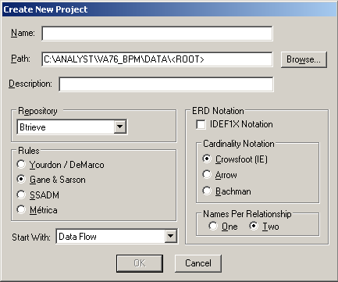

Open the Menu: | 1 | Click on the File menu with the left mouse button.
 | 2 | Select New Project. A dialog box like that in Figure 5-1 is displayed.

Name the Project: | 3 | Figure 5-1 New Project Dialog Box  Type TUTOR into the Project Name field. A project name
 |  | or ―root‖ can be up to 128 characters long. It must begin with a letter and can be composed of letters and numbers.
Describe the Project: | 4 | Click the cursor inside the field marked Description. Type  ―Tutorial Project.‖ Another common method for moving the cursor to other fields in a dialog box is to use the TAB key. Try pressing the TAB key a number of times. The highlighted selection changes as the cursor moves to a new field. Press the TAB key until the cursor returns  to the Description field.

The next steps help familiarize you with the options available when creating a project. If a default is incorrect, you can click on the item to change the setting.

Select the database Engine: | 5 | Choose Btrieve as the database engine. Btrieve is included with Visible Analyst.
Select the Rules to Apply: | 6 | In the box entitled Rules, select Gane & Sarson. This is where you choose the rule set you want applied to your project. An unstructured diagram does not follow any rules, but it is necessary to select the type of rules to be applied to all of the diagrams that might be created for this project. (Rules are covered in more detail in Lesson 8  – Data Flow Diagrams.)
Select ERD Notation Conventions: | 7 | In the area entitled ERD Notation, the default notation is IDEF1X. This selects the type of relationship line notation you use on your Entity Relationship Diagrams. Crowsfoot is selected as the alternate. (This is covered in more detail in Lesson 7 – Entity Relationship Diagrams.)
 | 8 | In the box entitled Names Per Relationship, the default is Two. This refers to how relationship lines on ERDs are labeled.
Choose a Window Type: | 9 | Select the type of document window that will be opened automatically after the project is created. If you  don't want a window opened (if you will be performing a Reverse Engineering operation for example), choose None.
Activate the Project: | 10 | Click OK to activate the project. When you do this, the New Diagram dialog box is automatically displayed.
Now you have created a project. The name of your project is displayed in the lower right-hand corner of the application workspace. If you turned off the help bar from the Options menu, the project name is not displayed. The next step is to create a diagram.

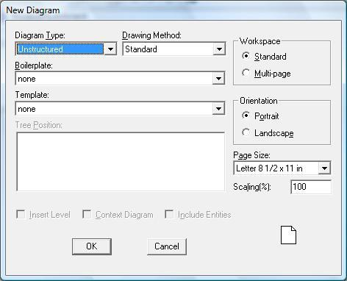

Figure 5-2 New Diagram Dialog Box

CREATING A NEW DIAGRAM
After creating a project and before creating a diagram, the screen should look just as it did when you started Visible Analyst, except that the name of your project appears in the lower right-hand corner. To create a new diagram, follow these steps:

Open the Menu: | 1 | Click on the File menu (or click the New Diagram button on the standard tool bar).
 | 2 | Select New Diagram. A dialog box like the one in Figure 5-2 is displayed.
Set the Diagram Type: | 3 | Open the selection box for the Diagram Type by clicking the arrow at the end of that field. Select Unstructured. The fields marked Boilerplate and Template should say None.

A boilerplate is a template you can create to keep information such as diagram creation date, diagram created by information, and a diagram heading without rewriting it each time you create a new diagram.
Templates allow you to add image files to an unstructured diagram template file, and create unstructured diagram using the images as the diagram symbols. (See the Operation Manual or the online help system for more information on boilerplates and templates. Boilerplates and templates are not enabled in the Education Editions of Visible Analyst.)
Select a Workspace: | 4 | In the area entitled Workspace, select Standard. This sets your diagram size to one page. Multi-page allows  you to spread large diagrams over a workspace of 90 x 88 inches. You can go to larger pages as needed later or select them now if you know you are going to work on a large diagram. (Multi-page is not enabled in the Education Editions of Visible Analyst.)
Select Orientation: | 5 | In the Orientation area, select Landscape.
Select Page Size: | 6 | Open the Page Size drop-down list and select 8-1/2 x 11.
Select Scaling: | 7 | Accept the default scaling, 100%.
Create the Diagram: | 8 | Click OK to open a blank diagram.
The control bar is located just above the diagram and below the menu. The  button is highlighted.

Above the menus, notice the title of your diagram. Since it has not been saved, it is marked Untitled: US. The US indicates that the window contains an unstructured diagram.

EDITING A DIAGRAM

Adding Symbols to a Diagram
Now add symbols to the diagram to become familiar with the different methods for doing this.

Turn on Auto Label | 1 | Open the Options menu. There should be a check mark
Symbols: |  | next to the selection Auto Label Symbols. This indicates

 |  | that you are automatically prompted to label a symbol as soon as it is drawn. If there is no check mark next to the selection, set the option by clicking on the selection.
Change to  Symbol-Adding Mode: | 2 | Click the first symbol button in the control bar, then slowly move the cursor from button to button. As you move the mouse over each button, a brief description appears on the control bar describing its function. Icon buttons are added to the control bar for each type of symbol available to you for the current diagram type. Only certain symbols are available for most types of diagrams, but they are all available for an unstructured diagram. When you move the cursor back over the drawing area, it changes to indicate that you are in symbol adding mode
Position the Symbol: | 3 | Place the cursor where you would like the symbol to appear on the diagram and click the left mouse button. The symbol is drawn. Because Auto Label Symbols is turned on, a dialog box appears for labeling the symbol.
Label the Symbol: | 4 | Type ―First‖ into the Text field.
 | 5 | Click the OK button.
Repeat for Another Symbol: | 6 | Click the third symbol button and add it to the diagram as above.
 | 7 | Type ―Second‖ into the Text field and click OK. Note that the new symbol is now highlighted, indicating that it is the current object, and the previous symbol you added has returned to normal display.
Save and Label the Diagram: | 8  9 | From the File menu, select Save.  Type the diagram label ―Diagramming Technique.‖
 | 10 | Click OK. The diagram label appears in the window title bar. (See Figure 5-3.)

Note
 The only difference between saving a new diagram and saving an existing one is that you have to give the new diagram a name in the dialog box that is

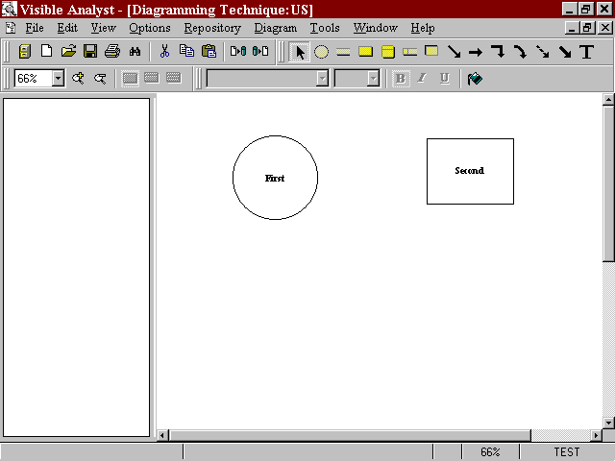displayed. The only restrictions on diagram labels are that they cannot exceed 128 characters and that they must be unique within the diagram type of the project. To change a diagram's name select Save With New Name from the File menu. After that, the process is identical to that described for a new diagram, above.

Figure 5-3 New Diagram with Symbols Added

Stylizing a Symbol
Change into Selection 1 Click the  button on the control bar or press the
Mode: ESC key. This changes the cursor, indicating that Visible Analyst is now in selection mode.

Use the Object Menu: 2 Position the cursor over the symbol labeled First and click
on it with the right mouse button. A menu appears with functions that can be performed on the symbol.

- Select Stylize.

Stylize the Symbol: | 4 | In the dialog box, adjust the level of boldness by double- clicking the right-hand arrow on the scroll bar under the word Boldness.
 | 5 | Click the Apply button. The symbol in the box indicates how your symbol looks. (See Figure 5-4.)

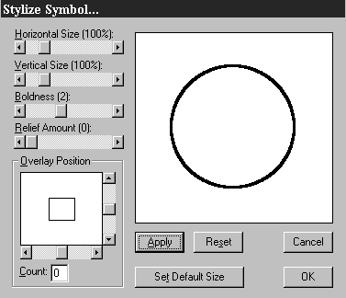Figure 5-4 Stylize Symbol Dialog Box

6 Click the OK button and the stylization you selected is applied to the symbol on the diagram.

Moving, Cutting, and Pasting a Symbol
Select the Symbol: | 1 | Position the cursor inside the symbol Second and click the left mouse button. The symbol changes color to show that it is now the selected or current object.
Move the Symbol: | 2 | Position the cursor inside the symbol Second and click and hold the left mouse button. Move the symbol by dragging the box around. A rectangular outline, called the  ―bounding box,‖ appears in place of the symbol. Release the mouse button when your symbol is where you want it

or press the ESC key if you want to cancel the move operation.

Cut and Paste the 3 While the symbol is selected, click on the Edit menu.
Symbol:
- Select Cut. The symbol disappears from the diagram, but is saved on the Windows Clipboard.

- Go back to the Edit menu and select Paste. The symbol is displayed surrounded by a dashed outline, indicating the symbol is the current object. Position the cursor within the outline of the symbol, hold the left mouse button down and drag it to the desired location on the diagram. Release the mouse button.

Deselect the Symbol: 6 Click on an empty space on the diagram with the left
mouse button. This deselects the highlighted current object.

Notes
 You can use the Windows keyboard shortcuts for the editing functions to speed up these operations and to edit in dialog boxes.

 When selecting or changing line types and line terminator choices, Visible Analyst performs differently depending on what state it was in when the modifications were entered. When no diagram is selected and the line types are changed, the default choices are modified. When a diagram is selected but no line is highlighted, the choices remain in effect for the diagram. If a line is selected, the change only impacts the selected line.

Adding Lines to a Diagram
Now add a line to connect the two symbols you have drawn.

Turn on Auto Label Lines: | 1 | Open the Options menu. There should be a check mark next to the selection Auto Label Lines. This indicates that you are automatically prompted to label a line as soon as it is drawn. If there is no check mark next to the selection, set the option by clicking on the selection.
Set Line-Drawing Mode: | 2 | Click the first line button in the diagram tools tool bar to put Visible Analyst in line-drawing mode. The cursor changes to indicate this.

Draw the Line: | 3 | Position the cursor on the edge of the symbol labeled First that is nearest to the symbol labeled Second.
 | 4 | Press and hold the left mouse button.
 | 5 | Drag the line to the edge of symbol Second. The way the line stretches between the cursor and the start-point is sometimes called ―rubber-banding.‖
 | 6 | Release the mouse button to signal the end of the line. If you release the mouse button within the symbol, the line is connected automatically to the edge of the symbol.  When the line is completed, it changes color and handles appear at the endpoints. (See Figure 5-5.) A dialog box appears for labeling the line.

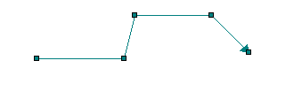Figure 5-5 A Line With Its Handles

Label the Line: | 7 | Type ―Flowname.‖
 | 8 | Click OK to draw the label next to the line on the diagram.

Now that you know how to add a line to a diagram, you can adjust the position and appearance of that line.

Note
 If you want to move the name of a line, select the name by positioning the cursor on the text and press and hold the left mouse button. Drag the label to the desired position and then release the mouse button.

Selecting and Adjusting Lines
Return to Selection | 1 | Click the  button on the control bar or press the
Mode:  Select the Line: | 2 | ESC key.  If the line is not currently highlighted, click on any point

along the line. When a line is selected, you can see its handles, little boxes at the end of each segment that allow you to move the segments by dragging the handles with the mouse.

Set Line 3 From the Options menu select Line Settings.
Characteristics:
- Choose Single Dashed for Line Type.

- Click OK. The line is redrawn using the new type.

Changing Line Settings as above allows you to adjust the line characteristics for the selected line. If no line is selected, you choose the characteristics for the next line you draw.

Adding Caption Text to a Diagram
You can add text in the form of a title or a paragraph. This text is used to enhance the definition of your diagram or its parts. When entering the text, press ENTER to continue the text on another line.

Set Caption Text Mode: | 1 | Click on the large T (text) button on the control bar.
Select the Caption Position: | 2 | Position your cursor at the top of the diagram and click with the left mouse button.
Enter the Text: | 3 | Type ―Unstructured Diagram #1.‖ Then press ENTER  to move the cursor down to the next line. Type ―Diagram Drawing Techniques.‖
 | 4 | Click OK.
 | 5 | Click the  button on the control bar or press the ESC key to return to editing mode.
Change the Caption Characteristics: | 6 | Click the right mouse button over the caption you  just added to display the Object menu for the caption.
 | 7 | Select Text Settings from the Object menu.
 | 8 | Select Times New Roman in the box labeled Typeface. Refer to Figure 5-6.

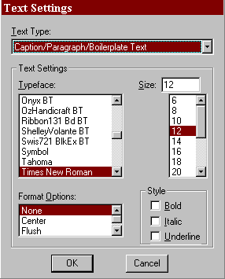Figure 5-6 Text Settings Dialog Box

  - Change the Point Size to 16 in the Size box.

  - Select Bold in the box labeled Style.

  - Select Center in the box labeled Format Options.

  - Click the OK button and then deselect the text. The completed diagram should appear more or less like that shown in Figure 5-7.

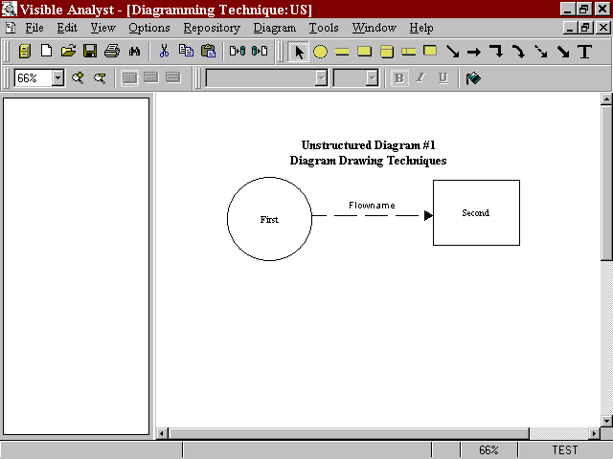Figure 5-7 The Completed Diagram

Note
 The ―T‖ icon text should not be used to define symbols or lines. Only symbol labels are entered into the repository for rules based components. To label an unlabeled diagram object, click the object with the right mouse button and choose Change Item from the object menu.

OTHER DIAGRAMMING FUNCTIONS
Now we take a look at some of the other functions available to help you create Visible Analyst diagrams.

Colors
Different screen objects displayed in different colors makes it easier to distinguish them on the screen. You have a number of choices available that you can experiment with to find a pleasing combination.

Open the Menu: | 1 | To change the colors of your symbols, lines, and text select Colors from the Options menu.
Change the Color: | 2 | Under Object Type, select Symbol Color. Select a color by clicking on one of the color squares or by adjusting the slide bars.
 | 3 | Click OK. If no objects are selected, the default colors are set. If objects are selected, only those items are changed.

Displaying and Hiding Symbol Labels
It is sometimes easier to see the overall layout of objects on a diagram if there are no text labels distracting your attention from the structure the diagram represents. Visible Analyst allows you to hide the labels of symbols and lines if you wish to do so.

Hide the Labels: | 1 | From the View menu, click Show Symbol Names. The symbol labels should disappear. (A check mark in front of this selection indicates that the symbol names are shown; otherwise they are not shown.)
Redisplay the Labels: | 2 | From the View menu, select Show Symbol Names  again to reset the names to show.

Note
 Turning line or symbol labels off is not the same as not labeling them. A line or symbol that has never been labeled does not exist as far as the repository is concerned.

Changing Text Characteristics for a Block of Diagram Objects
Select a Group of | 1 | Draw a box around the symbols on the diagram. Place the
Objects: |  | cursor in the upper left corner of the diagram and hold the
 |  | left mouse button down while you drag the mouse to the
 |  | lower right corner of the diagram. A bounding box
 |  | rectangle is created as you drag the mouse. After you
 |  | release the button, all items completely inside the
Change the Text: | 2 | bounding box are highlighted.  From the Options menu select Text Settings.

- Choose Symbol Labels in the box marked Text Type.

- Choose a Typeface and Point Size.

- Return to the Text Type box and choose Line Labels.

- Choose a Typeface and Point Size.

- Click OK.

- Click in an empty area outside of the bounding box to deselect it.

The symbol labels and line labels for the items completely contained in the box change to the new text settings.

Note
 The text values of all items in the bounding box are set by this function. Those text types that you do not explicitly set revert to the default values shown in the dialog box.

CLOSING A DIAGRAM
To close a diagram:

Activate the Control Menu: |  | Click on the diagram Control menu button (not the Analyst Control menu button) in the top left corner of the diagram window, or to the left of the File menu when the diagram is maximized. There is also a Close Diagram function on the File menu.
 | 2 | Select Close. If your diagram has not been maximized, meaning that it occupies less than the entire Visible Analyst workspace, you can close the diagram by double- clicking on the Control menu button.
 | 3 | Visible Analyst prompts you to Save the diagram. Click Yes to close the diagram. Selecting No closes the diagram without saving any changes made since the last Save operation was performed.

THE TUTORIAL PROJECT
For the rest of this tutorial, you add diagrams to an existing project. We created the project to save you the time it would take to enter the repository information and create the diagrams that are necessary to demonstrate some of the more advanced features of Visible Analyst. To access the TEST project:

  - Choose Select Project from the File menu or click the File Cabinet button on the control bar.

  - Select TEST from the list displayed on the Select Project dialog box and click OK.

TEST is now the current project. As when you created the first project, the lower right corner of the Visible Analyst screen displays the name of the current project.

CONCLUSION
Now that you understand the basic methods for drawing symbols, lines, and text in Visible Analyst, as well as how to change some of the optional settings, you are ready to build more significant diagrams.

We have provided diagrams to help demonstrate some of the structured modeling capabilities of Visible Analyst. The objects on the diagrams and entries in the repository have been filled in for you.

Lesson 6

Planning and Using Functional Decomposition Diagrams

OVERVIEW
In Visible Analyst, planning is done with functional decomposition diagrams (FDDs). They give you the ability to do high-level planning of business functions and their hierarchical relationships while concurrently populating the repository. You can enter business functions that you define onto diagrams and break them down into successively finer gradations. At some point, one that is entirely up to you, you can break down business functions (hereafter called simply functions) into processes. These processes are semantically equal to the processes that appear on data flow diagrams. The processes can themselves be broken down into smaller parts (still lower-level processes) on the FDDs.

The FDD is typically derived in close association with the user community. As they describe their organization responsibilities, it translates into functions. Once they begin describing
―what‖ they do, it indicates the transfer to processes. This is the point at which you want to show finer gradations of functionality as processes. You can lay out all of the processes of this branch of your functional decomposition diagram, together with their hierarchical relationships. You can then instruct Visible Analyst to produce a set of DFDs for this branch of processes. This procedure is called ―spawning‖ DFDs from an FDD function. You can then work on the DFDs and add data flows, files, external entities, etc. See Figure 6-1.

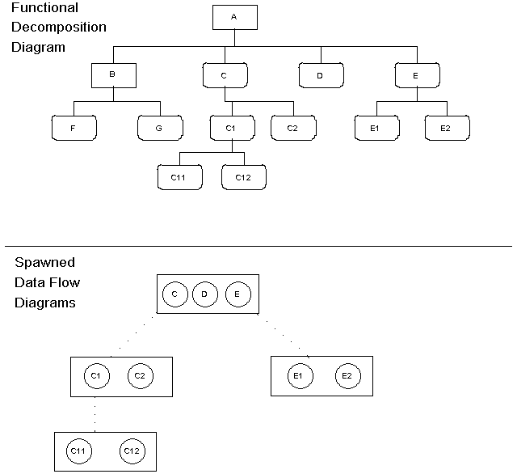Figure 6-1 DFDs Created by an FDD Using Spawn

This lesson leads you through the process of creating a functional decomposition diagram. It also introduces you to a number of new techniques that you use frequently with Visible Analyst. The technique of spawning is also demonstrated.

As you create FDDs, repository entries are created. When you show hierarchical relationships between functions and/or processes, they are known to Visible Analyst, even though you cannot see them if you look in the repository. Since there is some overlap in repository support between DFDs and FDDs, it is significant which rules methodology (Yourdon, Gane
& Sarson, SSADM or Métrica) you chose when you create a project. You can analyze your FDDs, either individually or as a group, to locate inconsistencies and violations of methodology rules. The types of analysis and the Analyze function are explained below.

Note
 A functional decomposition diagram is very different from a process decomposition diagram. The former is a full diagramming methodology for doing business planning. The latter, discussed in Lesson 8 – Data Flow Diagrams, is simply an unstructured diagram laying out the hierarchy of processes that are descendants of an indicated process.

DEFINITIONS
There are four meaningful things that appear on FDDs (see Figure 6-2):

Function A function is denoted by a rectangle. It is the first of the three symbol buttons that appear on the control bar.

Process A process is denoted by a rectangle with rounded corners. The conceptual dividing point between functions and processes is arbitrary and entirely up to you. The process symbol is the second symbol button on the control bar.

Connector The lines between functions, between processes, and from
functions to processes are called simply ―connectors.‖ They allow you to specify the hierarchical relationships between the functional elements of your model. The higher-order symbol can be referred to as a ―parent‖ and each of the lower-order symbols connected can be called a ―child‖ of the parent. The connectors between processes represent the same type of parent/child relationships as exist on DFD. Processes with the same parent would appear on the same DFD once the parent function has been ―spawned.‖ This technique is explained further in this lesson. There are three line buttons that appear on the control bar.

Page Connector Unlike a data flow model, which occupies a tree-like structure of different diagrams at various levels of detail, a functional decomposition diagram is conceptually all one diagram. If a large model appeared entirely on a single page, it would be unreadable, so you are free to spread it over as many pages as you like. (Although not available in the Education Editions, you could also use a multi-page diagram.) Visible Analyst is able to keep the details straight if you indicate how the pages are linked by using page connectors. The page connector symbol is the third symbol button on the control bar and is identical in appearance to the off- page connector for structure charts.

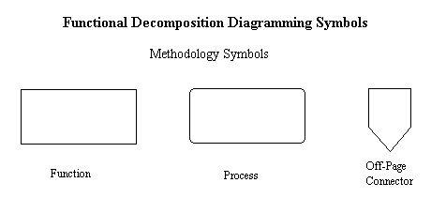Figure 6-2 FDD Symbols

CREATING AN FDD

Adding Symbols to an FDD
Next you add symbols to create a very general functional decomposition diagram. The symbols are arranged in a hierarchical fashion, with the lower-level process symbols at the bottom. The description for adding symbols is brief because it is assumed that you have reviewed Lesson 5 – Diagramming Basics that covers adding symbols.

Create a New Diagram: | 1 | Create a new diagram by selecting New Diagram from the File menu or the new diagram button. Choose Decomposition and click OK.
Maximize the Diagram: | 2 | If you have other diagrams open, click the Maximize button in the top right corner of the window. Set the zoom level to 66% from the View menu or by clicking the right mouse button on the zoom level indicator at the bottom of the screen or use the zoom level buttons on the control bar.
Add Symbols: | 3 | Click on the first symbol button, the function symbol, and add four functions: Department of Motor Vehicles, Registration Department, Licensing Department, and Motor Vehicle Regulation Department. (Refer to Figure 6-3.)
It is not always easy to make your symbols line up in well-ordered rows. You can increase the zoom magnification so that you can see small details better. You can also turn on Grid,

from the View menu, to give you a framework for positioning objects. If all you want to do is align symbols in horizontal or vertical rows, there is an easy alternative.

Align the Symbols: | 4 | Click the  button on the control bar, the selection mode button.
 | 5 | Select into a block the symbols you want to line up in one horizontal or vertical row by drawing a box around them with the mouse cursor. All symbols completely enclosed in the block are highlighted.
 | 6 | Choose Snap Symbols from the Diagram menu. Your symbols are aligned.
 | 7 | Click the mouse on some open area outside the block to deselect the symbols.
Add More Symbols: | 8 | After returning to symbol entry mode using the control bar, click on the process symbol (the second symbol) and add the three processes: Registration System, Driver‘s Licensing System, and Regulation System. Then align the processes. (Refer to Figure 6-3.)

Note
 If you need more room at the bottom of the screen to add symbols, you can use the window scroll bars or the PAGE DOWN key.

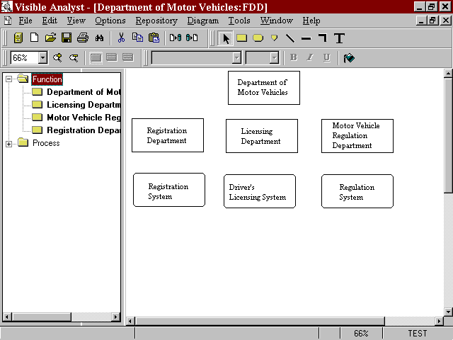Figure 6-3 Function and Process Symbols Drawn on FDD

Now add lower-level processes to the current diagram so that you can practice spawning.

Add More Processes: | 9 | Below the process labeled Driver‘s Licensing System add
 |  | a process labeled ―Issue License.‖ This is the name of a
 |  | process contained in the second-level DFD that came with
 |  | the TEST project.

Note
 Since processes may exist in the repository, you can search for names during labeling by selecting the search button on the Label menu. If the object browser is displayed, you can also click and drag an existing object from the browser onto the diagram.

10 Below Issue License add three processes: Get Photograph, Create License, and Update DMV Database.

Save the Diagram: 11 Select Save from the File menu. Name the diagram
―Department of Motor Vehicles.‖

Adding Connection Lines to an FDD
Now add lines to establish the hierarchical relationships among the functions and processes on the diagrams. The line drawing process for a functional decomposition diagram is nearly automatic. Select into a block all of the symbols you want to connect and instruct Visible Analyst to connect them. You can also use a different method of selecting symbols into a block.

Enter Selection Mode: | 1 | Click the  button on the control bar.
Make a Block: | 2 | While pressing the SHIFT key, click the left mouse button on the function labeled Department of Motor Vehicles. The symbol changes colors to show that it has been selected, and a box is drawn around it.
 | 3 | While holding down the SHIFT key, click the function labeled Licensing Department. Repeat the procedure for Registration Department and Motor Vehicle Regulation Department. The selection box expands to encompass each new symbol that you select using SHIFT+click. If you select a symbol that you do not want in your line grouping, simply press the SHIFT key and click the symbol again to deselect it. See Figure 6-4.

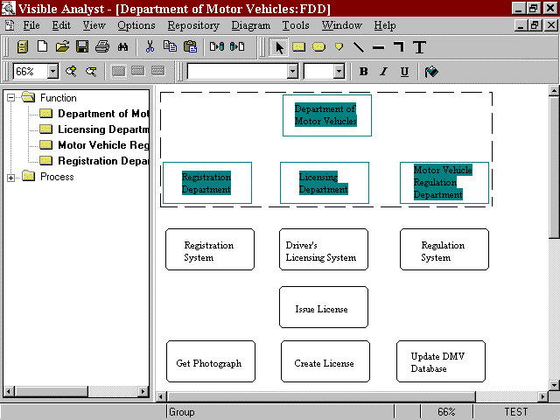Figure 6-4 Connecting Selected Symbols

Connect the Symbols: 4 From the Diagram menu, select Connect. The
connection lines are drawn automatically, as shown in Figure 6-5.

Note
 This function is designed to connect only two levels at a time; for example, a parent symbol and its children. If you select more levels into the block and connect, Visible Analyst assumes that there is one parent and that all of the other symbols are children of that parent.

 | 5 | Clear the block by clicking on an open area of the diagram outside the block.
Add More Lines: | 6 | Press and hold the SHIFT key and click the left mouse button on Licensing Department and Driver‘s Licensing System. The box expands to encompass these symbols.
 | 7 | From the Diagram menu select Connect.

- Similarly, add connectors between Driver‘s Licensing System and Issue License and between Issue License and Get Photograph, Create License, and Update DMV Database.

- Click on the first line button and add a line between Registration Department and Registration System.

- Click the first line button and add a line between Motor Vehicle Regulation Department and Regulation System.

- Select the third line button, an elbow, and draw a connector between Driver‘s Licensing System and Motor Vehicle Regulation Department. (This is an error you are deliberately making that will be discovered by Analyze.)

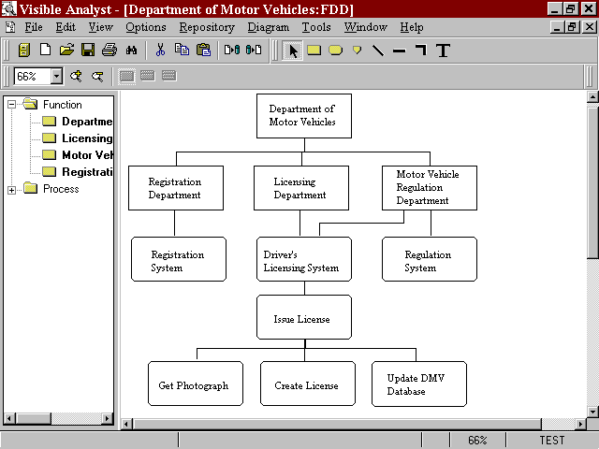Save: 12 Select Save from the File menu.

Figure 6-5 Functions with Connector Lines Drawn

Analyzing an FDD
Now use the Analyze function to check the diagram for correct syntax.

Analyze the Diagram: | 1 | Select Analyze from the Diagram menu. Be sure that
 |  | Current Diagram and Syntax Check are selected. Click
 |  | OK. After processing, a dialog box appears; you can
 |  | maximize it to see it better. You see an error message
 |  | about the extra connection line attached to Driver‘s
 |  | Licensing System, as well as warnings about process
 |  | symbols that are not on data flow diagrams. These
 |  | messages serve as a reminder that you may want to
 |  | decompose these processes in order to have a fully
 |  | defined project.

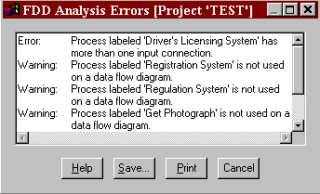Figure 6-6 FDD Analysis Error Messages

Note
 You can keep analysis error dialog boxes on the screen while you carry on various Visible Analyst activities. This is to make it easier for you to correct the errors found by Analyze.

  - Click Cancel.

  - Click the  button on the control bar, the selection mode button.

To make the diagram analyze correctly, you must remove the extra line you added to produce the above error. Because these connection lines are sometimes superimposed, it can be difficult to select the line you want; the wrong line may be selected when you click on an

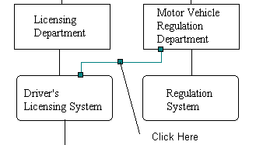endpoint. However, a line can be selected by clicking any point on the line, not just at the endpoints. Since the line you drew has two right angles in it, it has two segments. At the junction of the segments there is a handle. Although the handle is invisible except when the line is selected, you can still click on it. (See Figure 6-7 where the positions of all of the line handles are revealed.)

Figure 6-7 Select a Line by a Handle

Select the Line: | 4 | Click the right mouse button on any point of the line added between Driver‘s Licensing System and Motor Vehicle Regulation Department to display its Object menu. Make sure the line you have selected is the one you drew in step 11 of Adding Connection Lines to an FDD.
Delete the Line: | 5 | Select Cut or Delete from the Object menu to remove the line from the diagram. You can also delete the line by pressing the DELETE key or by selecting Delete or Cut from the Edit menu.

Note
 Visible Analyst asks you to confirm Delete but not Cut.

Analyze Again: 6 Run Analyze again. The diagram is correct, except for the warnings.

Note
 It is not necessary to save a diagram after Analyze has been performed because Visible Analyst automatically saves it for you before analysis begins. The Save option may not be available at various times. This means the diagram has already been saved.

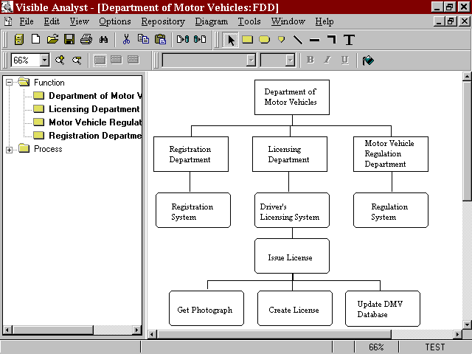Figure 6-8 The Completed FDD

Generating DFDs from an FDD (Spawning)
The Spawn function is used to generate data flow diagrams from the decomposed processes contained on a functional decomposition diagram. The Spawn function only works with functions that have been directly decomposed into processes. This feature would not work for the function Department of Motor Vehicles or for any process on the diagram.

Select a Function: | 1 | Click the  button on the control bar.
 | 2 | With the right mouse button, click the function labeled Licensing Department.
Start Spawn: | 3 | Select Spawn from the Object menu and choose New DFD Set. This would ordinarily be used to create new DFDs, but a data flow diagram already exists containing the process Driver‘s Licensing System. There is also a

 |  | child diagram of that process containing the process Issue License. Therefore, Spawn checks for the existing connections and opens a dialog box explaining that it wants to add the three lower-level processes that you just created to a diagram that is given the name of the parent process of that diagram. In this case, it is Issue License.
Update Existing DFDs: | 4 | Click Update DFDs. Visible Analyst adds the three  new processes to a DFD and opens the top-level DFD for you. This is one of the diagrams supplied with the TEST project and is displayed in Figure 6-9. You work with the spawned DFDs in Lesson 8 –Data Flow Diagrams.

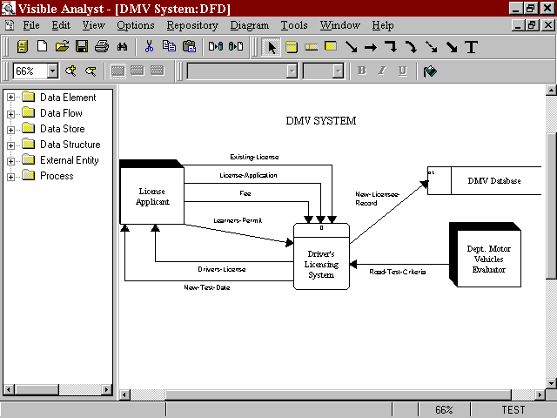Figure 6-9 TEST Project Context Diagram

Notes
 If the error message ―Decomposition hierarchy incompatible with data flows diagrams‖ is displayed, check the spelling of the process ―Driver‘s Licensing

System.‖ Make sure that the apostrophe s (‗s) in the word ―Driver‘s‖ is correct. To correct the spelling, click on the process ―Driver‘s Licensing System‖ with the right mouse button and choose Change Item. Save the changes, and then perform the Spawn operation again.

 The spawn process produces detailed level DFDs. You must define, build, and then nest the appropriate higher-level DFDs (such as the context diagram and the level 1 DFD) to the spawned ones. The spawn process can build a blank context diagram. You can add a context diagram, and then open and complete the spawn generated top level diagram. The Nest connectors still have to be built (see Lesson 8 - Data Flow Diagrams).

 The structured modeling technique (structured analysis and structured design) is used for the licensing application within the DMV, and the object modeling technique is used for the vehicle registration application. This illustrates the principles of each approach and also shows that Visible Analyst is flexible enough to allow either or both to be used within the same project.

What to do Next?
You now have a real life choice to make in pursuing the structured methodology life cycle. Having used the FDD Spawn function to build some intermediary DFDs, you can continue to build top-level DFDs and the overall data flow model. To do this, go to Lesson 8.

The alternative is to move to the data modeling process, build a data structure, and then return to the DFDs. To do this, continue with Lesson 7. The choice is entirely yours. You could also build part of your data model, then move to DFDs, and return later to finish or change your data model. Total flexibility with integration is a key feature of Visible Analyst.

Lesson 7 Entity Relationship Diagrams

OVERVIEW
This data modeling technique provides a precise method for detailing and illuminating the interrelationships of the data used by a system. You can depict the ―entities‖ (see definition below) in the data you are modeling and the relationships between them by drawing them onto an entity relationship diagram (ERD). The data model (ERD) shows the major data objects of an application and how they fit together using the relationships. You can define the primary keys for the data entities and the composition of the data attributes of the entities in the Visible Analyst repository. (Defining primary keys and adding data attributes are explained in Lesson 16, Working with the Repository Functions.) The defined components can then be displayed on your ERD diagram by selecting these options from the View menu.

A diagram containing a picture of all or a subset of your data is called a ―view.‖ Each view can show an arbitrarily large or small part of your data model. You can show multiple views of your data model by including different combinations of entities and relationships on various diagrams. However, the entire data model, including the data elements composing each entity, is retained in the repository and can be accessed by creating a global view of the data model. This feature is explained in this lesson.

Definitions
The important diagram constructs in entity relationship data modeling include:

Entity The entity (or, more properly, the entity type) is nothing more than a real-world object that you want to describe. The most generic type of entity is really a fundamental or independent entity but is usually simply called an entity. It is composed of data elements (also called attributes), and you can describe these in the entity’s repository composition field. A fundamental entity is an object or event. It is represented on an entity relationship diagram as a rectangle and is accessed by the first symbol button on the control bar.

Associative Entity Another type is the associative entity (sometimes called a
junction, intersection or concatenated entity, a gerund or a correlation table). This is basically a relationship (see below) about which you want to store information. It can only exist between two other entities that participate in a many-to-many relationship. For example, the relationship between a customer and a product produces as a by-product the associative entity purchase order. A purchase order entity would not exist without the relationship between the other two entities. An associative entity is represented as a rectangle with straight diagonal lines across each corner. It is accessed by the second symbol button on the control bar.

Attributive Entity The third entity type is the attributive or dependent entity. This is used to show data that is wholly dependent upon the existence of a fundamental entity. It is also used to show repeating subgroups of data. For example, the associative entity purchase order may have a dependent attributive entity named shipment showing the full or partial shipments that fulfill the purchase order. It is represented as a rectangle with rounded lines across each corner and is accessed by the last symbol button on the control bar.

Relationship A relationship shows how one entity interacts with or can be
affiliated with another entity. It appears on a diagram as a line drawn between two entities. Relationship lines ordinarily have two labels, one for each direction. The relationship lines can have terminators that show that the entities relate to each other on a one-to-one, one-to-many, or many-to-many basis (the relationship’s cardinality), and whether the relationship is optional(may), mandatory (must) or optional becoming mandatory (will eventually). There are four line buttons on the control bar. Line types may be changed after they are drawn on the diagram.

Supertype/Subtypes Specialized subtype entities can be created that are based on a
generalized supertype entity and share common attributes. Only the attributes unique to the specialized entity need to be listed in the subtype entity. This is closely related to the object class inheritance concept. Visible Analyst also provides a detail field for specifying the exact number of relationships, if known. The supertype/subtype button is the fifth line button on the control bar.

Cluster A cluster is a collection of entities and the relationships between them. It is not truly a part of your data model because it carries no new information. However, it can be very useful when you want to Show very large data models on a single diagram and still have

it comprehensible. You have the ability to cluster groups of entities and show these clusters and the relationships between them in summary fashion on a diagram. This limits the amount of detail on the diagram so that the larger outlines of what is contained in your data model are more visible.
The Automated Rapid Business Change (ARBC) editions of Visible Analyst (the ARBC Corporate Edition, the ARBC University Edition and the ARBC Student Edition) have the unique ability to derive Clusters of entities that are needed by each process.
The last line of each cluster is either an Associative or Intersecting entity (for a Process), a Subtype entity (for a database) or a 5BNF Structure [4] entity (for an Expert System Knowledgebase). These Clusters show the Project Phase Number of each entity.
The Cluster Report is listed in Outline format (similar to a Gantt Chart) to be used as derived Project Plans for Managers to prioritize urgent processes for early delivery.

A cluster is created in the repository and entities are added to its composition field. A cluster view can then be created by Visible Analyst to display the pseudo-relationships between clusters rather than real relationships between specific entities. The diagram Visible Analyst generates is an unstructured diagram, but the information contained in the diagram pertains to your entity relationship diagrams. For more information on Clusters, see the Operation Manual or the online help system.

View Object A view object can be thought of as a derived or virtual table. It is composed of two components: a list of column names and a select statement used to filter information from the tables in the view.
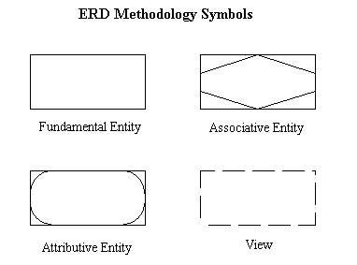For each view, there is one primary select clause and any number of sub-select and union select clauses. Using the Define View dialog box, you select the tables and columns and define the join relationships, clauses and flags to be used by the view. For more information on view objects, see the Operation Manual or the online help. (View objects are not available in the Education Editions of Visible Analyst.)

Figure 7-1 Entity Relationship Diagramming Symbols

Relationship Cardinality
Visible Analyst supports four different relationship cardinality notations: IDEF1X, Crowsfoot, Arrow, and Bachman. The type of notation you use is up to you, and you select it when a new project is created. The number of names per relationship line is also your choice. You can indicate one or two names per relationship. For this lesson, we use the standard crows foot notation with two names per relationship.

If you select IDEF1X as the relationship cardinality when creating the project, the default notation is IDEF1X. You would then select crows foot, Arrow or Bachman as an alternate cardinality notation.

THE EVOLUTION OF DATA MODELING
By Clive Finkelstein []

Data Modeling today is an integral part of Systems Development and Maintenance. It was not always so. In the 1970’s Software Engineering was the preferred development method, and for many organizations it still is. When we were developing Information Engineering (IE) from 1976-1980 we found in project after project a high degree of redundant data versions in data bases developed using Software Engineering. These were very expensive to develop and maintain because any data value changes had to be synchronized across all redundant data versions. This data redundancy cost large organizations hundreds of millions of dollars of Systems Development and Systems Maintenance Costs and time.

This also required data maintenance programs to be developed redundantly, which resulted in redundant data entry, redundant work, redundant staffing, redundant equipment and redundant floor space. This data redundancy also cost large organizations hundreds of millions of dollars of Annual Operating Costs and time.

In the late 1970’s data modeling methods started to emerge, based on the work by Dr Edgar Codd []. This was due to Normalization following his research work on mathematical set theory.

Normalization ensures that attributes are positioned in tables where they are wholly dependent on the primary key. It is based on 5 Normalization Rules: First Normal Form (1NF); Second Normal Form (2NF); Third Normal Form (3NF); Fourth Normal Form (4NF); and Fifth Normal Form (5NF). When correctly applied to data bases in Third Normal Form (3NF) the number of redundant data versions are reduced. This is a data-oriented method, while Software Engineering (SE) is process-oriented.

It took many years for the Industry to recognize that data is more stable than processes. Processes are very volatile and are changed by many factors: management decisions; new technology; and competition.

Data Modeling was applied by data modelers interviewing business experts one-on-one. If a business expert did not have personal knowledge on how a data element was used; this issue was often left till later to be resolved. In many cases it was not resolved by anyone but was left to the programmer (who was the least knowledgeable person to make a decision about the issue). The programmer then locked the decision in manual code, which was extremely expensive to change.

To avoid this problem, we found that it was more effective to bring all business experts who were knowledgeable about the data, who together could discuss any data issues and make an informed collective decision to resolve the issue.

We found in project after project that business experts had difficulty understanding the Normalization Rules, which were academically worded. We experimented with changing the academic definition of each rule to a business-oriented definition that explained “how” to apply each rule. This was very successful and enabled the business experts to participate actively in the data modeling sessions.

We also found that their active participation eliminated redundant data versions that had been missed by 3NF. We called these business-driven rules “Business Normalization []” with 5 Business Normalization Rules: 1BNF; 2BNF; 3BNF; 4BNF; and 5BNF to distinguish from “Traditional Normalization”; 1NF; 2NF; 3NF; 4NF and 5NF.

4BNF identified supertype and subtype entities, for which the business expert data modelers could provide much data attribute detail. 5BNF was unique, as it identified relationships between occurrences of data entities using common knowledge, which was expert knowledge. 5BNF resulted in the development of Knowledge Bases for Expert Systems. 5BNF is very powerful and captures expert knowledge held by a few experienced business experts that could be shared by all business people in the organization.

I documented Business Normalization in a separate chapter for the book that I was co-authoring with James Martin in 1980 []. This was a critical chapter. It made IE data-oriented and business-driven in contrast to Software Engineering, which was process- oriented and IT-driven. When the book was published in November 1981 this critical chapter had been excluded and replaced by a chapter on “Data Design”. This was a mainframe software package for Normalization developed by James Martin’s company: Data Design Inc. (which later was renamed Knowledgeware).

When James Martin subsequently published 3 books on Information Engineering in 1986-1988 there was no mention of Business Normalization and when Knowledgeware subsequently released “Information Engineering Workbench” (IEW) and later “Application Development Workbench” (ADW), the benefits of Business Normalization were missing. The books and modelling tools (IEW and ADW) were clearly process-oriented and IT-driven.
Knowledgeware had obviously used Software Engineering concepts. They did not understand the benefits of Information Engineering and Business Normalization. The problems and costs of redundant data versions were still there. However, the industry accepted these books and modeling tools without question because they were associated with James Martin’s company [].

Recognizing Data-Oriented and Process-Oriented Data Models.

A Data-Oriented, Business-Driven Data Model uses the crows-foot symbol on a relationship line to indicate many entity occurrences of the entity touched by the crows-foot symbol. One entity occurrence touched by a relationship line is indicated by the absence of a crows-foot.

A Process-Oriented, IT-Driven Data Model also uses the crows-foot to indicate many occurrences of the entities touched by the crows-foot symbol. One occurrence touched by a relationship line is indicated by a vertical bar across the relationship line.

Both of these notations indicate a one-to-many relationship between two entities. To indicate mandatory-one-to-many, a vertical bar is placed at the “one” end of the relationship line. For the Process-Oriented data model this means that two vertical bars are used to indicate mandatory-one, while for the data-oriented data model only one vertical bar is needed to show mandatory-one.

In Summary: if a data model shows two vertical bars for mandatory-one, it is a Process-Oriented data model. If a data model shows only one vertical bar for mandatory-one, then it is a Data-Oriented data model.

BUSINESS RULES NOTATION
We will now discuss the symbols used on Relationship lines to represent Business Rules.

Table 7-1: Using Relationship Symbols for Data-Oriented, Business-Driven Business Rules

Symbols in Tables 7-1 and 7-2 are used to show Business Rules and are referenced each by a number.
- The crows-foot symbol (2) on the relationship line indicates many entity occurrences
- The absence of a crows-foot (1) indicates one entity occurrence
- One vertical bar (1) on a relationship line indicates one entity occurrence (must have one)
- The vertical bar (4) indicates mandatory-many (must have many)
- The O (5) indicates optional-one (may have one)
- The O indicates optional-becoming mandatory one symbol (7) (will, eventually have one) (Complex Business Rules)
- The O indicates optional-becoming mandatory many symbol (8) (will, eventually have at least one or many) Complex Business Rules)
- The recursive symbol (9) indicates a 5BNF entity with expert knowledge between entity occurrences.
- When a symbol is added to a Relationship line, the Business Rule associated with that symbol is automatically added as the Relationship name. That name can later be changed if a different name is preferred.

Table 7-2: Using Relationship Symbols for Process-Oriented, IT-Driven Business Rules

Table 7-2 shows symbols used for Process-Oriented Business Rules
- The crows-foot symbol (2) on the relationship line indicates many entity occurrences
- One vertical bar (1) on a relationship line indicates one entity occurrence
- The second vertical bar (3) indicates mandatory-one (must have one)
- The vertical bar (4) indicates mandatory-many (must have many)
- The O (5) indicates optional-one (may have one)
- The O 6 indicates optional-many (may have many)
- The optional-becoming mandatory symbol is not supported (Complex business rules)
- The optional-becoming mandatory symbol is not supported (Complex business rules)
- The recursive symbol (9 indicates a 5BNF entity with expert knowledge between entity occurrences.
- When a symbol is added to a Relationship line, the Business Rule associated with that symbol is automatically added as the Relationship name. That name can later be changed if a different name is preferred.

Cluster Analysis and Cluster Report

Visible Analyst has the capability to automate the analysis of an ERD data model to identify the project plans of sub-projects that can be prioritized and extracted from the data model for early delivery into production. This analysis is called “Cluster Analysis” and the sub-projects that are identified are called “Clusters”. They are documented in a “Cluster Report” that is printed in sub-project priority sequence.

The Relationship Symbols that touch each entity are used to apply relevant Business Rules as follows:
- An entity that is touched only by mandatory-one symbols is a “Phase 1) entity. It appears in the cluster as 1) PROJECT, for example.
- If the other end of the relationship line is a many symbol, that entity is a Phase 2) entity. It appears in the cluster indented one position to the right as 2) PROJECT BUDGET, for example. [PROJECT BUDGET will be an Associative (Intersecting) entity and the cluster represents an Activity or a Process. BUDGET will be another Phase 1) entity. This cluster is shown next.

CLUSTER NAME: PROJECT BUDGET MANAGEMENT ACTIVITY
1) PROJECT
1) BUDGET
2) PROJECT BUDGET (PROJECT BUDGET MANAGEMENT ACTIVITY)

- If the many symbol touching PROJECT BUDGET is mandatory-many, the cluster is a Reusable Process and is shown in the cluster with all entities in bold as shown above. The automatically generated Cluster Name can later be renamed, if preferred.

If another Phase 1 entity (say BUDGET) touches the PROJECT BUDGET entity in an optional-many or optional-becoming-mandatory-many, the cluster still represents a reusable process. As a general rule of thumb, any two entities related in mandatory-many to an optional-many or optional-becoming-mandatory-many will result in at least one Reusable Process.

A cluster that contains supertypes and subtypes will have separate clusters with each subtype entity as the last line of the cluster (called the “End-Point” entity). These clusters with subtype End Point entities are “data base clusters”, which take the Cluster Name from these subtype entities. For example:

Supertype: INSTRUCTOR
___________________________|_________
| | |
Subtypes: PROFESSOR LECTURER TUTOR

The above example of supertype and subtypes will produce 3 data base clusters:
PROFESSOR database; LECTURER database; and TUTOR database.

If an end-point entity is 5BNF the cluster represents an Expert System Knowledgebase. For example:

5BNF Entity: SALESPERSON will appear as the cluster SALESPERSON Expert System Knowledgebase

Milestone Clusters

Some clusters can be very complex, with many entities. If you find any entities touched by one or more mandatory-one symbol and at least one or more many symbols, that entity is a potential “Milestone” entity. The large cluster in which it resides can be broken at the Milestone entity into two or more smaller “Milestone Clusters” for progressive delivery into production as the Milestone databases and systems are completed.

Moving Clusters into a Different Functional Area

The clusters in the Cluster Report represent systems and databases that are likely needed by different functional areas of the organization. The data model should be displayed (by File < OPEN DIAGRAM). Click on a Associative (Intersecting) entity to highlight it in a different color. A Select Menu will enable you to choose “Select Cluster”. All of the other entities in that cluster will be highlighted in the same color. SChoose the “Move Menu” where all of the entities in the cluster will be listed together with a drop-down list of functional areas that were defined in the FDD. Choose the functional area that the cluster should be moved into and click OK. When the data model for that selected functional area is displayed all of the moved entities in that cluster will be displayed.

Data Model Display Orientation

The data model can be displayed in either a horizontal or vertical orientation.

Horizontal Orientation: All Phase 1 entities are displayed on the top row of the data model diagram; Phase 2 entities are displayed in the second row; Phase 3 entities are displayed in the third row – in a “top-down orientation. Senior Managers will be interested in the top 2 or 3 rows, while detailed operational entities will be displayed in the lower rows.

Vertical Orientation: All Phase 1 entities are displayed vertically on the left side of the diagram; Phase 2 entities are displayed 1 column to the right; with the highest phase number displayed on the right hand side of the diagram. The result is a data model diagram that appears similar to a Pert Chart.

Potential Export Capability to Microsoft Project

The Clusters can potentially be exported to Project Management Software Products such as Microsoft Project. This is described in Chapter 7 of the Reference Textbook.

BUSINESS NORMALIZATION

We will now discuss Business Normalization Principles, which are used by Data-Oriented Business-Driven Data Models to eliminate data redundancy. We will use a Purchase Order Form (see below) as a source document to provide input to Business Normalization in an unnormalized Entity List format.

We will extract the field names in the Purchase Order Form above and write them in Entity List Notation as shown in the left of this table.
A data entity name is always shown in all capitals.
- For example, a key attribute is shown with a terminating # (hashtag or Pound sign). A primary key is underlined, while a foreign key is not underlined.
- (A foreign key exists as a primary key in another data entity and links the two entities together.)
- A [secondary key] is written surrounded by square left and right brackets. They are not technically “keys” (which must be unique) but are more correctly called “selection attributes” as they need not be unique. A good example is “supplier name”. Secondary keys or “selection attributes” are implemented as Indexes in a database,
- A (group attribute), such as (supplier address) signifies that it has not yet been decomposed into its elemental attributes, such as “street number, street name, suburb or town, city, state postal code or country.
- A {derived attribute} is surrounded by left and right curly braces, such as an “total amount" to signify that its value is calculated by a formula that is yet to be defined.
- A ((repeating group)) is a number of attributes separated by commas – all surrounded by double left and right curved brackets to signify that all of the attributes occur multiple times.
- The unnormalized entity at the bottom is used as input to Business Normalization to completely eliminate all data redundancy.

DEVELOPING YOUR DATA MODEL
Each entity relationship diagram is complete in and of itself and shows one view of the data model of your project. (Remember that a view is a portion or subset of your entire data model represented on a single diagram.) When beginning your data model, you must manually add new entities and relationships to a view diagram. After this has been done, you can create additional views by using the File menu View function to select existing entities and relationships from the repository. Visible Analyst automatically draws the views for you.
Then you can add to or subtract from each view and rearrange it as you wish. Thus you avoid having to draw portions of your data model repeatedly on different views.

Adding Entities to a View
Since the basic building block of the data model is the entity type (or simply, the entity) and since relationships cannot exist except to relate already existing entities, you begin by adding entities to a view.

Set the Zoom Level: | 1 | From the View menu, select 66% zoom so that you can see all of your needed workspace.
Create a New Diagram: | 2 | From the File menu, select New Diagram.
 | 3 | Select the diagram type to be Entity Relationship with standard drawing method.
 | 4 | Select the Page Size to be Standard.
 | 5 | Click OK.
Add Entities: | 6 | Click the first symbol icon, the rectangle. This is a fundamental entity.

- Place the cursor in the middle of the diagram workspace and click the left mouse button. An entity is drawn.

- Name the entity ―Student Driver‖ and click OK.

- Add another fundamental entity below the first, and name it ―Driving School.‖

- 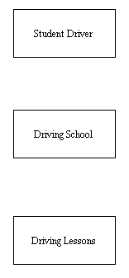Add another fundamental entity below Driving School, and name it ―Driving Lessons.‖

Figure 7-2 New Entities

Save the Diagram: 11 From the File menu, choose Save and name the diagram
―Driving School View.‖

Changing a Symbol Type
In the diagram we have created, the entity Driving Lessons is actually an attributive entity because the entity exists solely because it is an attribute of the fundamental entity Driving School. Since we placed it on the diagram as a fundamental entity, it is necessary to change the symbol type.

Select Symbol to Change: | 1 | Put the cursor in selection mode by clicking the  button on the control bar.
 | 2 | Click the symbol labeled Driving Lessons with the right  mouse button so that its Object menu appears.
Change the Entity Type: | 3 | Select Change Item. The Scope must be set to Global change in the Change Object dialog box. This option is important when you change an object’s type or label.  Selecting Global causes the change to be made on every diagram where that object occurs. If you select Individual, the change is only made to the selected object. A Local change would modify all occurrences on the current diagram. All changes to a symbol type must be Global.
 | 4 | Select Change Type.
 | 5 | Select Attributive Entity and click OK.
 | 6 | Click OK on the Change Object dialog box. The symbol is changed on the diagram.

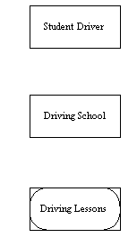Figure 7-3 Changed Entity Type

Adding Relationship Lines
We need to establish the relationships between the entities on the current diagram.

Draw the 1 Click the first line button on the control bar.
Relationship:
2 Draw a line from Driving School to Student Driver. The procedure is the same as that used to draw a line in Lesson 5 - Diagramming. Click and hold the left mouse button where you want the line to begin, drag the line
to where you want it to end. If you release the button within the symbol, the line is connected automatically. If not, you must double-click the left mouse button to end the line.

Note
 When you use an elbow line and the elbow in the line does not bend in the direction that you want it to, click the right mouse button while you are still holding the left one, and the elbow inverts.

Label the | 3 | Enter ―Instructs‖ for the label of the first relationship. To
Relationship: |  | set the relationship cardinality, click One for the
 |  | Minimum, and click Many for the Maximum. This means
 |  | that ―Driving School instructs one or many Student
 |  | Drivers.‖ If you know the exact maximum number of
 |  | relationships, you can enter it in the detail box. (See
 |  | Figure 7-4.)

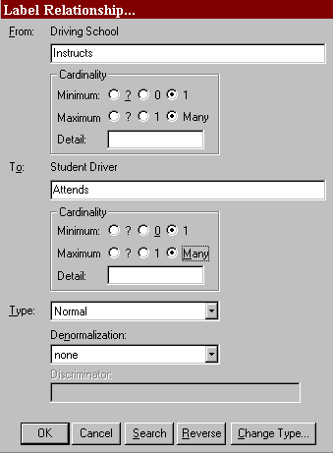Figure 7-4 Label Relationship Dialog Box

- Press the TAB key to move the cursor to the next field or click the mouse in the other label field.

- Enter ―Attends‖ for the reverse relationship name. For the Minimum click One, and for the Maximum click Many. (This deliberate error is added to demonstrate the capabilities of the Analyze function.) It means a ―Student Driver attends one to many Driving School.‖ Both of these relationships are considered mandatory because it is necessary to attend driving school to be a student driver, and it is necessary to have students to be a driving school. Ensure that Type is set to Normal, and click OK.

Draw Another | 6 | Draw a line from Driving School to Driving Lessons. For
Relationship: |  | the first label, type ―Offers,‖ and set Minimum to Zero
 |  | and Maximum to Many. For the second label, type ―Are
 |  | Provided By.‖ Because this is an Identifying relationship,
Save: | 7 | the cardinality is automatically set to 1:1. Click OK.  Press CTRL+S to save the diagram.

Analyzing the Diagram
The Analyze function checks to ensure that the diagram is syntactically correct, meaning that all relationship lines and symbols are labeled. You can also use the Analyze function to check for certain normalization errors.

Start Analyze: | 1 | Select Analyze from the Diagram menu.
 | 2 | Choose Current Diagram and Syntax Check. Click OK. It tells you that the current diagram is correct.
Insert an Error: | 3 | Add a symbol to the diagram without naming it.
Analyze Again: | 4 | Run Analyze again. You see an error message indicating that there is one unnamed entity. Click Cancel to return to the diagram. The unnamed entity can be deleted from the diagram by highlighting it with the cursor in selection mode and pressing Delete.
Analyze Still Again: | 5 | Run Analyze again, but this time choose Normalization. You see the error message that the relationship ―Driving School [Instructs] Student Driver‖ is not normalized. This is true. The error indicates that the cardinality is 0:many or many:many in both directions. It is flagged as an error because optional:optional and many:many relationships can be difficult to implement. Click Cancel to close the box.
Correct Cardinality Error: | 6 | To change the cardinality of the relationship Attends, click the relationship line with the right button.
 | 7 | Select Change Item. Change the cardinality for Attends from a maximum of Many to a maximum of One.

 | 8 | Click OK.
Analyze Once More: | 9 | Select Analyze from the Diagram menu. Choose Normalization and click OK. The diagram is now correct.

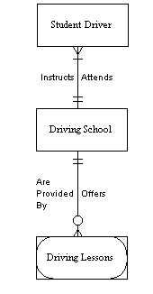Figure 7-5 Normalized Diagram

Automatically Generating a View of Your Data Model
Another very useful feature of Visible Analyst is the ability to generate new data model views automatically. Since a data model can become very large and sometimes very difficult to decipher with many relationship lines and symbols, generating a specific view of the data model allows you to focus on one portion of your data model without having to redraw all of the symbols and connections that you want to have on the diagram. The function for generating a view is found on the View of Data Model submenu from the File menu.

There are three different options for generating a view from this function.
  - There is an option to generate a Global view of your data model. All of the entities and relationships that are in the repository are placed on one diagram. This feature is important when additions are made to one portion of the data model and you would

like to see how those changes have affected the entire model. Another use for this feature is to generate an entity relationship diagram for imported entity information.
- You can generate a New view, allowing you to choose from the entities you have already created on a diagram or in the repository those entities and attached relationships you would like displayed on a new diagram. This allows you to make additions or changes to your entire data model while concentrating on only one portion.
- The other view option from the View of Data Model option is Process. A Process view is an entity relationship diagram that represents a subset of your data model and is based upon a process existing on a data flow diagram or in the repository. Data elements that enter or leave the selected process in data flows and that are also contained in the composition of entities cause those entities to appear in the process view, along with the relationships existing between pairs of entities. A process view allows you to concentrate on the specific portion of your data model that is involved with the selected process. This is the type of view that you now create. The composition information for the entities that appeared, as well as the attribute information of the particular process, has already been entered for you in the sample diagrams we supplied. This is so that you do not have to enter the information necessary to demonstrate this feature of Visible Analyst.

To create the process view:

Start View Generation: 1 Select View of Data Model from the File menu, then
choose Process. The Select Process for Views dialog box appears.

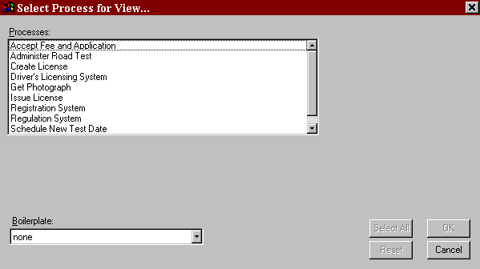Figure 7-6 Process View Dialog Box

Select the Process: | 2 | Click the process Issue License and click OK. Visible Analyst searches the repository for entities that contain data elements in common with the data flows that are attached to Issue License and creates a ―View‖ of the data model.
Save the New View: | 3 | Select Save from the File menu.
 | 4 | Title the diagram ―Process View: Issue License.‖ This diagram is a subset of your entire data model.
 | 5 | Click OK.

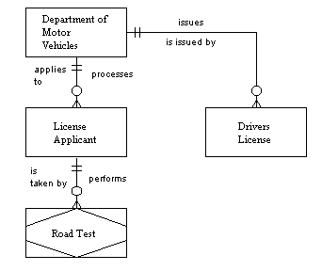Figure 7-7 The Generated Process View

Lesson 8 Data Flow Diagrams

OVERVIEW
As described in Lesson 4 – Structured Modeling Techniques, a data flow diagram (DFD) is used for process modeling. This modeling technique shows the flow and transformation of the data without regard to the details of the data structure or type. It clearly represents where the transactions and transformations occur in your system.

A DFD is not the same as a flow chart, although there are certain similarities. A flow chart is much less specific with regard to how pieces of data are broken down, combined, and moved around the system than is a DFD. On the other hand, a flow chart is much more specific and physical than a DFD with regard to how processing is performed. A data flow diagram is more flexible and has a more general applicability than does a flow chart.

Data flow diagramming is not designed to show materials flow, just data. For example, if you were modeling a bookstore, how all of the receipts, invoices, inventory counts and financial transaction items are handled would be shown on your diagrams; but the books themselves would not. The books are materials, and their movement from the publisher to the store‘s loading dock to the shelves to the bag in the customer‘s hand is materials flow and not a part of data flow diagramming.

In any structured analysis methodology, the first task is to draw a top-level diagram, a simple summary of the overall system. It shows the system environment and major inputs and outputs, and is sometimes referred to as the basic problem statement. This is usually much less specific than the way most people picture a system because so many details are omitted. It should involve only one, two, or three processes and a very few external entities (source/sinks). In the example that follows, you use only one process and two source/sinks, though a top-level diagram could contain a few more of each. You break down (decompose) these top-level elements into more specific processes and flows. Some methodologies and analysts like to use a single process to represent the highest level of the data flow diagram.
This is called a context diagram, and only one process is allowed on a context diagram to designate the entire system. For child diagrams, though, you can have multiple processes on any diagram.

The idea behind creating a general top-level diagram is twofold:
  - To ensure agreement and understanding of the fundamental, overall mission of the system. There is confusion on this more often than is realized, and the details can rarely work well if the overall mission is unclear.
  - To make explicit the source and derivation of the more detailed operations of the system. Often it is the second or third level of design that is the taken-for-granted starting point. Making the derivation explicit is important both for the design discipline itself and for the completeness of the resulting documentation. If you start Visible Analyst at the highest level, the tracking of all subsequent derivations automatically results from the data repository documentation.

There are four meaningful objects that appear on data flow diagrams:

Process The process symbol is accessed with the first symbol button on the control bar. If you are using Yourdon rules, a process is represented by a circle. For Gane & Sarson rules, a process is represented by a rounded-corner square. For SSADM and Métrica rules, a process is represented by a square.

A process signifies that something is happening to transform data. At the highest level you could show the whole bookstore as a single process.

After creating the context (or high-level) diagram, you then break that diagram down into processes representing the various departments of the store, then into processes representing the functions of the departments, then into subdivisions of these processes, and so forth to as fine a level of description as you wish. This is done by ―nesting‖ or decomposing a process and creating a child diagram at a greater level of detail, one that shows all of the inputs and outputs to the parent process and allows you to show what is going on inside it. Processes have numbers, and those numbers reflect the decomposition hierarchy, as shown in Figure
8-1.

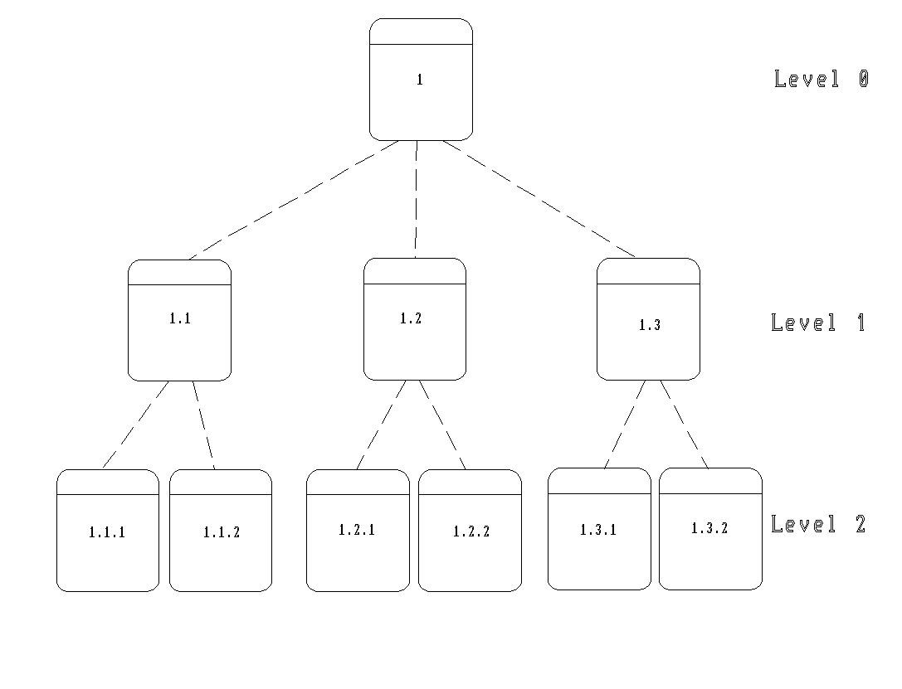Figure 8-1 A Process Numbering Scheme

Data Store (or File) A data store or file is accessed using the second symbol
button on the control bar. If you are using Yourdon rules, a file is represented by two horizontal parallel lines. For Gane & Sarson , SSADM and Métrica rules, a data store is shown as a rectangle with the right side open, and it has a number. A data store is a place where data is kept while it is not actively being processed. Your process model does not show how it is stored, whether encoded on magnetic disk or scribbled on the back of an envelope, just that it is stored. Data can only enter a data store from a process and can only leave a data store to a process. The detailed data element in a data store can be defined in the Visible Analyst repository.

External Entity (or An external entity is accessed using the last symbol
Source/Sink) button on the control bar. It is represented by a large square under Yourdon rules, or a square drawn with relief under Gane & Sarson rules. For SSADM and Métrica rules, an oval represents an external entity. An external entity is something outside the boundary of the system you are modeling that either sends data to your system or receives data from it. It is effectively a black box, in that what happens inside the external entity is not material to your system description. It is only there to make clear some of the environment in which your system resides.
External entities are optional. A net input data flow can just as well be shown coming from nowhere as from an external entity. Note that an external entity has no relation to the entity that is a part of entity relationship modeling. It is simply an unfortunate duplication of terminology.

Data Flow A data flow depicts the movement of one to many items of data. Data can enter a system from outside, such as the entries that appear on a publisher‘s invoice or a packing list. (The invoice data flow is shown entering a process— it must enter a process—where it is examined and acted upon.) This process might send some of the data to be stored, some to be printed, some to be ignored. These invoice data elements may or may not be combined with elements from other input data flows and may then exit the process as parts of other data flows. To draw a data flow line, click on a line type in the control bar.

Yourdon/DeMarco

0

Process File Source/Sink

Gane & Sarson

1 D

Process Data Store External Entity

Métrica and SSADM

D

1

Process Data Store External Entity

Figure 8-2 Data Flow Diagramming Symbols

Note
 In Yourdon methodology, names of data flows contain hyphens instead of spaces. When you enter a space in a data flow name, Visible Analyst uses a hyphen.

This lesson leads you through the diagram creation process for a Gane & Sarson-based process model. Basic drawing and decomposing a process into a subordinate ―child‖ diagram

are shown. Also, you see how the system is validated using the rules capabilities of Visible Analyst. You build errors into your diagram to demonstrate the types of errors that can be identified by the Analyze function.

CREATING AND POPULATING A TOP-LEVEL DIAGRAM
The basic procedure for creating a top-level DFD is the same as creating a new diagram for the unstructured diagram type. The only difference is that if you choose a context diagram, by clicking the box at the bottom of the New Diagram screen, a process symbol number 0 is automatically placed on the diagram; and you are prompted for its name. A context diagram is permitted only one process symbol. You can add data flows and other symbols to the diagram.

This diagram has already been created for you so that you do not have to draw the diagrams and enter repository information. It is named DMV System and is shown in Figure 8-9, the top-level diagram of the DFDs you spawned from your FDD. This diagram also has one child diagram called Driver‘s Licensing System. You can display a list of diagrams by selecting Open Diagram from the File menu, or by clicking the Open button on the control bar. When a diagram type has a plus sign next to it, it means that diagrams of that type have been created. Click the plus sign to display the list of existing diagrams, and then double-click the diagram you would like to open. (You can hide the list again by clicking the minus sign next to the diagram type name.)

To close a diagram, click the control button in the top left corner of the diagram window and select Close, double-click the control button, or choose Close Diagram from the File menu.

NESTING A PROCESS
In this unit, you structurally decompose a process symbol. This is also called ―nesting‖ or
―exploding‖ a process. The File menu contains the Nest function for this purpose; the submenu contains the Explode function. Explode can also be found by clicking the right mouse button on a process symbol that you want to model in more detail to display its Object menu, and then selecting Explode.

If the process has not previously been decomposed, this generates a ―child‖ diagram from this
―parent‖ process. All of the data flows attached to the parent process are automatically
―dragged down‖ to the child diagram by the Nest function. These flows can be attached to the lower-level processes that you create on the child diagram. Those lower-level processes can then be nested further to increase the level of detail. In the current example, the child diagram was created by the Spawn function that you executed in Lesson 6 – Functional Decomposition Diagrams, and the processes you added to the FDD were placed on it.

Open the Diagram: 1 From the File menu or the open diagram button on the

 |  | control bar, open the data flow diagram DMV System, if it is not still open from a previous lesson. This is the context diagram for this project.
Select a Process: | 2 | Click the right mouse button on the process Driver‘s Licensing System to open its Object menu, and choose Explode. This opens the existing child diagram Driver‘s Licensing System and is an alternate way to navigate between the diagrams of your project, avoiding the File menu.
Explode It: | 3 | Click the right mouse button on the process labeled  Issue License and choose Explode. The flows attached to the parent process are dragged down to the spawn-created diagram entitled Issue License, where the three process symbols from the functional decomposition diagram were placed. Maximize the diagram. The dragged-down flows are lined up on the sides of the child diagram, input flows on the left, output flows on the right. (See Figure 8-3.) Since you did not move the symbols on the diagram before nesting, it is possible that the dragged-down flows were drawn over a symbol.

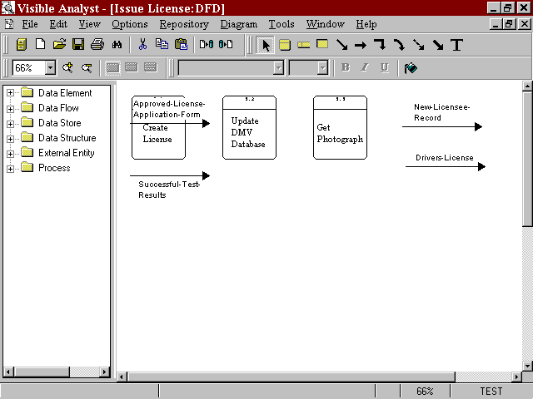Figure 8-3 Child Diagram With Dragged-Down Flows

Edit the Diagram: | 4 | Move the symbols and attach the flows as shown in
 |  | Figure 8-4. To move a symbol, click and drag it with the
 |  | left mouse button. To attach the lines, click one endpoint.
 |  | Then click the left mouse button on the middle of the data
 |  | flow and drag the line so that it is positioned correctly.
 |  | When the data flow is selected, it changes color; and the
 |  | line becomes a dashed line as it is moved on the diagram.
 |  | Do the same for the other data flows. (Ignore for now the
 |  | other flows you see in Figure 8-4; you add them later in
 |  | this section.)

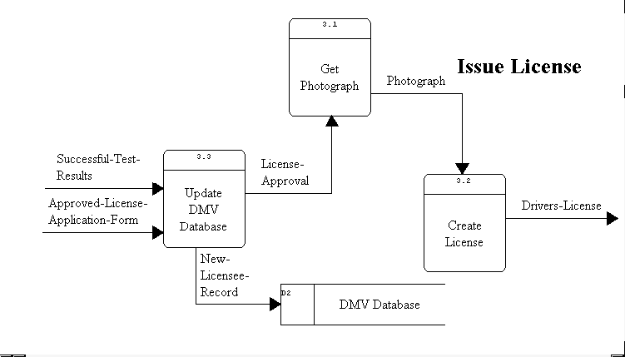Figure 8-4 The Completed Diagram

Note
 When you want to show a data flow line (or another type of line) as attached to a process (or another type of symbol), you must drag the end of the line into contact with the symbol. With the Auto Connect option on, Visible Analyst redraws your connection at the outer edge of the symbol.

Add Flows and Text: | 5 | Add two new data flows: License-Approval and Photograph. Since these are internal flows, as opposed to
 |  | net input or net output data flows7appearing on the parent,
 |  | the Nest function could not create them.
Change Line Format: | 6 | You may want to change the data flow lines from straight
 |  | to elbow. This can be done by highlighting the line and
 |  | then selecting Line Settings from the Options menu and
 |  | changing the line orientation to elbow. Or click the elbow
 |  | line button on the control bar before drawing the lines.
 |  | To change the orientation of an elbow, position the cursor
 |  | over the line segment handle to change and click, but do
 |  | not release, the left mouse button. Move the mouse
 |  | slightly until the line changes from solid to dashed, and
7For a full explanation of net input and output flows, please see the Visible Analyst Operation Manual or the online help.

 |  | then press the right mouse button. Release the left mouse button to save the change.
 | 7 | Click the T button on the control bar to add the caption text ―Issue License‖ to display the diagram title on the diagram. Note that there is a way to do this automatically by using boilerplates. You can read about this in the Visible Analyst Operation Manual or in the online help system. (Boilerplates are not available in the Education Editions of Visible Analyst.)
Add a File: | 8 | If you wish, you can add the file DMV Database to the diagram. Since it appears on the context diagram, this is not necessary, but some people feel that showing it on a lower-level diagram adds clarity. Move the flow New Licensee-Record to attach it to the file DMV Database. A symbol is considered attached to a line when the endpoint of the line is touching the edge of the symbol. (It does not automatically connect to the symbol.)
Save: | 9 | Select Save from the File menu.

CREATING A NEW DIAGRAM
In previous sections of this lesson, you worked with diagrams that were either supplied by Visible Systems or created by the Spawn function. In this unit, you create and populate a new diagram yourself and practice more data flow diagramming techniques. You structurally decompose the process Administer Road Test (drawing a level-three diagram) that details what occurs within the process Administer Road Test.

If you have any other diagrams open, you should maximize the window by clicking the Maximize button in the upper right corner of the window.

Set the Zoom Level: 1 Set the zoom level to 66% from the View menu.

Open the Parent | 2 | Select Nest from the File menu.
Diagram:
 | 3 | Select Parent from the submenu. You move up the
 |  | diagram tree to display the diagram Driver‘s Licensing
Nest a Process: | 4 | System.  With the left mouse button, select the process symbol

Administer Road Test by clicking on it. It is highlighted as the current object.

- From the File menu, select Nest and then Explode.

- Choose Create New Diagram. If you had previously nested this process, the child diagram would have displayed automatically. This option is useful to drag down new data flows that you may have drawn on the parent diagram to child diagrams after the child diagram has been created. A new diagram is drawn with your input flows in the upper left corner of the diagram, and the output flows in the upper right corner. If you cannot see the flows, select 33% zoom from the View menu and your diagram, shown in Figure 8-5, scales down so that you can see more of it.

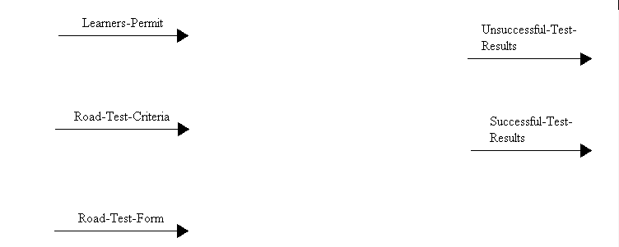Figure 8-5 Exploded Diagram with Flows

Save: | 7 | Select Save from the File menu and click OK. The title
 |  | of your diagram defaults to the name of the parent
 |  | process. Visible Analyst indicates that it is saving both
 |  | diagrams. This is because they are involved in a nest
 |  | relationship and both ends of the nest relationship must be
 |  | saved in the repository.

Adding Processes to a Child Diagram
Now add processes to the child diagram named Administer Road Test. The processes contained in this diagram are the individual processes that make up the parent process Administer Road Test. This diagram is a more detailed representation of the transformations and interactions that occur to the data flows within the parent process.

Add Processes: | 1 | Click the first symbol button, process, in the control bar.
 | 2 | Add and label three processes: Validate Applicant, Test Vehicle Knowledge, and Test Driving Capabilities.
Save: | 3 | Select Save from the File menu.

Attaching Data Flows to Symbols
The input data flows on the left side of the diagram and the output data flows on the right side of the diagram were dragged down to the child diagram with the Nest function. It is necessary to attach the data flows to the appropriate processes on the child diagram. To attach a flow to a symbol:

Select a Line: | 1 | Put the cursor in selection mode by clicking the   button on the control bar.
 | 2 | Select the data flow Learners-Permit. The line handles appear.
Drag It Into Position: | 3 | Drag it to the edge of the process symbol labeled Validate Applicant, as shown in Figure 8-6.
Repeat for Other Flows: | 4 | Attach the other dragged-down flows as shown in Figure 8-6.
Add New Flows: | 5 | Click the first line button on the control bar.
 | 6 | Add a flow from process Validate Applicant to Test Vehicle Knowledge and label it ―Valid-Applicant.‖
 | 7 | Click the straight line button on the control bar and add an input flow into the process Test Driving Capabilities and label it ―Test-Criteria.‖
 | 8 | Add a flow from process Test Vehicle Knowledge to process Test Driving Capabilities, but leave it unlabeled

by clicking Cancel or pressing ESC when you are prompted to enter a name. (This deliberate error is added to demonstrate the capabilities of the Analyze function.)

9 Add an unattached data flow labeled ―Driving-Criteria.‖ (Remember, you must double-click to end the line when it is not attached to a symbol.) This demonstrates the ability to select an existing flow from the diagram when a flow is split.

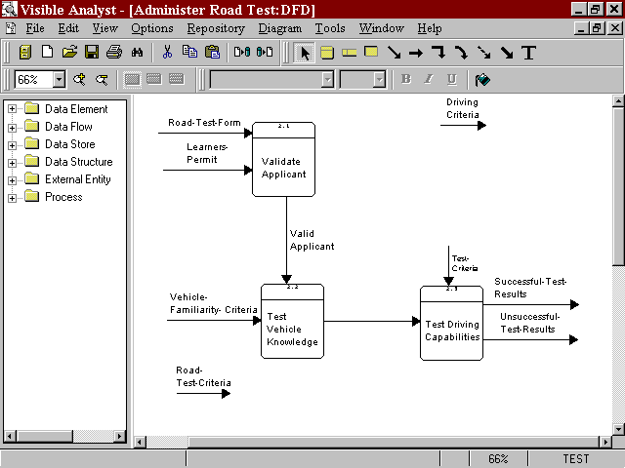Save: 10 From the File menu select Save.

Figure 8-6 Child Diagram with Processes and Flows

Splitting Data Flows
Decomposing, or ―splitting,‖ a data flow offers the capability to divide net input or net output data flows into subflows, creating more detailed representation on lower-level diagrams. The concept is illustrated in Figure 8-7. This capability greatly aids in the system analysis process by showing more complex data flows at high levels of the structured specification and smaller or even atomic data flows at the lower levels of the structured specification. This decomposition capability provides a better understanding of the entire system and its parts.
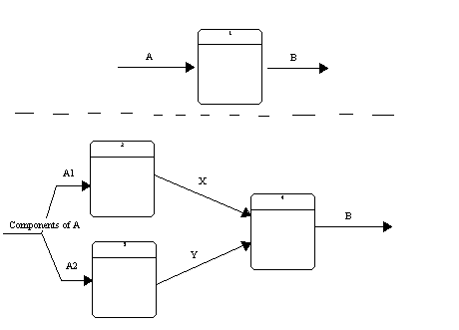Whenever a dragged-down data flow is split into subflows, the original flow is erased from the current diagram and replaced by the selected or created subflows.

Figure 8-7 Splitting a Data Flow

Select a Flow to Split: | 1 | Click the  button on the control bar to put the cursor into selection mode.
 | 2 | Display the Object menu for the data flow labeled Road- Test-Criteria by clicking on one end of it with the right mouse button.
Start the Split: | 3 | Choose Split Data Flow.
 | 4 | In the box labeled Enter Subflows, type in ―Vehicle- Familiarity-Criteria.‖ This option draws a new flow (a subflow of Road-Test-Criteria) on the diagram with this

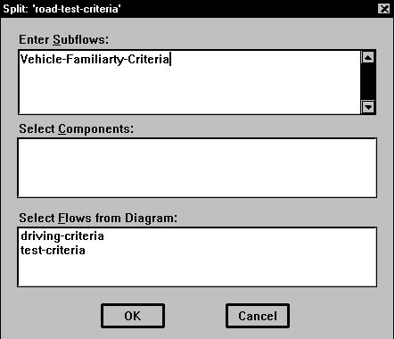label. See Figure 8-8. If you want to add more than one name in this box, press ENTER to place the cursor on a new line.

Figure 8-8 Split Data Flow Dialog Box

- In the box marked Select Flows from Diagram, click Driving-Criteria. This option allows you to select an existing flow to be a subflow of Road-Test-Criteria.

- Click OK. Notice that the flow Road-Test-Criteria is no longer on the diagram and that the flow Vehicle- Familiarity-Criteria has been added to the diagram.

- Attach the flow Driving-Criteria to the process Test Driving Capabilities with the arrow pointing away from the process symbol. (This error is made deliberately; it is explained during the discussion of Analyze.)

- Ignore the data flow Vehicle-Familiarity-Criteria, as another test for Analyze.

ANALYZING FOR BALANCE AND COMPLETENESS
As a project goes through a number of nested decompositions (nests), data flow splits, various object moves and other edit procedures, there is a significant possibility that various data flows are incorrectly used, or that objects are forgotten, etc. For a large project with many symbols and flows, this is a real probability; and the errors are not easily detected by visually checking the diagrams yourself. The Analyze function, found on the Diagram menu, is designed to warn you of completeness and logic errors. The function checks diagrams for:
- Labels on all objects.
- Unattached objects.
- At least one input flow and one output flow for each process.
- Data flow balance, which implies that an input flow is used everywhere as an input flow rather than an output flow and that data flows are properly accounted for at all levels of the diagram hierarchy.

The diagram is now analyzed for adherence to the rules of the Gane & Sarson methodology. Those rules are outlined in the Visible Analyst Operation Manual and in the online help.

Analyze the Diagram: | 1 | Select Analyze from the Diagram menu.
 | 2 | Select Current Diagram and click OK.

Visible Analyst displays the errors found. To display the errors full screen, click the Maximize button in the upper right corner of the error window. If an error message extends beyond the box, use the scroll bar at the bottom of the box to scroll the text to the left. There should be five messages.

Data Flow labeled This indicates that Vehicle-Familiarity-Criteria is not
‘Vehicle-Familiarity- attached to a process.
Criteria’ is dangling.

There are 1 unnamed This is the data flow that you left unlabeled on the
Data Flow(s). diagram.

Net input Data Flow This indicates that the data flow Test-Criteria has been ‘Test-Criteria’ is not added to the child diagram but is not accounted for on the shown attached to parent parent diagram.
Process.

‘Driving-Criteria’ This indicates that Driving-Criteria is being used as a net should be shown as a net output flow on the diagram, while it is used as a net input input Data Flow. flow on the parent.

Input Data Flow This message is a result of the fact that Vehicle-
‘Road-Test-Criteria’ Familiarity-Criteria, a child flow of Road-Test-Criteria is
on parent is not shown. not attached to a process as a net input flow, even though
it appears on the diagram.

Note
 Analysis error dialog boxes allow you to keep them on the screen while you carry on various Visible Analyst activities. This is to make it easier for you to correct the errors found by Analyze. If you don‘t want to keep the box open, press ESC or click Cancel to close it.

Fixing the Errors
Correct the Data Flows: 3 Attach the data flow Vehicle-Familiarity-Criteria to the
process Test Vehicle Knowledge, as shown in Figure 8-9.

- Reverse the direction of Driving-Criteria, so that it becomes an input flow to Test Driving Capabilities (see Figure 8-9), by dragging the endpoints.

- Delete Test-Criteria by clicking on the line and pressing the DELETE key.

- Label the unlabeled data flow ―Vehicle-Knowledge‖ by clicking on the line with the right mouse button and selecting Change Item from the Object menu. Then enter the label and click OK

Analyze Again: 7 Select Analyze from the Diagram menu again.

8 Choose Current Diagram and click OK. The diagram should now be correct.

Note
 It is unnecessary to save a diagram after Analyze has been performed because Visible Analyst automatically saves it for you before analysis begins.

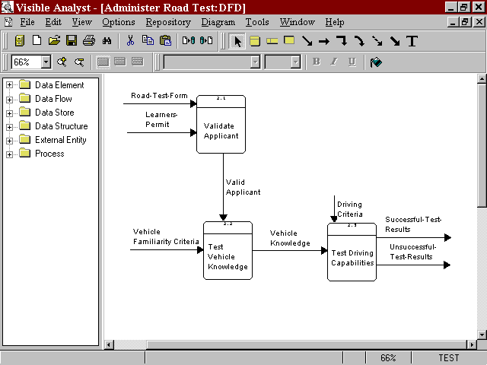Figure 8-9 The Completed Diagram

GENERATING A PROCESS DECOMPOSITION MODEL
A process decomposition model for a process shows you the hierarchical structure of a decomposed process that has been nested.

Note
 A process decomposition diagram is very different from a functional decomposition diagram. The former is simply an unstructured diagram displaying the hierarchy of processes that are descendants of an indicated process. The latter, discussed in Lesson 4 -Functional Decomposition Diagrams, is a full diagramming methodology for performing business planning.

Open the Diagram: | 1 | From the Window menu, click ―DMV System: DFD.‖
Select a Process: | 2 | Click the process Driver‘s Licensing System with the

 |  | right mouse button.
Create the Decomposition: | 3 | Select Decompose. An unstructured diagram is generated showing the hierarchical structure of the process.
Save the New Diagram: | 4 | Select Save from the File menu. Label the diagram  ―Process Decomposition‖ and click OK.

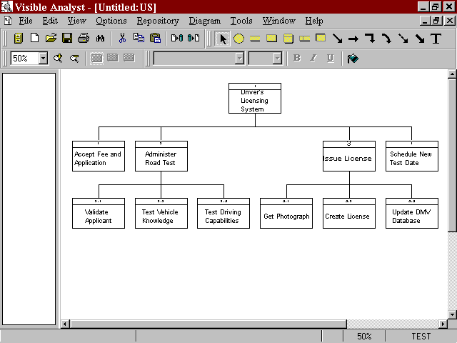Figure 8-10 Process Decomposition Diagram

Lesson 9 Structured Design and Structure Charts

OVERVIEW
Structured design (SD) and structure charts (SC) produce the road map of how the new information application is built, tested and operated. SD and SC define modules, invocation sequences, control architectures, calling and return flows, decision logic, looping and other programmatic level operations. The structure chart is top-down, hierarchical in nature, and produces one overall diagram of the application. The repository entries for the modules can contain pseudo-code and detailed specifications for how the module performs its operations. Specifications for testing, test data and other project details can also be defined in the repository. In addition, the components from the data flow models and the data models can be reused to assure that all processes have been covered in the structured design and the defined database structures used to build the programmed data stores.

A key concept in structured design is to define, build and test clearly defined, limited function programming modules. These modules are easier to build and maintain, and they operate using a hierarchical control executive that manages the flow and control between modules.
The use of standards for calling sequences, operational flows and parameter passing helps to maintain the consistency of the design logic and to make the application easier to build, test and maintain.

This unit leads you through the diagram creation process for a basic structure chart. Previous lessons acquainted you with the fundamental drawing techniques. Therefore, this unit is short and concentrates on drawing features unique to structure charts. You are also shown a different method of adding items to a diagram.

Definitions
A structure chart is the diagram used for structured design. The purpose of structured design is to provide a technique for transforming process descriptions and specifications generated using data flow diagramming into a design for a set of computer programs. As such, it is almost a graphical programming technique. Structured design is practiced in a more subjective manner than is structured analysis, meaning that there are fewer hard and fast rules for how a given project analysis should be transformed into a structured design. We lead you through a simple design process that produces a set of program design specifications. If code generation is part of your tool, we show you how to use Visible Analyst to generate shell code.

Unlike a data flow diagram, a structure chart is considered to be a single, possibly huge, diagram. For ease of viewing, parts of the structure chart are displayed on different pages. Modules can invoke modules on other pages of the chart, but all modules are conceptually on the same level. As an alternative to connecting many diagrams with page connectors, you could generate one large diagram using the multi-page option. (The multi-page option is not available in the Education Editions of Visible Analyst.)

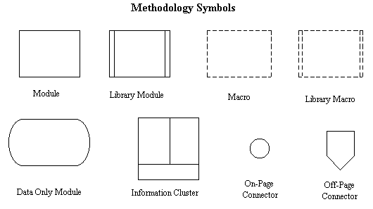There are only a few diagramming constructs used in structured design (Figure 9-1).

Figure 9-1 Structure Chart Diagramming Symbols

Module A module symbolizes a package of instructions to carry out some operation, that is, a computer program or subroutine. They come in various forms (modules, library modules, macros, library macros), but they are all essentially capsules of instructions. There is a very loose relationship between the processes appearing in a process model and the modules appearing on a structure chart, in that the modules contain the code for performing the processes; but the correspondence is highly variable and subjective. The means of transforming one into the other is beyond the scope of this tutorial; please consult one of the texts on the subject referred to in Lesson 4 – Structured Modeling Techniques for details. A basic module is a rectangle with solid borders.

Library Module This is a module that is executed in the same way each time it is invoked. It differs in usage from the standard module by the fact that its interfaces to other modules (if any) are hidden from the designer. It is represented as a rectangle with double lines on the two vertical sides.

Macro A macro is a module whose body is effectively copied in-line during translation (that is, compilation or assembly) as a result of being invoked by name. The only practical difference between a macro and a module is that macros tend to make a system operate faster, but at the expense of more memory space required to operate the system. A macro is represented as a rectangle with dashed sides.

Library Macro This is a macro that is repeated in a system. It is a rectangle with dashed lines and double lines for the vertical sides.

Data Only Module A data only module is simply a collection of data, analogous to a data store or a common area. This kind of module cannot be invoked since it contains no instructions, only data. The data can be shown being used by one or more modules. It is represented as a rectangle with rounded, convex sides.

Information Cluster An information cluster is an aggregate symbol, a combination of two or more modules and a data only module that the modules share in common. You can tell Visible Analyst how many modules you want in your information cluster when you label it, and Visible Analyst draws the symbol appropriately.

On-Page Connector To avoid crossing lines on a diagram, it is often convenient to
begin an invocation on one part of a diagram and complete it discontinuously on another part. For this, the on-page connector is used. The on-page connector symbol is a small circle.

Off-Page Connector A structure chart is viewed by Visible Analyst as one unified
diagram. You can, however, spread your chart over multiple pages by linking them using invocations that begin on one page and end on another. The off-page connector symbol is identical in appearance to the page connector for FDDs.

Invocation Line An invocation is a line drawn from one module to another showing that the first module invokes (or calls) the second, with the implication that control will eventually return to the invoking module. The line is usually, but not always, drawn with an arrowhead terminator pointing to the invoked module. There are two variants of the invocation line called the control connection and the data connection.

Control Connection A control connection describes a one-way transfer of control
between modules. It is drawn as a line with a filled in circle on one endpoint and an arrowhead on the other. The arrowhead is optional.

Data Connection A data connection depicts the passing of data between a module and a data only module. It is a line with an open circle on one endpoint and an arrowhead on the other. The arrowhead is optional.

Couple A couple is a piece of information passed between modules and symbolizes the arguments passed between computer programs or functions. It is shown next to an invocation line, pointing in the direction in which it is passed. There are data couples, control couples, and generic couples.

A data couple represents data parameters that are passed between program modules. It is a short line with an open circle at one end and an arrow at the other.

A control couple represents information pertaining to the way modules function rather than the data on which they function. It is a short line with a filled circle at one end and an arrow at the other.

A generic couple shows that both data and control are passed between modules upon invocation. It is a short line with no circle at one end and an arrow at the other

Interface Table Row An interface table row represents a set of couples and is used to (ITR) make complex diagrams more clear. The same symbols that are used for data, control, and generic couples are used to denote an
ITR for that couple type. An ITR is drawn on a diagram in the same manner as a couple. Then the type of the line is changed to an ITR in the repository in the entry type field and the couples to

be contained in the ITR are listed in the composition field of its repository entry.

Loop Line The loop line type is the open ellipse shape shown in Figure 9-2. Even though it is a line, it cannot be labeled and cannot be defined in the repository. Its purpose is to show that an invocation line (of any type) is part of an iterative and/or an ordered set of invocations. In usage, a loop can be drawn around the start point of one or more invocation lines. Loops can be nested.

DRAWING A STRUCTURE CHART

Adding Symbols
Since you are already familiar with adding symbols, the description for this section is brief.

Create a New Diagram: | 1 | Select New Diagram from the File menu and choose Structure Chart.
Maximize the Diagram: | 2 | Maximize the workspace by clicking on the Maximize button in the top right corner of the window.
Set Zoom Level: | 3 | Set zoom level from the View menu to 66%.
Add Symbols: | 4 | Add the symbols to the diagram as shown in Figure 9-2.
Save: | 5 | Select Save from the File menu. Name the diagram  ―Menu Structure.‖

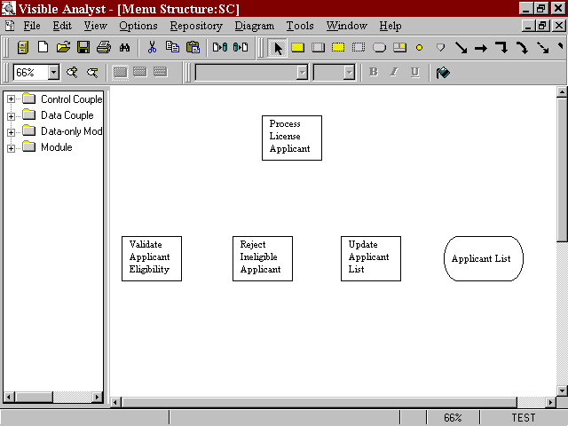Figure 9-2 Structure Chart with Symbols

Adding Invocation Lines to a Structure Chart
The method for adding lines to a diagram is the same for all diagram types. This section reviews the line-adding procedure and also explains how to use different line terminators and line types. For any line that you create on a diagram, you can change its type immediately by selecting Line Settings from the Options menu while the line is still selected (highlighted). This gives you the ability to draw a line and then set the terminators. In this section, though, when it is necessary to draw a different type of line, you change the line type before you draw the line.

Draw an Invocation: | 1 | Click the first line type and position the cursor over the
 |  | bottom line of the module Process License Applicant.
 |  | Click and hold the left mouse button, and drag the line to
 |  | the top of the module Validate Applicant Eligibility.

 | 2 | Release the mouse button within the symbol. (If Auto Connect is turned off, you must double-click to end the line.) This ends the line, and the line terminator is drawn.
Deselect the New Line: | 3 | Open the Diagram menu. Note that the Lines menu item is checked, indicating that you are in line entry mode. If you were to click Lines, you would return to selection mode. This same type of action works for getting out of caption text modes. For symbol mode, you must click the selected symbol on the submenu.
 | 4 | You should still be in line adding mode. Click on an empty space on the diagram, so that the line you drew is no longer selected. (If you don‘t deselect the line, making changes in Line Settings affects the selected line, not a future line, as you want to do in this case.)
Change the Terminator Type: | 5  6 | Select Line Settings from the Options menu.  Select Decision as the Terminator Type and click OK.
Draw Conditional Invocations: | 7 | Draw an invocation line from Process License Applicant to Reject Ineligible Applicant. The line has a conditional terminator at the starting point of the  line.
 | 8 | Click the left mouse button on the conditional terminator of the invocation you just drew and draw a line from Process License Applicant to Update Applicant List. The conditional terminator of the new invocation can be overlaid on top of the previous one, so that they appear as one binary choice. (Since the two invocations are in fact distinct, they can later be separated, if you want to display them as independent choices.) This establishes another conditional invocation relationship. It means that under certain circumstances, either Reject Ineligible Applicant is invoked or Update Applicant List is invoked. In this case, the circumstances depend upon whether or not the Applicant is valid.
 | 9 | Deselect the line.

Draw a Data Connection: | 10  11 | Select Line Settings from the Options menu.  Select the Line Type to be Data Connection and the
 |  | Terminator Type to be Single Arrow. Click OK.
 | 12 | Draw a line between Update Applicant List and the data only module Applicant List. Then deselect the line.
Draw a Loop Line: | 13 | Select Line Settings from the Options menu.
 | 14 | Select the Line Type to be Loop and click OK.
 | 15 | You want to end up with a loop line like that shown at the bottom of the module Process License Applicant in Figure 9-3. Place your cursor on the edge of the module near the lower left corner. Click and drag the line so that its endpoint is at the lower right edge of the symbol and double click to complete the line. While the line is still selected, notice its handles. You can drag these around to change the shape and size of the loop.
Save: | 16 | Select Save from the File menu.

Drawing Couples
Enter Couple Mode: | 1 | Deselect the line.
 | 2 | Select Line Settings from the Options menu.
 | 3 | Select the Line Type to be Data Couple and click OK.

Note
 When the cursor is over the drawing area, it displays as the couple-adding cursor. On any cursor there is a spot, called the ―hot spot,‖ that is the business end of the cursor; that is, the location at which you want some action to take place. For the couple-adding cursor, the hot spot is at the point of the large arrow at the top of the cursor.

Select the Invocation: 4 Click on either end of the invocation line between Process
License Applicant and Validate Applicant Eligibility. This selects the line.

Draw the Couple: | 5 | Click on the start point of that line. A data couple is drawn pointing in the direction the data is passed. By clicking at the start of the invocation line, you indicated that the data couple is passed from Process License Applicant and follows the direction of the invocation line.
 | 6 | Name the couple ―Applicant Name‖ and click OK.
Draw More Couples: | 7 | Now that you know how to enter diagram objects using the Diagram menu, you can continue doing it the easy way using the tool bar buttons. Click on the couple with a filled circle (the last line button). This is a control couple. (You may have to click on the ―gripper‖ to drag more of the diagram tools tool bar into view.)
 | 8 | While it is still selected, click on the endpoint of the same invocation line where it meets Validate Applicant Eligibility. Name the new control couple ―Applicant Valid‖ and click OK.
 | 9 | Click on the second to the last line button, the data couple.
 | 10 | Click on one end of the invocation line between Process License Applicant and Update Applicant List. This selects the line.
 | 11 | Click on the endpoint of that line, where the terminator is attached to Update Applicant List. Name the data couple  ―Applicant Information.‖
Invert the Couple: | 12 | Look at Figure 9-3. If the couple you just drew is facing the wrong direction, it is easy to fix. To select the couple you just drew, press ESC to activate selection mode and click on the couple with the right mouse button.
 | 13 | Choose Change Item from the Object menu, click the Invert Couple box, and click OK. The couple and its label move to the other side of the invocation.
Complete the Diagram: | 14 | Draw the other couples as shown in Figure 9-3.

Save: 15 Choose Save from the File menu to save the diagram.
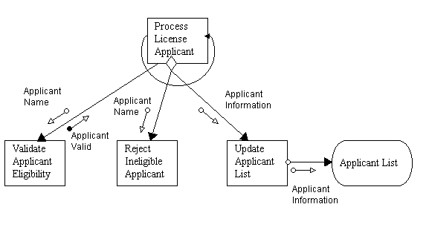Your structure chart is complete.

Figure 9-3 The Completed Structure Chart

Lesson 10 The Class Diagrams

OVERVIEW
Visible Analyst provides a series of capabilities for supporting the definition of object classes and a variety of object relationships and methods. Visible Analyst implements the concepts of Object Modeling and Design (OMT), as developed by Rumbaugh, et al, for the General Electric Company, and Rational‘s Unified Modeling Language (UML). These methods are similar, so they are covered together here.

The key to object modeling is the development of class diagrams that show the object elements and relationships, including cardinality, attributes, association, inheritance, and aggregation. There is considerable flexibility in these concepts to allow the user to define and implement a number of variations and options in the object model.

Visible Analyst‘s object modeling approach is implemented in a way that is very similar to the entity relationship model. A rectangular symbol is used to represent both a data entity and a class object. The relationship and cardinality questioning sequence is similar. Attributes of both entities and classes are displayed in similar formats. The key differences are in the extended definitions of the object in the Visible repository.

The object model is represented by class diagrams (CLDs) that contain classes, with an object being an instance of a class. The relationships between the classes for a project are depicted with lines and symbols to depict inheritance and aggregation. Like the ERD, the CLD can be built into views that show all or a subset of the classes and their relationships.

Definitions
The components of the class modeling process include:

Aggregation An aggregation is a relationship that indicates the parent class
contains the child.

Attributes Attributes are data members describing the class object.
An attribute can be assigned a name, class type, limit, type of visibility, reference method and a qualification flag indicating whether it is static or volatile.

Class A class is a group of objects with the same data structure (attributes) and behavior (operations). A class is an abstraction that describes properties that are important to an application.

Inheritance Inheritance is the sharing of attributes and operations among
classes based on a hierarchical (parent and child) relationship.

Instance Instance is a specific object from a class. Each instance of the class has its own value for each attribute but shares the attribute names and operations with other instances of the class.

Method A method is a specific implementation of an operation by a certain class.

Operation An operation is an action or transformation that an object performs or is subject to.

Relationship The relationships between classes can define cardinality of classes (numeric relationships), aggregations, and inheritance. Refer to Adding Relationships to a View later in this chapter for a discussion of relationship attributes.

Stereotype A Stereotype is a special denotation and is used as a mechanism to extend the UML. The stereotype indicates that the class is a special kind of class, and conforms to some rigid specifications. The two surrounding characters “«»” of the stereotype selection are called guillemets (pronounced Gee-may).

The class stereotype selection is specified on the Change Class dialog, and may have the following values: no stereotype selected;
<<implementationClass>>; <<interface>>; <<metaclass>>;
<<powertype>>; <<process>>; <<structure>>; <<thread>>;
<<type>; <<union>>;<<utility>>. When a class is also used on an entity relationship diagram, no stereotype selection is available.

Subtype Subtype provides additional information on how a class is used. A Standard class (the default) indicates a normal class. Elemental indicates the class contains no attributes and physical characteristics should be defined. Structure and Union subtypes indicate C type components should be used instead of a class.
Entity, Associative, and Attributive indicate the class is persistent and can be used on an Entity Relationship Diagram.

Symbols The symbols for a class diagram consist of rectangles that are defined as classes.

Visibility Indicates the level of exposure to the outside world permitted by the class. The options are: public, private or protected.

DEVELOPING YOUR CLASS MODEL
Each class diagram is complete in and of itself and shows one view of the classes in your project. You begin your class model by specifying and defining classes of objects on a diagram and then establishing a definition of the relationships between the classes. You can also define the attributes and operations for the classes within the Visible Analyst repository. Once you defined a class diagram, you can create additional views by selecting the File menu New Diagram function and choosing the New View Drawing Method. This selects existing class entities and relationships from the repository, and Visible Analyst automatically draws the views for you. You can add or subtract elements from each view and rearrange it as you wish. This allows you to establish object models for various portions of your project without having to create redundant definitions or large confusing diagrams. Any new objects or relationships created on any view are automatically updated into the Visible Analyst repository.

Adding Classes to a View
The basic building blocks of the class model are classes of objects that exist within an application. You begin the CLD with a new diagram and add and define classes to this view. For the lesson exercise, we return to the Department of Motor Vehicles application and concentrate on the Registration portion of the application.

Set the Zoom Level: | 1 | From the View menu, select 66% zoom so that you can see all of your needed workspace.
Create a New Diagram: | 2 | From the File menu select New Diagram.
 | 3 | Select the diagram type Class.
 | 4 | Select Standard Workspace and Landscape Orientation.
 | 5 | Click OK.
Add Classes: | 6 | Click the class symbol button on the diagram tools tool bar.

 | 7 | Place the cursor in the middle of the diagram workspace and click the left mouse button. A class object symbol is drawn.
 | 8 | Name the Class symbol ―Registrations.‖
 | 9 | Add another class below Registrations, and name it  ―Trailers.‖
 | 10 | Add another class below Registrations and name it  ―Vehicles.‖
 | 11 | Add a class below Vehicles and name it ―Trucks.‖
 | 12 | While trucks is still selected, click the right mouse button to display the Object menu, then select Stylize. Change the horizontal and vertical sizes to 75%. Click Apply, then click Set Default Size. Click OK.
 | 13 | Below Vehicles, add two more classes: Cars and Motorcycles.
 | 14 | To the right and slightly under Vehicles, create four more classes: Engine, Axles, Fuel, and Weight.
Save the Diagram: | 15 | From the File menu, choose Save and name the diagram  ―Registration Object Classes.‖
Reset Default Object Size: | 16  17 | Click on the Registrations object.  Select Stylize from the Diagram menu. Change the
 |  | horizontal and vertical sizes to 100%. Click Apply, then click Set Default Size. Click OK.

Adding Relationships To A View
The relationships between classes establish the cardinality, aggregations or inheritance connections between the classes.

Drawing Relationships: | 1 | Click the first line choice on the diagram tool bar. This
 |  | establishes a normal relationship between the classes.
 |  | (Because the first line type icon is selected, the default
 |  | cardinality is 1:1 and 1:1.)

 | 2 | Draw a line from Registrations to Vehicles. This procedure is the same as that used to draw an Entity Relationship Diagram in Lesson 7. Click and hold the left mouse button where you want the line to begin, and drag the line to the symbol where you want it to end.
 | 3 | Type ―identify‖ for the label of the first relationship.
 | 4 | Use the TAB key to move to the next relationship label. Type ―are licensed by‖ for the label that establishes the relationship of the vehicle to the registration. Click OK.
 | 5 | Draw a similar relationship between Registrations and Trailers. Use the same labels as you did for Registrations and Vehicles.
 | 6 | Select the line type for Inheritance, the fourth line button, and make connections between Vehicles and Trucks, Cars and Motorcycles. Start drawing the line at the same point on the class Vehicles so that the lines are overlaid as shown in Figure 10-1. The default label ―is a‖ is automatically entered. You can change this or just click OK. You can also use the Shift + Click method as described in Lesson 6 to select the class symbols and use the Connect option on the Diagram menu to auto-connect the symbols.
 | 7 | Select the line type for Aggregations and make the connections between Vehicles and Engines, Axles, Fuel and Weight. Start drawing the line at the same point on the class Vehicles so that the lines are overlaid. (When drawing a line over an existing line, the new line is red indicating the lines are overlaid.) Use the labels ―have,‖  ―use,‖ ―have,‖ and ―have,‖ respectively, from Vehicles to these classes.
Save: | 8 | From the File menu choose Save. Your diagram should be similar to the one shown in Figure 10-1.

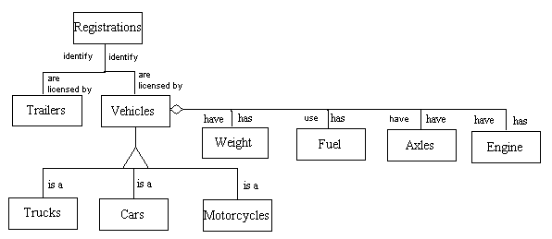Figure 10-1 Class Relationship Notation

The information that is maintained for a relationship is:
- From. The name of the parent entity or class
- Cardinality. How many instances of one entity or class relate to another. The Detail field can be used to store a specific quantity, for example 1, 3 or 5+
- To. The name of the child entity or class.
- Type. The type of relationship. An aggregation relationship indicates the parent class contains the child. An inheritance relationship indicates the definition of the To class is based on the From class. The base class contains the basic definition, while the derived class implements only those features that need to be different. A normal relationship indicates there are no special characteristics between the objects involved.
- Role. The role names used for the parent and child classes. For normal relationships, a role should exist as an attribute of the class at the other end of the association with the Reference type set to Address. For aggregation relationships, it should be set to Value. The Visibility in both cases should be Protected, and the type set to the opposite class.
- Qualifier. The qualifier names used for the parent and child classes. If a qualifier is used, an attribute of type Void is created in the class at the other end of the association with the Reference type set to Address and the Visibility set to Protected. You can change the type of the qualifier by modifying the attributes field in the repository.

- 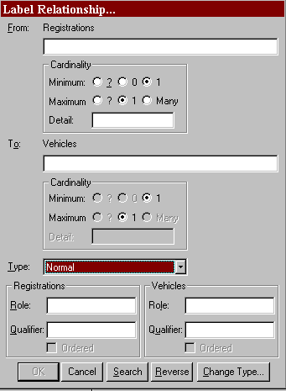Ordered. Ordering indicates the objects on the many side of a relationship have an explicit order. The term set is commonly used to describe an unordered association, while a list indicates an ordered association.

Figure 10-2 Labeling Relationship for DMV

Note
 Each relationship between two entities or classes is a unique object in the repository. The fact that two relationships between two different pairs of objects may have the same name does not change the fact that the individual relationships are distinct. When using the Search function to name relationships, you are only selecting a name, not a relationship repository object. If, when you are finished, a pair of objects on this view is connected by relationships with the same names as relationships joining the same object on another view in the data or object model, then both sets of relationships are considered two different instances (locations) of the same repository object.

ATTRIBUTES OF AN OBJECT
Class objects are defined by their data members that can be selected in the Visible Analyst repository. The following information can be defined:
  - Name. The name of the attribute. Each attribute of a class has a separate entry in the repository with a type of Local Data Element. This is an optional field. The Search button can be used to find other Member Names in the repository.
  - Type. The attribute type can be a Class, Data Element, or Data Structure. If the type does not exist in the repository, a new class is created. The location field of the attribute type will contain a reference to the current class. This is a mandatory field. The Search button can be used to display a list of valid types. If the attribute type is a Data Element or Elemental Class, its physical characteristics are displayed.
  - Limit. The number of occurrences of the attribute. If this field is blank, the attribute occurs once.
  - Reference. A qualifier to indicate the access method for an attribute. Value indicates the object defined in the Type field is used; Address indicates a pointer to the object is to be used; and Reference indicates a reference to the object is to be used. The default is Value.
  - Visibility. Public members have global visibility. Private members are only accessible to member functions and friends. Protected members are accessible to derived classes and friends. Implementation members are only accessible to the class itself. The default is Private.
  - Qualification. Constant indicates a member‘s value cannot be changed. Volatile indicates the member can be modified by something other than the program, either the operating system or hardware. Static indicates there is only one instance of the member regardless of the number times a class is instantiated. The default is None.
  - Physical Characteristics. If the attribute type is elemental, the physical characteristics can be set.

For every item entered into the Type field, Visible Analyst creates a repository entry (if one with the same name does not already exist) and updates that entry‘s location field. Likewise,
if an item is removed from this field, that entry‘s location field is updated to reflect this. These repository entries are generally created as classes unless a data element already exists with the same name or the physical characteristics are defined.

As you enter items, the dialog box automatically scrolls as necessary to allow you to enter more items until you have finished. Insert is used to insert a new attribute into the list at the current position, while Delete removes the current attribute (the current position is indicated by ➢➢ ). When you have completed the entries, click OK to add them to the Attributes field.

Item names entered into this field may contain up to 128 characters each and may consist of any upper or lower case letters, numbers, spaces, periods, underscore characters and hyphens; but the first character must always be a letter.

Adding Attributes to a Class Diagram
Bring your Registration Class Objects CLD to the working diagram position and follow these steps:

Move to the Repository: | 1 | Select the Registrations class object and double-click the left mouse button to go to its repository entry.
Enter the Attributes Field: | 2 | Move the entry cursor to the Attributes field.
Bring Up Attributes | 3 | Click the Attributes Details button
Entry: |  | or select Add/Change from the Repository Object menu that is displayed when you right-click in the Attributes field.
Define Attributes: | 4 | Type values for the Registrations class object, as shown in Figure 10-3.
 | 5 | Click OK to save your entries and return to the Define dialog box. Note that the attributes you entered are displayed in the Attributes field. Click Save and Exit to return to the diagram.

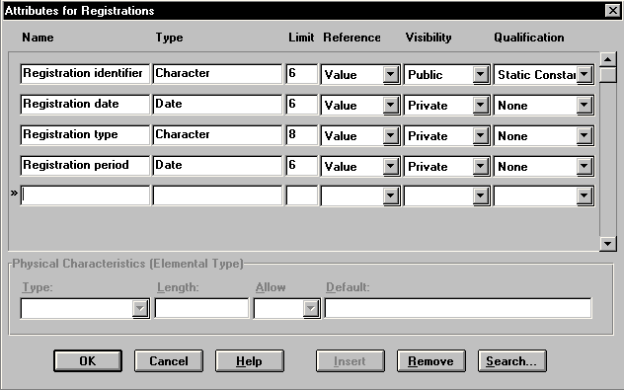Figure 10-3 Attributes for Registration Class Object

Define More Attributes: | 6 | Select the Trailers class object and double-click the left mouse button to go to its repository entry.
 | 7 | Move the entry cursor to the Attributes field.
 | 8 | Click the Attributes Details button, and complete the Attributes dialog box. Type ―Weight‖ in the Name field, type ―Character‖ in the Type field, type ―1‖ in the Limit field. Select Value in the Reference area, Public in the Visibility area, and None in the Qualification area.
 | 9 | Click OK to save your entries and return to the Define dialog box. Click Save, then click Exit to return to your diagram.
 | 10 | Double-click the left mouse button on the Vehicles class object to display its repository entry.
 | 11 | Right-click in the Attributes field and select Add/Change from the Object menu that is displayed.

 | 12 | Complete the Attributes dialog box by typing ―Motor Number‖ in the Name field, ―Numeric‖ in the Type field, and ―1‖ in the Limit field. Select Value in the Reference area, Public in the Visibility area, and None in the Qualification area.
 | 13 | Click OK to save your entries and return to the Define dialog box. Click Save, then Exit to return to your diagram.
Complete Your Attributes: | 14 | Continue adding attributes to the remaining class objects on your diagram.
Exit the Define Dialog Box | 15 | When you have completed adding attributes to class objects, click Exit to close the Define dialog box.

METHODS FOR AN OBJECT
Methods are the operations defined for accessing a class. The methods are specified in the Visible Analyst repository and include the following information:
- Returns. The return type can be a Class or Data Element. If the type does not exist in the repository, a new class is created. The location field of the attribute type contains a reference to the method. This is an optional field. The Search button can be used to display a list of valid types.
- Limit. The number or size of the parameter. If this field is blank, it occurs once.
- By. A qualifier to indicate how the return value is passed. Value indicates a copy of the parameter is passed; Address indicates a pointer to the object is to be used; and Reference indicates a reference to an object is to be used.
- Visibility. Public methods have global visibility. Private methods are only accessible to other member functions within the same class and friends. Protected methods are accessible to derived classes and friends. Implementation methods are only accessible to the class itself. The default is Public.
- Qualification. Static indicates a method can be used without a specific instance of an object (it can only be used with static attributes (data members)). A Virtual method is one that you expect to be redefined in a derived class. A pure Virtual method has no definition and must be defined in a derived class. A class with any pure virtual functions is an abstract (or virtual) class. The default is None.
- Arguments. A list of parameters to be used by the method. This is an optional field. If a method appears more than once with the same name within a class, it must have a

different argument list for each definition. This is known as function overloading. See the next section for defining arguments.

When a method is added to a class definition, an entry of type Module is created in the repository. The long name includes the class name and the argument list. The argument list is needed to differentiate between overloaded functions.

Note
 Because the same name can be used for more than one method, there may be duplicate Module entries in the repository, each belonging to a different class.

Arguments for Methods
When defining methods (member functions) for a class, the parameters to the function need to be specified. To add, change, or remove arguments, click the Arguments button on the Method Definition dialog box. For each argument, the following information can be defined:
  - Name. The name of the parameter. This is an optional field.
  - Type. The parameter type can be class or data element. If the type does not exist in the repository, a new class is created. This is a mandatory field. The Search button can be used to display a list of valid types. If the parameter type is a data element or elemental class, its physical characteristics are displayed.
  - Limit. The number or size of the parameter. If this field is blank, it occurs once.
  - Pass By. A qualifier to indicate the how the parameter is passed. Value indicates a copy of the parameter is passed; Address indicates a pointer to the object is used; and Reference indicates a reference to an object is used. The default is Value.
  - Qualification. Constant indicates a parameter‘s value cannot be changed. Volatile indicates the parameter can be modified by something other than the program, either the operating system or hardware. The default is None.
  - Physical Characteristics. If the parameter type is elemental, the physical characteristics can be set.

For every item entered into the Type field, Visible Analyst creates a repository entry (if one with the same name does not already exist). These repository entries are generally created as classes unless a data element already exists with the same name or the physical characteristics are defined.

As you enter items, the dialog box automatically scrolls as necessary to allow you to enter more items until you have finished. Insert is used to insert a new parameter into the list at the current position, while Delete removes the current parameter (the current position is indicated by ➢➢ ). When you have completed the entries, click OK to update the method name field.

Item names entered into this field may contain up to 128 characters each and may consist of any upper or lower case letters, numbers, spaces, periods, underscore characters and hyphens; but the first character must always be a letter.

Adding Methods to a Class Diagram
Methods are defined in the Visible Analyst repository. Bring the ―Registration Class Objects‖ CLD to the working diagram position and follow these steps:

Move to Repository: | 1 | Select the class object ―Registrations‖ and double-click the left mouse button to go to its repository entry.
Methods Window: | 2 | Move to the third page of the repository dialog box by clicking the Methods/Friends tab.
 | 3 | Move the cursor to the Methods field.
 | 4 | Click the Attributes Details button or select Add/Change from the Repository Object menu that is displayed when you right-click in the Methods field.
Enter Methods: | 5 | Define methods for the Registration. To do this, click the New button to name the new method ―Registration Renewal,‖ and click OK. Type ―Data Element‖ in the Returns field, and ―6‖ in the Limit field. Select Value in the By area, Public in the Visibility area, and None in the Qualification area. (Refer to Figure 10-4.) Repeat this process for new methods ―Create New Registration‖ and  ―Suspend Registration.‖

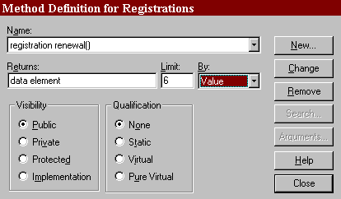Figure 10-4 Method for Registration Object

 | 6 | Click Close to return to the Define dialog box.
 | 7 | Click Save, then Exit to return to your diagram.
Enter More Methods: | 8 | Double-click on the Trailers class object to display its repository entry, then click the Methods/Friends tab.
 | 9 | Click the Attributes Details button to display the Methods Definition dialog box.
 | 10 | Click the New button, and type ―Weight Specification‖ in the Name field. Click OK.
 | 11 | Type ―Data Element‖ in the Returns field, and type ―1‖ in the Limit field. Select Reference in the By area, Public in the Visibility area and None in the Qualification area.
 | 12 | Click Close to return to the Define dialog box.
 | 13 | Click Save, then Exit to return to your diagram.
 | 14 | Select Vehicles, then right-click to display its Object menu.

- Select Define to display its repository entry.

- Click the Methods / Friends tab and put the cursor in the Methods box.

- Right-click to display the Object menu, and select Add/Change to display the Method Definition dialog box.

- Click the New button and name the new method ―Motor Number Specification.‖ Click OK.

- Type ―Data Element‖ in the Returns field and ―1‖ in the Limit field. Select Reference in the By area, Public in the Visibility area, and None in the Qualifications area. Click Close.

- Click Save, then Exit to return to your diagram.

Note
 The attributes and/or methods for an object can be displayed on object model diagrams. This is done by making the appropriate selection of items to display from the View menu Class options window.

ANALYZING THE CLASS DIAGRAM
The Analyze function evaluates the following conditions of a class diagram.
- Syntax errors. These are errors that would make your class diagram impossible for Visible Analyst to understand.
- Connection errors. These indicate classes are improperly associated with other classes. Different rules apply depending on whether the relationship type is normal, inheritance or aggregation.
- Use errors. These indicate classes have not been used, either on a diagram or in the definition of another class.
- Definition errors. These indicate a class definition is incomplete; attributes or methods have not been defined. Different rules apply depending upon the class subtype.

Execute Analyze: 1 With your diagram for ―Registration Class Objectives‖ in
the active diagram window, select Analyze from the
Diagram menu.

  - Review your error messages and decide an appropriate corrective step.

  - Save the diagram when finished.

Lesson 11 State Transition Diagramming

OVERVIEW
The state transition model defines the dynamic changes that occur in the life history of an object. The understanding of the different states and the conditions that trigger the changes from state to state represent the programmatic modules that must be built to allow the application to perform in harmony with the real world. State transition modeling consists of defining each stable state of an object and then defining the triggers or events that cause the object to change to another state. For example, an object ―customer order‖ could be defined in states such as completed, back-ordered, partial, awaiting shipment, in-shipment, delivered, lost, overdue, billed-but-not-paid, paid partial, paid-in-full, etc. As the states are natural positions, and the events or triggers actions on the objects, the transitions from one state to another represent the operations modules of a system. In addition, the attributes that define the state condition are established and can be used to develop the triggers and event processes.

Definitions
The components of state transition modeling include:

State The condition that an object can be at rest in. The state can be defined as a class of objects.

Triggers The action or change of condition that will cause an object to change from one state to another.

Transitions The steps that the object passes through in transition from one state to another.

Relationships
The relationship structure in a state transition diagram (STD) is directional arrows showing how an object moves from one state to another. The indication of the event triggers and the transition steps are outlined on the relationships.

DEVELOPING YOUR STATE TRANSITION MODEL
Each state transition model is composed of objects and provides a sequence of steps for each major transition within a project. The state transition model can be linked to the object class models using the nesting concept.

When beginning your state transition model you can enter the objects or nest down to the STD from a class diagram. For the lesson exercise, you develop the state transition model for the registrations in the DMV application. You use the definition that a registration can be in the following states:
  - Never Registered (New Vehicle)
  - Registered
  - Unregistered
  - Renewal Registration
  - Registration Expired
  - Vehicle Resold

These states and their transitions provide a reasonable picture of the processing requirements for the registration application.

Adding States To A View
The basic building block of the state transition model is the state entity. The relationships between states represent the transitions.

Set the Zoom Level: | 1 | From the View menu, select 66% zoom so that you can see all of the needed workspace.
Create a New Diagram: | 2 | From the File menu select New Diagram.
 | 3 | Select the diagram type State Transition Diagram.
 | 4 | Select Standard Workspace.
 | 5 | Click OK.
Add States: | 6 | Click the first symbol button, the rectangle, on the control bar. This is the state object.
 | 7 | Place the cursor in the middle of the diagram workspace and click the left mouse button. A state object is drawn.
 | 8 | Label this state ―Registered.‖

 | 9 | Add the rest of the state objects as shown in Figure 11-1.
Save the Diagram: | 10 | Save the state model with the label ―Registration States.‖

Adding Relationships To The State Model
The relationships in a state model define the transitions that occur to produce the various states. The transitions are events or triggers that cause the state to change from one value to another.

Build Relationships: | 1 | Select elbow line type in the control bar and begin the connections from the state of Never Registered to Registered. This process is similar to the one used in defining entity relationships.
 | 2 | Label the transition ―Vehicle is Purchased.‖
 | 3 | Continue the relationship labeling until the model is complete, as shown in Figure 11-1.
Save: | 4 | Select Save from the File menu.

Note
 The state model is the dynamic view of the objects in the class model. The Nest process can be used to link the class objects to their dynamic state transition diagrams. To do this return to your class diagram and select the Registration class. Then choose Nest/Explode from the File menu.

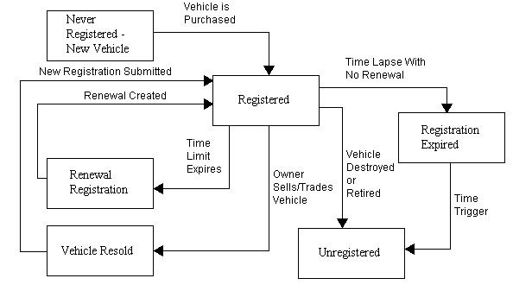Figure 11-1 Completed State Transition Diagram

Lesson 12 Activity Diagramming

OVERVIEW
The activity diagram describes the sequencing of activities, with support for both conditional and parallel behavior. An activity diagram is a special form of a state diagram in which the states represent the performance of actions and the transitions are triggered by the completion of the actions. The activity diagram can be attached to a class or to the implementation of an operation or a Use Case. The purpose of an activity diagram is to focus on flows driven by internal processing (as opposed to external events). Usually activity diagrams are constructed in situations where all or most of the events represent the completion of internally generated actions.

DEFINITIONS
The main components of an activity diagram include:

Activity An activity is a state of doing something. It could be a task such as receiving a payment, or the execution of a software routine, such as a method on a class. It is represented by a rectangle with rounded corners.

Decision A decision is used when more than one activity can be performed next, based on a certain condition. There is a single incoming transition and several guarded outgoing transactions. The guards are mutually exclusive and so only one of the outgoing transactions is followed. A diamond denotes the decision start and end.

Synchronization Bar A synchronization bar is used to show parallel activities. It is
represented by a black bar with one or more input transitions and one or more output transactions, that are all taken in parallel. This means that the sequence of the output transactions is irrelevant. In order to show that all the parallel activities need to be completed before the following activities, use a second synchronization bar that has multiple incoming transactions and a single outgoing transaction. The outgoing transaction is taken only when all the incoming transactions are completed.

Start The start object designates the starting point of the activity diagram and is represented by a filled circle.

End The ending point of the activity diagram is represented by a filled circle inside a hollow circle.

Swimlane A swimlane is a way of designating responsibility for each action state. An activity diagram may be divided visually into ''swimlanes''; each separated from neighboring swimlanes by vertical solid lines on both sides. Each action is assigned to one swimlane.

Transition Represented by a solid line with a stick arrowhead, transitions
may cross swim lanes. Transitions are implicitly triggered by the completion of the preceding them. The transitions may include guard conditions and actions. It is labeled by a transition string of the form ‗Event [guard]/Action‘. All components of the transition string are optional

RELATIONSHIPS
The relationship structure in an activity diagram is directional arrows showing how the order in which the activities occur. The completion of one activity triggers the flow to move on to the next activity as dictated by the arrows.

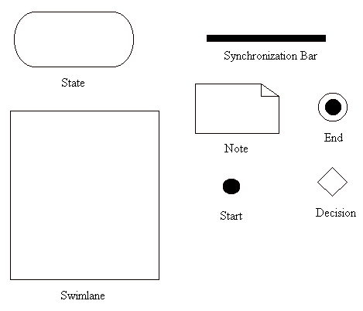Figure 12-1 Activity Methodology Symbols

DEVELOPING YOUR ACTIVITY DIAGRAM
An activity diagram is a variety of activity states arranged in the sequence in which they must be performed. For our tutorial example, we look at the process of getting a driver‘s license.

Designating the Starting Point
For every activity diagram there has to be a designated starting point shown on the diagram with a filled circle.

Set the Zoom Level: 1 From the View menu, select 66% zoom
so that you can see all of the needed workspace.

Create a New Diagram: | 2 | From the File menu, select New Diagram.
 | 3 | Select the diagram type Activity.
 | 4 | Select Standard Workspace.
 | 5 | Click OK.
Add Start: | 6 | Click the fourth symbol button, the filled circle, on the control bar. This is the start object.
 | 7 | Place the cursor in the top center of the workspace, and click the left mouse button. The starting point is drawn on the diagram.
Save the Diagram: | 8 | Save the activity diagram with the label  ―Driver‘s License Activity Diagram‖.

Adding A Synchronization Bar
A synchronization bar is helpful in depicting activities that are performed in parallel. For instance in our example, the receiving clerk can receive the application form and proof of insurance simultaneously. It is not important which order they are received in. Furthermore, the next activity of validating the applicant can be performed only after both application and insurance proof have been received. The synchronization bar denotes the starting and ending of activities performed in parallel.

Add Synchronization Bar: | 1 | Click the third symbol button, the bar, on the control bar. This is the synchronization bar that denotes forks and joins.
 | 2 | Place the cursor under the start circle and click the left mouse button. A synchronization bar is drawn.
 | 3 | Add the other bar as shown in the Figure 12-2.

Save the Diagram: 4 Save the activity diagram.

Adding Activities
Activities are the basic building blocks of the activity diagram. By determining what activities need to be performed, and arranging them in the order in which they are performed, with support for conditional and parallel behavior, the activity diagram is complete. Activities are represented as rectangles with the activity described inside the rectangle.

Add Activities: | 1 | Click the first symbol button, the rectangle, on the control bar. This is the activity (state) object.
 | 2 | Place the cursor under the start circle and click the left mouse button. An activity is drawn.
 | 3 | Label this activity ―Receive Road Test Form/Learner‘s Permit‖.
 | 4 | Add the rest of the activities as shown in the Figure 12-2.
Save the Diagram: | 5 | Save the activity diagram.

Adding Decisions To A View
In a process, some activities may occur only if a certain condition is met; otherwise certain other activities are carried out. The decision diamond marks the beginning and end of conditional behavior. In our example, only if an applicant is deemed valid does the testing procedure continues; otherwise the applicant is informed why his/her application was deemed invalid and the process ends there.

Add Decision: | 1 | Click the second symbol button, the diamond, on the control bar. This is the decision object.
 | 2 | Place the cursor under the activity  ―Validate Applicant‖ and click the left

mouse button. A decision symbol is drawn.

 | 3 | Add the rest of the decisions as shown in
Save the Diagram: | 4 | the Figure 12-2.  Save the activity diagram.

Adding Stopping To A View
The stopping point for a process is denoted with a filled circle inside a hollow circle.

Add Stop: | 1 | Click the fifth symbol button, the filled circle inside a hollow circle, on the control bar. This is the ending object.
 | 2 | Place the cursor under the activity  ―Validate Applicant‖ and click the left mouse button. An ending symbol is drawn.
 | 3 | Add the rest of the decisions as shown in the Figure 12-2.
Save the Diagram: | 4 | Save the activity diagram

Adding Transitions To A View
Transition lines are arrows that communicate the order in which the activities need to be carried out. They can be labeled or left unlabeled.

Turn Off Auto Label Lines: | 1 | Select the Options menu and click Auto Label Lines, so that it is not checked anymore.
Add Transition: | 2 | Click the symbol button labeled  ‗event‘, the horizontal arrow, on the control bar. This is the transition symbol.

 | 3 | Place your cursor on the start object. Click the left mouse button and hold down as you drag the cursor down to the first synchronization bar.
 | 4 | Add the rest of the transitions as shown in the Figure 12-2.
Save the Diagram: | 5 | Save the activity diagram.

Adding Labels to Transition Lines

Select the Transition to be labeled: | 1 | Click on the transition leading to the activity ―Test Vehicle Knowledge‖.
Add Transition: | 2 | Click the right mouse button and choose Change Item.
 | 3 | Type ‗valid‘ in the Event Name field and click OK.
 | 4 | Add the rest of the labels as shown in the Figure 12-2.
Save the Diagram: | 5 | Save the activity diagram.

Adding Swimlanes To A View
Swimlanes depict responsibility. One can use swimlanes to depict which people or departments are responsible for which activities. In programming, this translates to assigning a class to each activity. In our example, we can identify two DMV departments that would be responsible for the activities in our diagram. The testing department would take care of performing the actual tests, and evaluating the test results; while DMV administration staff would perform the other duties such as accepting applications, validating applicants, issuing licenses to qualified applicants, etc.

Add Swimlane: 1 Click the sixth symbol button, the

rectangle, on the control bar. This is the swimlane object.
 | 2 | Name this swimlane ―DMV Administration‖.
 | 3 | Place the cursor above the start object and click the left mouse button. A swimlane symbol is drawn.
 | 4 | Click the arrow to activate select mode.
 | 5 | Select the swimlane you just drew and expand its size by a clicking and dragging at its ends. Make sure the activities that are DMV Administration‘s responsibility fall in this swimlane as shown in Figure 12-2.
 | 6 | Add the other swimlane as shown in the Figure10-2.
Save the Diagram: | 7 | Save the activity diagram.

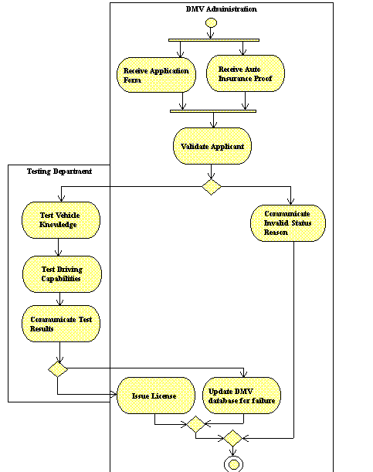Figure 12-2 Activity Diagram

Lesson 13 Use Case Diagramming

OVERVIEW
A Use Case diagram is a representation of a set of activities that are performed to satisfy user goals. It is based on the premise that a user interacts with a business system to obtain benefits and satisfaction.

A Use Case diagram defines a set of transactions and the flow of events that occur from the time the user first starts using the system until the user‘s goals are satisfied. The Use Case diagram includes ‗actors‘ representing the typical kinds of users that will interact with the system. The actors then communicate with ‗Use Cases‘, representing the activities that are needed to satisfy the user goals.

The Use Case diagram focuses on ‗what‘ a business process must do as opposed to ‗how‘ a business process is implemented.

DEFINITIONS
A Use Case diagram includes the following components:

System Boundary A system boundary is a rectangular box representing the business processes supported by an information system.

Use Case A Use Case is an elliptical shape representing an activity included in an information system.

Actor. An actor is a stick person shape representing a role or a set of roles that a user plays.

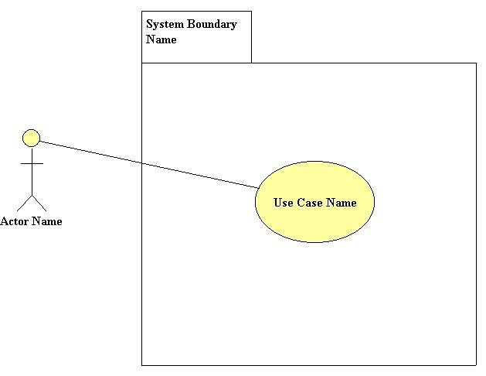Figure 13- 1 Basic Use Case Components

The following general rules apply to the Use Case components:
- A Use Case symbol is positioned inside the system boundary.
- A Use Case diagram may include one or more Use Cases.
- An actor is positioned outside the system boundary.
- A Use Case diagram may include one or more actors.
- An actor communicates with one or more Use Cases.

RELATIONSHIPS
A relationship is represented as by a line from one object to another. The following relationships may be shown in a Use Case diagram:

- Communicates. The communicates relationship is represented by a solid line with no arrow, and is drawn between an actor and a Use Case.
- Includes. The includes relationship signifies that a Use Case contains behavior that is common to more than one Use Case. Thus the common Use Case is ‗included‘ in the other Use Cases. The includes relationship is represented with a dashed line with an arrow. An includes relationship may exist between Use Cases, but not between actors. The arrow points to the common or shared Use Case.
- Extends. The extends relationship signifies that one Use Case possesses behavior that enables the other (extended) Use Case to handle an exception, or a variation from the usual. The extends relationship is represented with a dashed line with an arrow to the basic Use Case. The extends relationship may only exist between Use Cases (not between actors). When specifying an extends relationship, you may also specify one or more extension points. An extension point represents additional information that needs to be gathered in order to complete the transaction.
- Generalize. The generalize relationship signifies that one thing is more usual or typical than the other thing. A generalize relationship may exist between two Use Cases, as well as between two actors. It is represented with a dashed line with an arrow. The arrow points to the Use Case (or actor) that generalize the other Use Case (or actor).

Examples of Relationships
The following is a discussion of the relationships presented in Figure 13-2.
- Actor Communicates with Use Case
An example is an actor ‗communicates‘ with a Use Case. This is the most common relationship found on Use Case diagrams.
- Use Case ‘Authorize Transaction’ included in Use Case
The Use Case ‗Deposit Cash‘ and ‗Pay Bill‘ include the common Use Case ‗Authorize Transaction‘.
- Actor ‘Regular Customer’ Generalizes Actor ‘VIP Customer’
An example is an actor having a set of roles that ‗generalize‘ another actor‘s roles. For example, a ‗regular customer‘ is a generalization of a ‗VIP Customer‘.
- Use Case ‘Arrange Financing’ Extends Use Case ‘Sell Automobile’
The extended Use Case provides additional steps concerning the setup of the loan. The basic Use Case ‗Sell Automobile‘ involves a cash sale.

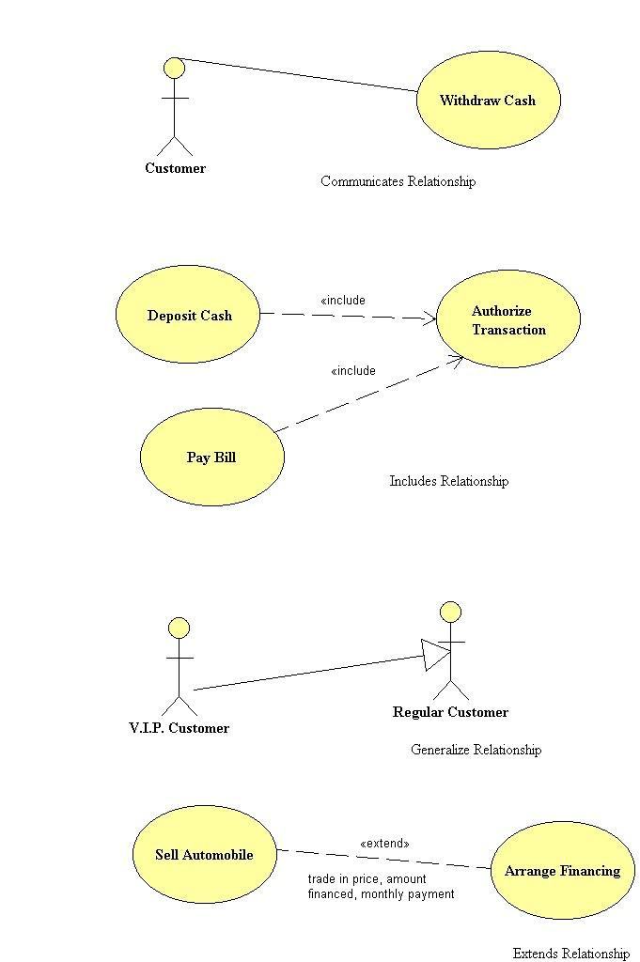Figure 13-2 Use Case Relationships

DESCRIBING USE CASE ACTIVITIES
Visible Analyst provides the following basic attributes for describing a Use Case activity:

- Name. The name of the Use Case that appears on the diagram.
- Description. A brief description of the Use Case object.
- Alias. An alternate name for the Use Case. Up to ten aliases are permitted.
- Scenario. A complete description of the business scenario, up to 64,000 characters.
- Notes. Optional comments concerning the Use Case, up to 64,000 characters.

DEVELOPING YOUR USE CASE DIAGRAM
The business analyst creates one or more Use Case diagrams to fully explore the following questions:

Who will be the users of a business system?
Classify the kinds of users by defining an actor for each distinct role played by the users.

What goals does the system satisfy?
Consider the benefit or added value that the actor is seeking

What Use Cases are needed?
Consider the flow of events that will occur when a typical user who comes prepared with complete and accurate information and any prerequisites such as having enough cash or credentials. Make sure the Use Cases will satisfy the base case scenario. Then consider what activities are needed to handle the exceptions.

Ultimately, after exploring the above questions, you have one or more Use Case diagrams to create using Visible Analyst. Use the following procedures to create a Use Case diagram.

BUSINESS SCENARIO
The following is a business scenario that will be rendered using Use Cases.

An applicant visits a Department of Motor Vehicle‘s driver testing facility, and provides the registrar with a personal details including name, address, and telephone number, as well as proof of automobile insurance and a learner‘s permit. The registrar schedules a driver road
test and written examination with a certified driver examiner. After passing the theoretical and practical tests the applicant is issued a driver’s license.

There are two actors in this scenario: the registrar and the driver examiner.

  - The registrar interacts with the system by registering applicants, by setting up appointments for driver tests, and by issuing drivers licences to successful applicants.
  - The driver examiners interact with the system by scheduling their availability, and by conducting driver tests.

The objective is to create a Use Case diagram that includes the following Use Cases:
  - Register Applicant
  - Schedule Driver Test
  - Conduct Driver Tests
  - Issue Licence

Adding System Boundaries, Actors, and Use Cases
The following procedure enables the analyst to create a Use Case diagram and add system boundaries, actors and Use Cases.

Set the Zoom Level: | 1 | From the View menu, select 66% zoom so you can see all the needed workspace.
Create a New Diagram: | 2 | From the File menu select New Diagram.
 | 3 | Select the diagram type Use Case Diagram.
 | 4 | Select Standard Workspace
 | 5 | Click OK.
Add System Boundary: | 6 | Click on the third symbol button, the rectangle, on the control bar. This is a system boundary.
 | 7 | Label this system boundary ―Driver Registration System‖.
 | 8 | Select the system boundary to highlight the system boundary, and its sizing handles. Then adjust the size and position of the system boundary so there is enough room to the left of the boundary to place actors, and enough room inside the boundary to place Use Cases.
Add Actors: | 9 | Click on the first symbol button, the actor, on the control bar. Place the symbol on the diagram.
 | 10 | Label this actor ―Registrar‖.

 | 11 | Add the rest of the actors as shown in Figure 13-3.
Add Use Cases: | 12 | Click on the third symbol button, the Use Case, on the control bar. Place the symbol on the diagram.
 | 13 | Label the Use Case ―Register Applicant‖.
 | 14 | Add the rest of the Use Cases as shown in Figure 13-3.
Save the Diagram | 15 | Save the Use Case diagram with the label Introductory Use Case.

Adding Relationships
The following procedure enables the analyst to add relationships to a Use Case diagram.

Adding a Communicates Relationship between an Actor and Use Case: | 1 | Select the first relationship button, the solid line Communicates. Begin the line on the actor ―registrar‖ and end the line on the Use Case ―Register Applicant‖.
Adding an Includes Relationship between Use Cases: | 2 | Select the second relationship button, the dotted arrow Includes. Begin the line on the Use Case ―Register Applicant‖ and end the line on the Use Case ―Collect Payment‖.
 | 3 | Add the rest of the relationships as shown in Figure 13-3.
Save the Diagram: | 4 | Save the Use Case diagram.

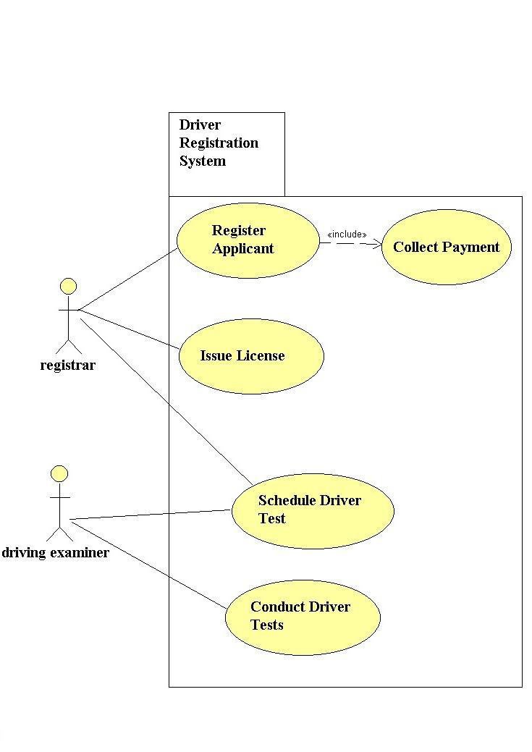Figure 13-3 Introductory Use Case Diagram

Lesson 14 Sequence Diagramming

OVERVIEW
A sequence diagram is a type of interaction diagram. Interaction diagrams describe how groups of objects interact and collaborate in performing a behavior. There are two types of interaction diagrams that basically model the same information: sequence diagrams and collaboration diagrams. In a sequence diagram, the interaction is modeled in time sequence. Generally, an interaction diagram captures the behavior of a single use case. The sequence diagram shows several objects participating in the interaction and the messages that are passed among these objects. The diagram shows the objects by their ''lifelines'' and the messages that they exchange arranged in time sequence. It does not show the associations among the objects. The associations can be obtained from the complementary collaboration diagram.

A sequence diagram has two dimensions: the vertical dimension represents time and the horizontal dimension represents different objects. Normally time proceeds down the page. (The dimensions may be reversed if desired.) Usually only time sequences are important; but in real-time applications, the time axis could be an actual metric. There is no significance to the horizontal ordering of the objects. Often call arrows are arranged to proceed in one direction across the page; but this is not always possible, and the ordering does not convey information.

DEFINITIONS
The components of the sequence diagramming process include:

Object An object is defined as an instance of a class. It is drawn as a rectangle with the name of the object and class name inside the rectangle.

Class A class is a group of objects with the same data structure (attributes) and behavior (operations). A class is an abstraction that describes properties that are important to an application.

Lifeline The lifeline represents an object‘s life and existence during the time period of the interaction. A dashed vertical line is the symbol of a lifeline. An object symbol is drawn at the top of the lifeline.

Activation An activation shows the time period during which an object is
performing an action. It represents both the duration of the action in time and the control relationship between the activation and its callers. An activation is shown as a tall thin rectangle whose top is aligned with its initiation time and whose bottom is aligned with its completion time. Activation symbols are drawn on the top of an object‘s lifeline.

Message A message is a communication from one object to another, usually communicating an order to perform an action. A message is represented by a horizontal solid arrow from the lifeline of one object to the lifeline of another object. The time order in which these messages occur is shown top to bottom on the page. Each message can be labeled with a message name, conditions, return arguments, etc.

Self Call This is a message that an object sends to itself. It is represented by a message arrow originating at the object lifeline and looping around to end at the same lifeline.

Object Deletion Objects that are deleted by a message or self-destruct during the time period of the interaction have a large X drawn at the bottom of their lifeline.

Return A return is a message that is not a new message, but rather a return message from an object to which a new message was previously sent. It is labeled with a dashed line rather than a full line.

Condition Some messages are sent only when a certain condition is true. In this case, you can label the message with the controlling condition.

Asynchronous Message An asynchronous message is one that does not stop the caller object from continuing processing.

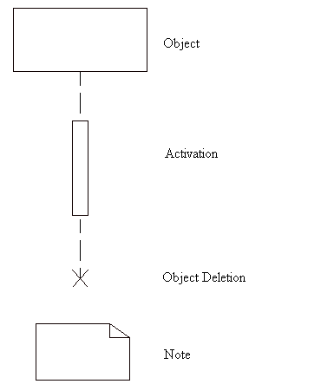Figure 14-1 Sequence Diagram Symbols

DEVELOPING YOUR SEQUENCE DIAGRAM
The sequence diagram primarily is composed of a group of objects and the messages that are passed between them.

Adding Objects
Objects are the basic building blocks of the sequence diagram. The objects are usually placed horizontally across the page in no particular order, while the vertical axis denotes time sequence. Objects used on the sequence diagram may already exist in the repository, or they may be new objects created during the time period of the interaction.

Each object will have a dashed vertical line under it, representing its lifetime. If the object is created or destroyed during the period of time shown on the diagram, its lifeline starts or stops at the appropriate point. Otherwise, it goes from the top to the bottom of the diagram.

Set the Zoom Level: | 1 | From the View menu, select 66% zoom so that you can see all of the needed workspace.
Create a New Diagram: | 2 | From the File menu, select New Diagram.
 | 3 | Select the diagram type Sequence.
 | 4 | Select Standard Workspace.
 | 5 | Click OK.
Add Object: | 6 | Click the first symbol button, the rectangle, on the control bar. This is the object symbol.
 | 7 | Place the cursor in the top left of the workspace and left-click the mouse. The object is drawn and you are prompted for an object name and class name. Leave the object name field blank. Type ―Application Entry Window‖ as the class name. Click OK.
 | 8 | You are prompted to create a new class if it doesn‘t already exist. Click the Yes button.
 | 9 | Add the rest of the objects as shown in the Figure 16-2.
Save the Diagram: | 10 | Save the sequence diagram with the label  ―DMV Sequence Diagram‖.

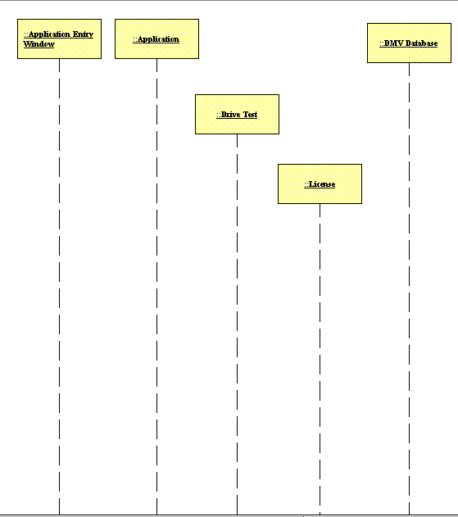Figure 14-2 Sequence Diagram with Objects

Adding Activation Symbols
An activation represents the time period during which an object is performing an action. It represents both the duration of the action in time and the control relationship between the activation and its callers. An activation is shown as a tall thin rectangle whose top is aligned with its initiation time and whose bottom is aligned with its completion time. The incoming message may indicate the action. In procedural flow of control, the top of the activation

symbol is at the tip of an incoming message (the one that initiates the action) and the base of the symbol is at the end of a return message.

In the case of a recursive call to an object with an existing activation, the second activation symbol is drawn slightly to the right of the first one so that they appear to ''stack up'' visually. Before drawing the second activation symbol, lengthen the size of the original activation symbol by grabbing the symbol handles when the object is highlighted. After drawing the second activation symbol on top of the first symbol, increase the width of the second symbol so that it visually ―stacks up‖ over the first symbol.

Add Activation Symbol: | 1 | Click the second symbol button, the narrow vertical bar, on the control bar. This is the activation symbol.
 | 2 | Place the cursor on the ―Application Entry Window‖ object‘s lifeline, and click the left mouse button. An activation symbol is drawn on top of the object‘s lifeline.
 | 3 | Add the other activation bars as shown in the Figure 16-3. You can size the length of the activation symbols by clicking on the rectangle and dragging the edges.
Save the Diagram: | 4 | Save the sequence diagram.

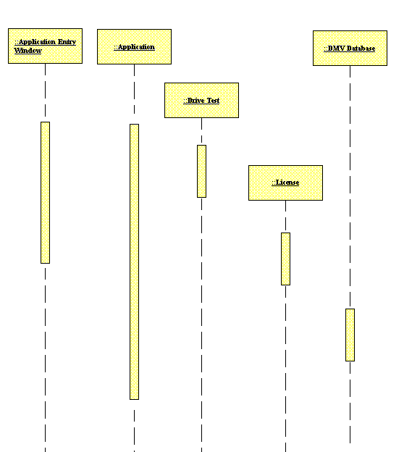Figure 14-3 Sequence Diagram with Activation Symbols Added

Adding Object Deletion
Objects can be deleted during an interaction during the time represented on a sequence diagram. Objects that are deleted by a message or that self-destruct during the time period of the interaction have a large X drawn at the bottom of their lifeline. In our example, the object Application is created when a new application is received and is deleted after the application has been processed.

Add Object Deletion: | 1 | Click the third symbol button, the X, on the control bar. This is the object deletion symbol.
 | 2 | Place the cursor under the ―Application‖ object lifeline and click the left mouse button. An object deletion symbol is drawn. Add the other object deletion symbols as shown in Figure 16-4.
Save the Diagram: | 3 | Save the sequence diagram.

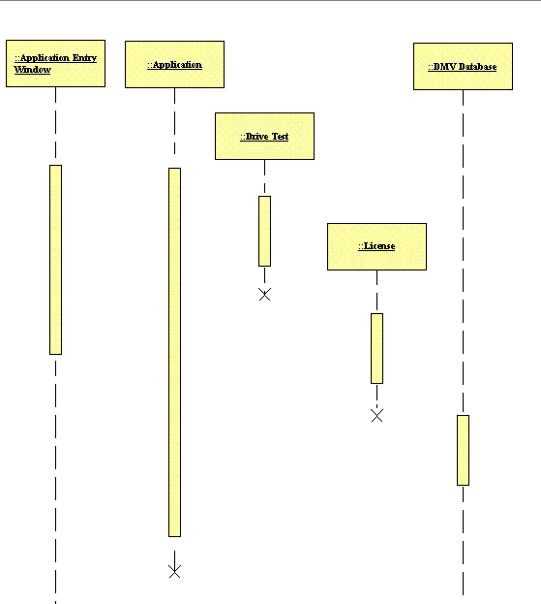Figure 14-4 Sequence Diagram with Object Deletion Symbols Added

Adding Procedure Calls to the Diagram
Messages that are procedure calls can be passed from one object to another. It is basically a command for the receiving object to perform a certain action. When adding any message, there are certain pieces of information you are required to enter:

- Name. Name of the message.

  - Type. A message can be of three types: procedure call, flat flow of control, or asynchronous stimulus.
  - Occurs Many Times. This is a flag that indicates whether a message is sent many times to multiple receiver objects.
  - Guard Condition. If the message is to be sent only if a condition is met, this field will contain that condition.

In our example, the object Application Entry Window submits an application to the object DMV Validation when a new application is accepted. This is an example of an unconditional procedure call. The Application object sends a message to the object License to create a new license. However, this message is sent only if the applicant passes the driving test. This is an example of a conditional procedure call.

Add Procedure Call: | 1 | Click the first arrow button, the bold full arrow on the control bar. This is the procedure call arrow.
 | 2 | Place the cursor on the activation bar under the ―Application Entry Window‖ object and click the left mouse button. Holding the left mouse button down, drag the cursor to the activation bar under the ―‖Application‖ object and release the left mouse button. The Label Message dialog box appears.
 | 3 | The Label Message dialog box appears. Click New Method and type ―New‖ for the name of the method. Click OK to return to the Label Message window. Click OK again to exit this window.
Add Procedure Call with Condition: | 4 | Place the cursor on the activation bar under the ―Application‖ object and click the left mouse button. Holding the left mouse button down, drag the cursor to the activation bar under the ―DMV Database‖ object and release the left mouse button.
 | 5 | The Label Message dialog box appears. Click New Method and type ―Update Success‖ as the method name. Click OK to return to the Label Message dialog box. Type ―passed‖ in the guard condition field and click OK.

 | 6 | Add the rest of the procedure calls as shown
Save the Diagram: | 7 | in Figure 14-5.  Save the sequence diagram.

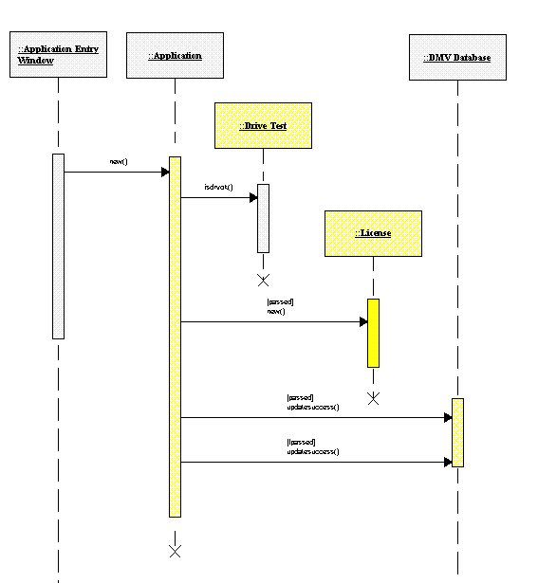Figure 14-5 Sequence Diagram with Procedure Calls Added

Adding Return to the Diagram
An object can send a message in response to a message sent to it earlier. In our example, the application object returns the message sent to it by the application entry window object.

Add Return: | 1 | Click the fourth arrow button, the dashed arrow, on the control bar. This is the return symbol.
 | 2 | Place the cursor on the activation bar under the ―Drive Test‖ object and click the left mouse button. Drag the cursor to the activation bar under the ―Application‖ and release the mouse button. A return arrow is drawn.
Save the Diagram: | 3 | Save the sequence diagram.

Adding Text Notes to the Diagram

Add Note: | 1 | Click the rightmost button on the toolbar, an uppercase T. This is the Add Text button.
 | 2 | Place the cursor under the procedure call isdrvok() and click the left mouse button. The Add Text window appears. Type  ―passed = isdrvok()‖ and click OK. The note is added to the diagram.
Save the Diagram: | 3 | Save the sequence diagram.

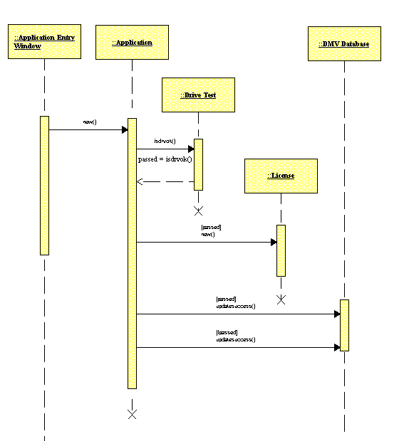Figure 14-6 Completed Sequence Diagram

Lesson 15 Collaboration Diagramming

OVERVIEW
UML includes specifications for two forms of interaction diagrams: sequence diagrams and collaboration diagrams. Both diagrams present the objects participating in a business scenario and show the messages sent and received.

The sequence diagram uses ‗lifelines,‘ parallel bars drawn below the objects, so that the sequence of messages sent and received can be understood by looking at the diagram from top to bottom. On the other hand, in a collaboration diagram the objects are arranged so that the basic relationships are highlighted; and sequence numbers are used to order the messages sent and received.

A collaboration diagram consists of a set of objects that together carry out a scenario, the links between the objects, and details concerning the messages sent and received. A collaboration diagram can be drawn at the class level or at the instance level.
- At the class level, it shows the associations or relationships between the different classes.
- At the instance level, it shows the links or messages that are passed between the instances.

DEFINITIONS
The important diagram constructs in collaboration diagrams include:

Object An object appears in as a plain rectangle with an underlined title. It represents an entity with a well-defined boundary and identity that encapsulates state and behavior. A collaboration diagram may be populated with objects representing different classes, as well as objects representing specific instances in a class.

Note A note appears as a rectangle with the top right corner folded over.
A note is used to record descriptive text that appears on the diagram.

Object Link An object link appears as a solid line connecting two objects and represents the fact that there is a relationship between the two objects. Visible Analyst automatically adds an object link (as part of the task) when a message is drawn between two objects.

Procedure Call A procedure call is a message between two objects, appearing as a filled solid arrow. The target object (at the arrowhead end) must complete its task before the calling process can continue.

Flat Flow of Control Flat flow of control is a message between two objects, appearing as a stick arrowhead and signifying the passing of control from the originating object to the target object.

Asynchronous Stimulus Asynchronous stimulus is a message between two objects,
appearing as a half-stick arrowhead, and used instead of a stick arrowhead to show an asynchronous communication between two objects in a procedural sequence.

Return A return is a message between two objects, appearing as a dashed arrow with a stick arrowhead, and represents a return from a procedure call.

Self-Delegation Self-delegation is a message from an object to itself, appearing as a recursive arrow.

Note Link A note link appears as a dotted line connecting an object with a note.

DEVELOPING YOUR COLLABORATION DIAGRAM

Describing Scenarios using a Collaboration Diagram
The business analyst creates a collaboration diagram to explore the following questions:
  - What objects are included in the scenario?
  - What messages are sent and received?
  - What is the sequence of the messages?

The objects that are included in a scenario are typically part of the enterprise model. For example, an object introduced to the repository using the class diagram can certainly be reused in a collaboration diagram. See Lesson 10, The Class Diagrams.

Object Instances Versus Object Classes
The objects appearing in a collaboration diagram may represent object instances or object classes. The way in which an object is identified determines if the object is an instance or a class. When the name is specified, it means this object represents a particular object instance. For example ‗John Smith:: Applicant‘ represents the fact that ‗John Smith‘ is a member of the
‗Applicant‘ class. If no object name is specified, the object represents the class.

Note the object class must always be specified. The object identifier is separated into two parts using a double colon (::); the first part specifies the name, the second part the class.

Object Methods
The messages sent to and from an object must ‗fit‘ the object, or correspond with its methods. Only methods from the derivation tree of the target (the one receiving the message) object's class can be used. All available methods are displayed in the drop-down list. If you want to create a new method, click the New Method button.

If the method has arguments, you can specify values for the arguments by clicking the Values button. By default the name and type for the method are displayed. If you want to change the argument list of the method, click the Change Arguments button.

 Note The degree to which you can change method or message attributes depends on your rights to the target object's class and the interaction diagram settings.

Object Links
A Label Message dialog box appears when an object link is drawn between two objects. You must then supply details concerning the messages. If you are not ready to define these details (or wish to define them a later), you can delete the message icons, and retain the object link as a solid line.

Messages
Messages are added to the collaboration diagram to describe the way in which the objects will work together.

The following information is maintained for each message:
- To and From. The name of the target object and source object. This can be switched by clicking the reverse button.
- Type. The type of message, either asynchronous stimulus, flat flow of control, or procedure call.
- Occurs Multiple Times. Indicates the message will be called more than once. If this option is selected, an asterisk will appear next to the message name on the diagram.

  - Guard Condition. Specify the guard condition that controls the firing of the message. This is a free-form text field. A guard condition is a logical expression that evaluates to TRUE or FALSE, and must be satisfied before the message can be sent.
  - Sequence Number. Indicates the order of messages. This can be either a single numeric value such as 1, 2, or 3, or a decimal such has 1.2, or 1.1.4. This option is only available on collaboration diagrams, since sequence diagrams by their very nature indicate message ordering.

DEPARTMENT OF MOTOR VEHICLES SCENARIO
The collaboration diagram example is based on the following scenario:
  - The registrar logs onto the system and selects the driver registration window.
  - By selecting the option New Applicant, an Applicant object appears. Details concerning the applicant‘s name, address, and phone number are recorded.
  - The registrar verifies that the applicant possesses an insurance certificate, and if yes, records the coverage limits. The registrar also verifies that the applicant has a learner‘s permit. Once these checks are made the applicant is considered ‗Valid‘ and is ready for the road test.
  - If the applicant passes the road test, a driver‘s license is issued. A completed collaboration diagram is shown in Figure 15-1.

Adding Objects to a View
The basic building block of the collaboration diagram is the ‗object‘. The following steps are taken to establish a new collaboration diagram and create the objects.

192
Set the Zoom Level: | 1 | From the View menu, select 66% zoom so you can see all of the needed workspace.
Create a New Diagram: | 2 | From the File menu select New Diagram.
 | 3 | Select the diagram type Collaboration Diagram.
 | 4 | Select Standard Workspace and Portrait Orientation.
 | 5 | Click OK.
Add Objects: | 6 | Click on the first symbol button, the rectangle, on the control bar. This represents an object.
 | 7 | Place the cursor inside the diagram workspace and click the left mouse button.

 | 8 | Label the object, leaving the name field blank, and the class field ―Applicant‖.
 | 9 | Add the rest of the objects as shown in Figure 15-1.
Save the Diagram: | 10 | Save the Collaboration Diagram, and give it the name ‗Driver Registration‘.

Adding Relationships to a Collaboration Model
The relationships in a collaboration diagram appear as object links. Messages to and from the objects are added to the object links.

This procedure was written with Auto Label Lines turned on; thus message details must be added when an object link is drawn.

Add Object Links: | 1 | Select the object link from the control bar and make a connection from ‗Driver Registration Window‘ to  ‗Applicant‘.
Add Message to the Object Link: | 2 | Select the method that is associated with the target object; or if no method exists, add a method. Add the method ―new‖.
 | 3 | Select the message type ‗Flat Flow of Control‘.
 | 4 | Leave the guard condition blank.
 | 5 | Enter the sequence number ‗1.1‘.
 | 6 | Continue adding messages until the model is complete, as shown in Figure 15-1.
Save: | 7 | Select Save from the File menu.

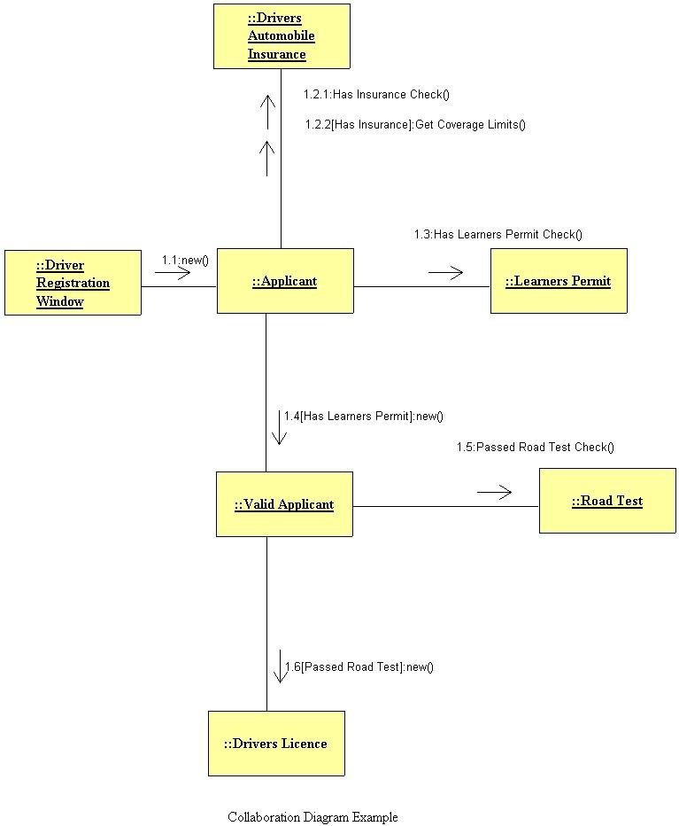Figure 15-1 Collaboration Diagram Example

Lesson 16 Business Process Diagramming with BPMN

OVERVIEW
Visible Analyst provides support for Business Process Modeling Notation (BPMN) diagrams based on the Business Process Modeling Initiative developed by the Object Management Group (OMG). The complete specification is available for download from the OMG website, www.omg.org.

The primary goal of BPMN is to provide a modeling notation is an effective communication medium across all the constituencies in computing technology supported organizations.
BPMN is specifically designed to communicate process behavior information in a manner easily understood by business end users while providing supporting technology organizations with sufficient information about process execution, flow and dependencies to understand the workings of the business processes being modeled. BPMN notation is designed therefore to support the needs of not only business end users but also the business analysts who develop models and technical analysts who implement the model processes.

Future releases of the Visible Analyst Workbench are planned that will use defined BPMN models to generate execution languages such as BPEL4WS (Business Process Execution Language for Web Services).

BPMN models describe business process behavior and as a result use an event based paradigm. Both parallel and conditional behavior is supported in the modeling notation and also in the Visible Analyst‘s implementation of BPMN. A number of symbols are used to describe process flows, events and decisions and allow the viewer to easily differentiate between sections of the BPMN diagram.

BPMN MODEL TYPES
There are three types of sub-models that may be used within an end-to-end BPMN model: Functional Private (internal) business processes - Private business processes internal to an organization, such as the Sales Department. If swimlanes (described below) are used, then a private business process will be contained within a single pool, with all Sequence Flows contained within the Pool and no Message Flows crossing the boundaries of the Pool.

Abstract (public) processes - These processes represent the interactions between a private business process and another process or participant. Only those activities that are used to communicate outside the private business process, plus the appropriate flow control mechanisms are included in the abstract process. The ―internal‖ activities of the private business process are not shown in the abstract process. Thus, the abstract process shows to the outside world the sequence of messages that are required to interact with that business process. An example of this would be the interaction between the Customer and the company‘s Sales Department.

Collaboration (global) processes - A collaboration process depicts the interactions between two or more business entities, and is defined as a sequence of activities that represent the message exchange patterns between the entities involved. A collaboration process can be shown as two or more abstract processes communicating with each other. The interaction of the company‘s Accounting Department and Sales Department and the processes performed by both to complete the sales cycle is an example of a collaboration process.

DEFINITIONS
BPMN diagrams are drawn using four basic categories of objects: Flow Objects, Connecting Objects, Pools/Swimlanes, and Artifacts

Flow Objects
Flow Objects are the main graphical elements of the diagram and consist of Event, Activity (process) and Gateway symbols.

Event An event is something that occurs during the course of a business process which affects the flow of the process.. There are three types of events: Start Events, Intermediate Events and End Events. Each Event type has a ―trigger‖, i.e., a determination for the cause of the event. Each event trigger has a unique appearance to indicate the trigger type, as shown in Figure 16-2.

Activity An activity (process) is a generic term that represents the work that a company or organization performs. Activities can be atomic or non-atomic (compound) and are represented as a rounded rectangle. Activity types include Process, Sub-Process (which can be defined as a Transaction), and Task.

Atomic Task Activity

Figure 16-1 Activity

Start Event Intermediate Event End
Event

Message

Timer

Error

Cancel

Compensation

Rule

Link

Multiple

Terminate

Figure 16-2 Event Types

Gateway A Gateway is used to control the divergence and convergence of multiple Sequence Flows. It will determine branching, forking, merging, and joining of paths.

The Gateway, sometimes called a ―fork in the road‖, is used to indicate Decisions, where the Sequence Flow can take two or more alternative paths. For a given performance (or instance) only one of the paths can be taken. A Decision is not an activity from the

business perspective, but is a type of Gateway that controls the Sequence Flow between activities. It can be thought of as a question that is asked at that point in the process, and the question has a defined set of alternative answers (Gates). Each Decision Gate is associated with a condition expression found within an outgoing Sequence Flow. The conditions are evaluated in a specific order and first condition that evaluates to ―True‖ determines the Sequence Flow that will be taken. One of the Gates may be marked as ―default‖, and is the last Gate considered.
Choosing a particular Gate chooses the corresponding Sequence Flow.

Exclusive Gateway (XOR) An Exclusive Decision (Gateway XOR) has two or more outgoing sequences, but only one of them may be taken. The conditions are evaluated in a specific order and first condition that evaluates to
―True‖ determines the Sequence Flow that will be taken. One of the Gates may be marked as ―default‖, and is the last Gate considered. Exclusive Gateways can be used as a merge, for alternative Sequence Flow, though rarely used in this way. There are two types of Exclusive Decisions: Data-Based and Event- Based.

Inclusive Gateway (OR) The Inclusive Gateway OR can be used to model Inclusive
Decisions or it can be used as a Merge. An Inclusive Decision Gateway symbol has a Bolded circle within the diamond Gateway symbol.

When used to model Inclusive Decisions, each of the Sequence Flows (at least two) would be attached to the Gates of the Gateway. The Condition Type of the Sequence Flow is set to Expression, and the modeler would add the expression to be evaluated in the Condition Expression field of the flow. A default Sequence Flow may be used.

When the Inclusive Gateway is used as a Merge, it will wait for (synchronize) all Tokens that have been produced upstream. It does not require that all incoming Sequence flow produce a Token, (as the Parallel Gateway does). It requires that all Sequence Flow that were actually produced by an upstream (by an Inclusive OR situation, for example). If an upstream Inclusive OR produces two out of a possible three Tokens, then the downstream Inclusive OR will synchronize those two Tokens and not wait for another Token, even though there are three incoming Sequence flows.

Complex Gateway Complex Gateways are included to handle situations that are not easily handled through the other types of Gateways. Complex Gateways can also be used to combine a set of linked simple Gateways into a single, more compact situation. Modelers can provide complex expressions that determine the merging/splitting behavior of the Gateway. The symbol for a Complex Gateway contains the asterisk symbol within the Gateway diamond symbol.

When the Gateway is used as a Decision, then the expression determines which of the outgoing Sequence Flow will be chosen for the Process to continue. The expression may refer to process data and the status of the incoming Sequence Flow. For example, the expression may evaluate the Process data and then select different sets of outgoing Sequence Flow, based on the results of the evaluation. The expression should be designed so that at least one of the outgoing Sequence Flows will be chosen.

When the Gateway is used as a Merge, then there will be an expression that will determine which of the incoming Sequence Flow will be chosen for the Process to continue. The expression may refer to process data and the status of the incoming Sequence Flow. For example, the expression may specify that any 3 out of 5 incoming Tokens will continue the Process. Another example would be an expression that specifies that a Token is required from Sequence Flow ―a‖, and that a Token from either Sequence Flow
―b‖ or ―c‖ is acceptable. The expression should be designed so that the Process is not stalled at that location.

.

Gateway Control Types | Appearance
Data-Based Exclusive Decision (XOR)
Event-Based
Exclusive Decision (XOR)
Inclusive Decision / Merge (OR)
Complex Decision / Merge
Parallel Fork / Join (AND)

Figure 16-3 Gateway Types

Connecting Objects
Flow Objects are connected on the diagram using Sequence Flows, Message Flows and Associations.

Sequence Flow A Sequence Flow is a solid graphical line that is used to show the order that the activities will be performed in a Process. Each flow has only one source and one target.

Normal Sequence Flow

Figure 16-4 Sequence Flow

Additional sequence flow sub-types may represent certain conditions, such as a Conditional flow, Default flow, Exceptions flow etc.

Conditional Flow A Sequence Flow can have condition expressions that are
evaluated at runtime to determine whether or not the flow will be

used. If the conditional flow is outgoing from an activity, then the sequence flow will have a mini-diamond at the beginning of the line.

Conditional Flow

Figure 16-5 Conditional Flow

Default Flow For Data-Based Exclusive Decisions or Inclusive Decisions, one type of flow is the Default condition flow. This flow will be used only if all of the other outgoing condition flows are not true at runtime. The Default Sequence Flow will have a diagonal slash at the beginning of the line.

Default Flow

Figure 16-6 Default Flow

Exception Flow An Exceptions Flow occurs outside the Normal Flow of the
Process and it is based upon an Intermediate Event that occurs during the performance of the Process. The Exception Flow begins at the Error Intermediate or End Event attached to the boundary of the activity, signifying an interruption in the activity.

Exception Flow

Figure 16-7 Exception Flow

Compensation Flow A Compensation Flow defines the set of activities that are
performed during the rollback of a transaction to compensate for the activities that were performed during the normal flow of the process. Compensation can also be called from a Compensate End or Intermediate Event

Compensation Association

Figure 16-8 Compensation Flow

Message Flow A Message Flow is drawn using a dashed line with a small circle at the beginning of the line. This line type is used to show the flow of messages between two entities that are prepared to send and receive them. In BPMN, two separate Pools on the diagram will represent the two entities

Message Flow

Figure 16-9 Message Flow

Association An Association Flow is used to connect one or more Data Objects (Artifacts) to an activity, and to show that the Data Object is either an input or output to the Activity.

Association Line

Figure 16-10 Association

Pools and Lanes
BPMN models utilize two important conceptual modeling devices to distinguish process flow characteristics, pools and lanes.

Pool A Pool (defined as a System Boundary entry type in the repository) represents a participant in a process, and it also acts as a "swimlane" and graphical container for portioning a set of activities from other pools.

When a Pool is added to a diagram, only the name of the Pool is displayed. The swimlane labels will be displayed once a BPMN item is moved within the pool boundary. If the orientation of the Pool symbol is vertical, the name of the Pool and lanes are displayed at the top of the Pool, otherwise the labels are drawn on the left-hand side of the pool. Pools whose width is greater than their height are vertical. To change the orientation of the Pool, highlight the pool symbol, select one of the ―handles‖ (the green boxes surrounding the Pool symbol) a drag the handle to a new location on the diagram, expanding the Pool symbol. You can also right mouse click on the Pool symbol and choose the Stylize option to modify the size and orientation of the Pool.

The Attributes field on the Define Item tab in the repository will display the items contained within the Pool and its lanes.

Lane A Lane is a sub-partition within a Pool and will extend the entire length of the Pool, either horizontally or vertically. Lanes are used to categorize the activities in the Pool. If there is only one lane, then the lane shares the name of the Pool. While BPMN does not specify the usage of the Lanes, they are often used to identify internal roles (Manager, Associate), systems (enterprise application) and internal departments (shipping, finance sales). See Figure 16-11.

Up to 4 Lane names can be assigned for each Pool.

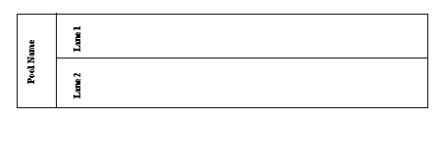Figure 16-11 Pool and Lanes

Artifacts
Artifacts are used to provide additional information about the Process, and are represented by a Data Object, a Group, and an Annotation.

Data Object A Data Object is represented by a square symbol with the top right corner of the symbol turned down. Artifacts are used to provide information about the process or elements defined or produced within the process, but do not affect the process. Data Objects are connected to other BPMN symbols by an Association Flow.

Data Object

Figure 16-12 Data Object

Group A Group is a visual representation around a number of activities. Groups are represented in the Visible Analyst through the use of symbol coloring, or the user can draw a flow around the diagram objects to represent a group.

Annotation An Annotation (referred to and implemented as a Note symbol in the Visible Analyst) is a Text Annotation, used as a mechanism for the modeler to provide additional information for the reader of a BPMN diagram. A Note object (and a Note Link) in the Visible Analyst does not maintain a repository entry; all information is written on the diagram as the Note label. Notes are connected to a specific object on the diagram with a Note Link line, but neither the Note nor the Note Link line affect the flow of the Process.

Note Symbol

Figure 16-12 Data Object

BUSINESS PROCESS DIAGRAM ATTRIBUTES
A number of attributes are associated with BPMN Diagrams. Some of these attributes include, Diagram Id, Name, Version, Author, Language (for code generation), Creation Date, Modification Date, etc. Use the Boilerplate and Boilerplate Keywords feature in the Visible Analyst to display these attributes on a BPMN diagram. See Boilerplates and Boilerplate Keywords.

Note
 Boilerplates and Boilerplate keywords are not available in the Educational version of Visible Analyst.

DEVELOPING BPMN DIAGRAMS
As described by the OMG group (www.omg.org.) in their Business Process Modeling Notation specification, there are three basic BPMN models:

    - Private (internal) business processes
    - Abstract (public) processes
    - Collaboration (global) processes.

Each of these types may contain Pools and Lanes, but are optional based on the process type being modeled. In this tutorial you will create a Collaboration process describing the Road Test processes to demonstrate the many features of BPMN diagramming. The Participants will be the DMV Evaluator and the License Applicant.

Designate the Starting Event
The event type will be a Timer event, indicating the scheduled appointment time for the Road Test. The Road Test will be the Business Process modeled by the BPMN diagram.

Set the Zoom Level: | 1 | From the View menu, select 66% zoom so that you can see all of the needed workspace.
Create a New Diagram: | 2 | From the File menu, select New Diagram.
 | 3 | Select the diagram type Business Process Model.
 | 4 | Select Standard Workspace and Landscape as the Orientation.
 | 5 | Click OK.
Add a Start Event: | 6 | Click the fifth symbol button, the open circle, on the control bar. This is the Start event.
 | 7 | Place the cursor in the upper left corner of the workspace, and click the left mouse button. The starting event is drawn on the diagram.
Name the Event: | 8 | Label the event ―Scheduled Driver Test‖.
Select the Event type: |  | Select ―Timer‖ in the Trigger field and click OK.
Save the Diagram: |  | Save the BPMN diagram with the label  ―Driver Test BPMN Diagram‖.

Add a Process Symbol to the Diagram
A Process is an activity performed within a company or organization. The Process symbol is a rounded rectangle, the first symbol in the symbol bar.

Add a Process symbol: | 1 | Click the first symbol button, the rounded rectangle, on the control bar.
 | 2 | Place the cursor to the right of the start event and click the left mouse button. A process symbol is drawn.
Label the Process: | 3 | Label the process ―Validate Applicant‖.
Add other Processes: | 4 | Add the other processes ―Perform Road Test‖ and ―Issue License‖ to the right of Validate Applicant as shown in Figure 16-13.
Save the Diagram: | 5 | Save the BPMN diagram.

Scheduled Driver Test Validate Applicant PerformRoad Test Issue License

Figure 16-13 Flow Object Layout

Adding a Pool to the Diagram
A Pool represents a Participant in a Process, and it also acts as a graphical container for portioning a set of activities from other pools. In our example, we can identify two DMV departments that would be responsible for the processes in our diagram. The ―Applicant Testing‖ department would perform the actual tests and evaluate the test results. The ―DMV Administration Staff‖ would perform the other duties such as accepting applications, validating applicants, issuing licenses to qualified applicants, etc.

Add a Pool: | 1 | Click the seventh symbol button, the rectangle, on the control bar. This is the Pool object.
 | 2 | Place the cursor above the ―Perform Road Test‖ process and click the left mouse button. A Pool symbol is drawn. Label the Pool ―Applicant Testing‖.

3 Click the control bar arrow to activate the select mode.

 | 4 | Select the pool you just drew and
 |  | expand its size by a clicking and
 |  | dragging at its ends. Make sure the
 |  | activities that are the Applicant Testing
 |  | department‘s responsibility fall within
Save the Diagram: | 5 | this pool as shown in Figure 16-14. Save the activity diagram.

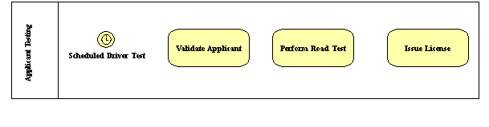Figure 16-14 Flow Objects within a Pool

Adding Sequence Flows to the Diagram
Sequence flows are directional lines that communicate the order in which the processes are to be performed. They can be labeled or left unlabeled with a default name of ―«unnamed»‖.
For clarity, we suggest that you label the sequence flows.

Add a Sequence Flow: | 1 | Click the horizontal arrow symbol button on the control bar, labeled Sequence Flow.
 | 2 | Place your cursor on the start event. Left-click the mouse and hold down the button as you drag the cursor to the right until it is within the first process symbol and let go of the mouse button.
Label the Sequence Flow: | 3 | Label the sequence flow ―Test

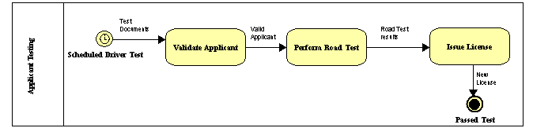

Documents‖.
Add an End event: | 4 | Click on End event circle, the third circle in the list. Add the End Event under the process ―Issue License‖ and label the event ―Passed Test‖.  Select ―Terminate‖ in Result field by clicking the down arrow.
 | 5 | Add the rest of the sequence flows as shown in the Figure 16-15.
Save the Diagram: | 6 | Save the BPMN diagram.

Figure 16-15 Sequence Flows Added

As designed, this example represents a Private internal process with the Application Testing department of the DMV. However, it is also important that you understand how Collaborative Business Processes interact. We will add another set of processes within a Pool to show the interaction of the Application Testing department and the Licensing Department. Included is a Gateway to display the decision making capability of the BPMN diagrams.

Add a Start Event: | 1 | Click the fifth symbol button, the open circle, on the control bar. This is the start event. Add the Start event ―Vehicle Road Test‖ of type ―Timer‖ below the current Pool, as shown in Figure 16-16
Add a Process symbol: | 2 | Click the first symbol button, the rounded rectangle, on the control bar. Add the processes as shown in Figure 16-16.
Add a Gateway: | 3 | Click the second symbol button, the diamond, and place your cursor to the

right of the process ―Test Results. Left mouse click to draw the gateway, labeled as ―Pass or Fail‖.

For the gateway type, choose ―Data- Based Exclusive Decision‖.
Add Sequence flow to Gateway: | 4 | Draw the sequence flow from the gateway to the process ―Reschedule Road Test‖. Because the gateway is a data- based decision, enter the following expression into the Expression field:  ―Test result=F‖.  Add a second sequence flow from the gateway to the process ―Issue New License, and enter this expression into the Expression field  ―Test result=P‖.
Add a Stop Event: | 5 | Click on the last circle icon, the Stop Event, and add it between the processes  ―Reschedule Road Test‖ and ―Issue New License‖. Label the event ―End of Test‖ and choose ―Terminate‖ as the end Event Result type.
Add Sequence Flows to the Diagram: | 6 | Add the rest of the sequence flows as shown in Figure 16-16.
Add a second Pool: | 7 | Click on the Pool icon, add it to the diagram and label the pool ―Licensing Department‖. Click the ESC key on the keyboard to exit drawing mode.
 | 8 | Select the pool you just drew and expand its size by a clicking and dragging at its ends. Make sure all of the new symbols are within the pool boundaries.
Save the Diagram: | 9 | Save the BPMN diagram.

Notes
 The labels of the Gateway, Sequence Flows and Events can be moved on the diagram. Left mouse click on the label name, hold down the mouse button, and drag the label to the new position on the diagram.

 To invert the direction of the sequence flow drawn between the ―Pass or Fail‖ gateway and the process ―Issue New License‖, right mouse click when drawing the line to invert the line direction.

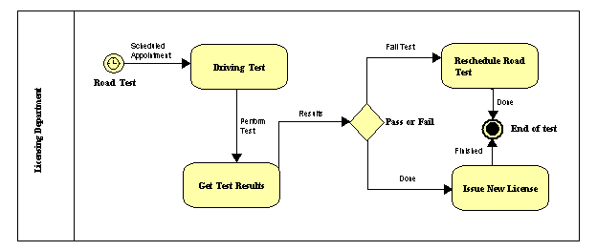Figure 16-16 Second Pool

Message flows are used to show the flow of messages between two entities that are prepared to send and receive them. In BPMN, two separate Pools on the diagram will represent the two entities.

Add a Message Flow: | 1 | Click the second line type, Message flow  , and draw the flow between the processes  ―Validate Applicant‖ and ―Driving Test‖ as shown in Figure 16-17.
Save the diagram: | 2 | Save the BPMN diagram.

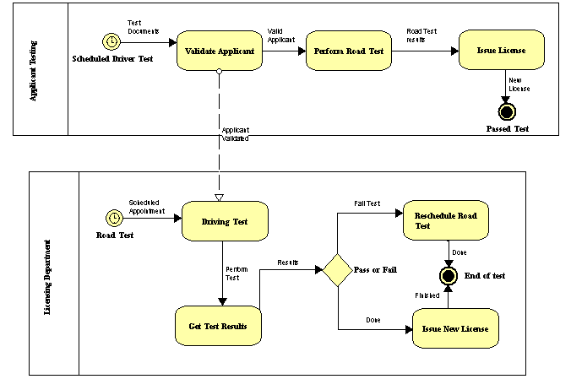Figure 16-17 Message Flow Between Pools

Lesson 17 Working with the Repository Functions

OVERVIEW
This unit helps familiarize you with the operation of the Visible Analyst repository and shows you the power of an online, interactive database for systems analysis, design and data modeling. The TEST project used in the previous lessons is used as the basis for your exercises.

The repository is a powerful tool for creating and managing the narrative portions of a system‘s specification. A project repository is used to provide an entry location for all project documentation. Each graphical entry on your diagrams has an automatically created corresponding entry in the project repository, as do any items entered into a Composition or Alias field.

You have the ability to thoroughly define all of your graphical entries in the repository or to simply enter notes about them in the Notes field. As an integrated part of Visible Analyst, the repository operates in parallel with the diagramming functions to accomplish data decomposition logically. It contains powerful data management, text editing, import/export, and report facilities. By using it, meaning can be ascribed to diagrams and an asset of ever- increasing value can be created. After defining items, changing entries and entering notes, you can generate reports from this information in many different forms.

When you finish defining your data and processing, the repository also allows you to put it into an ASCII file and export it. The ASCII file can then be sorted to move data specifications to your database and process specifications to your text editor for writing code. (The Shell Code Generation utility can also be used for this purpose.)

Note
 Users of the Educational and Demonstration versions of Visible Analyst cannot add items directly into the repository. First add the object to the diagram, and then edit it into the repository.

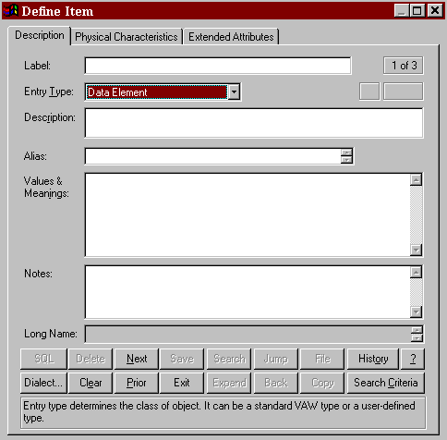Figure 17-1 Blank Repository Dialog Box, Page One

REPOSITORY BASICS

Repository Control Buttons
The repository control buttons (see Figure 17-2) are always displayed at the bottom of the repository dialog box. Each of the button functions is accessed by clicking on the button or, as is customary in Windows, by using its keyboard shortcut by holding down the ALT key and pressing the underlined letter to execute the button function. Only the functions available to you at a given time are active; the others are grayed. The button functions are:

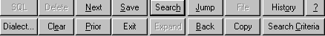Figure 17-2 Repository Dialog Box Control Buttons

SQL This button opens the Generated SQL for View dialog box. This dialog box displays the SQL generated for the current view object based on the view table and column specifications selected when creating the view, as well as the current SQL dialect. This button is active only when the entry type is View.

Dialect This activates the RDBMS SQL Dialect dialog box. From there, you can change the current SQL dialect.

Delete This deletes the current repository entry from the database. An entry can only be deleted when it has no location references, meaning that it does not appear on a diagram nor as an attribute of another repository item.

Clear This clears the display of an entry and displays a blank repository dialog box. This allows you to Search for an existing entry or add a new entry. If you have made changes, you are prompted to save them before clearing. Your current location in the repository remains unchanged.

Next This displays the next sequential repository entry that meets the repository search criteria (see below).

Prior This displays the previous sequential repository entry that meets the repository search criteria.

Save This saves all changes made to an entry.

Exit This or the ESC key exits from the repository.

Search This initiates a search for a particular entry in the repository.
The procedure is explained in the section on Search Capabilities.

Expand This allows you to expand or contract the display size of some
Contract fields. The fields that normally display four lines can expand to display 15.

Jump This allows you to jump immediately to another entry that is referred to in the current one. This feature is described in the section on Navigation Capabilities.

Back This button provides a means of jumping to the previous repository entry. You can then continue to move backwards displaying previous repository entries.

File This allows you to insert text from a DOS file at the cursor position or to copy highlighted text to a DOS file. It is explained in further detail in the Visible Analyst Operation Manual and in the online help system.

Copy This button provides a means of copying the current object.

History This provides a means of jumping back to a previously displayed repository object. A list is kept of every object definition that has been displayed. If you choose this button, the History dialog box appears and you can jump between entries by double-clicking on an entry. The maximum is 500 objects.

Help(?) This displays context sensitive help about the repository. You can also press F1 to activate the help system.

Search Criteria This allows you to specify how the repository is to be searched.
It is explained in the section on Search Capabilities.

Other buttons that may be displayed on the Define dialog box are:

Primary Key If the current object being examined is an entity type, the primary key button is displayed to the left of the Composition/Attributes field.

Attributes Details This button provides a means of populating the composition of a repository entry with components and physical information. This button is displayed to the left of the Composition/Attributes field.

When the Entry Type is a Class, or when the Classic User Interface is turned off, the Add button displayed beneath the Attributes Details button is active. You can use this button to add details.
When you begin typing in the field next to the Add button, the

button is enabled. Click the Add button to add the attributes to the Attributes field.

Editing Keys
Because the Edit menu is not accessible from the repository, you can use the right-click menu that is available when an object (text) is highlighted and you click the right mouse button.
Using the right-click menu, you can Cut, Copy, Paste, or Delete the selected object.

Field Types
The data repository of a Visible Analyst project is displayed using Define dialog box variations corresponding to different diagram objects. You see and work with some of these variations during the course of this lesson. The basic dialog box, shown in Figure 17-1, is for data elements, aliases, miscellaneous objects and external entities or source/sinks. Other objects, such as data stores, processes, functions, entities, relationships, modules, data flows information clusters, etc., have variations in individual fields and tabs of the Repository dialog box to accommodate the specific needs of those items. Some of these differences are seen later in the lesson.

Label Field
This is the name of the repository item. The names of items drawn on diagrams are automatically entered here.

Entry Type Field
This tells Visible Analyst what kind of object the item is: process, data flow, entity, etc. The entry type can be entered manually, or you can select the type from the scroll box accessed by clicking the down arrow at the end of the entry type field.

Note
 You can edit the Entry Type and Label fields of data elements and data structures that do not appear on diagrams. The entry type for a data element cannot be changed if physical information for that element has been entered.

Description Field
The Description field is a two-line field that provides a convenient place to enter a somewhat more extensive descriptive title of the object than the Label field allows. The contents of this field are used for the Comment on Column (data elements) and Comment on Table (entities) when SQL DDL is generated if the selected SQL dialect supports this syntax.

Alias Field
The Alias field contains 10 lines of 128 characters each. It allows for the entry of alternative labels to the one used as the object label. This is most commonly used for indicating the cryptic abbreviations that are sometimes used in the actual coding of a software program, as opposed to the plain English names that are desirable for reference. The Alias field is an intelligent field. Data names entered into it establish new repository entries for these aliases.

Attributes Field
The purpose of the Attributes field is to accumulate the collection of data elements that you wish to define as constituting a data flow, entity, data store, etc. The Attributes field is an intelligent field. Data names entered into it establish new data element repository entries or update existing ones. These new data elements can then be used for further definition. Data flows, data structures and couples can also appear in some Attributes fields.

When you click the Attributes Details button, the Add Attributes dialog box appears. Using this dialog box, you can define up to 12 components and some of their properties. As you enter items, the dialog box automatically scrolls as necessary to allow you to enter more items until you reach 12. When you complete the entries, click OK to add them to the Attributes field. If you need to add more than 12 components, click the Attributes Details button again; and a new dialog box opens so that you can add additional attributes.

Use the Add button at the bottom of the Attributes field to add components one at a time. When you begin typing in the field next to it, the Add button becomes active. Complete your entry, and then click Add to enter the component in the Attributes field.

Values & Meanings Field
The Values & Meanings field allows an unlimited number of lines. The maximum number of characters that can be contained in the field is 64K. This field allows the entry of specific information about the value(s) the item can take.

Discriminator Values & Meanings Field
If the current object is a data element that is used as a discriminator, this field contains a list of values to identify the subtype entities. For each subtype, a value can be entered that will uniquely identify it. By default, these values are numbers starting with 0 for the supertype. To change the value, click the value until an edit control appears, make your changes, then press ENTER.

Notes Field
The Notes field is also a field that allows you to enter any pertinent information about the object. The maximum number of characters that can be contained in the field is 64K. This is the logical field to use when creating hyperlinks to external documents, web pages or other application files.

Location Field
This field displays two types of usage information. The field can contain the diagram name (and, for DFDs, the diagram number) of every diagram where the item appears. The field can also tell you if the item appears as an attribute of another item. This second kind of location entry has the entry type of the parent item, followed by an arrow and the name of the parent item.

Other Pages and Fields
Other pages of the Define dialog box contain additional information. For example, pages 2 and 3 of the basic repository form provide location and relationship information and specifications for PowerBuilder/VISION extended attributes. These two pages are similar for most entry types. For some entry types, additional pages will be displayed:
- When the entry type is an entity, the next five pages contain keys, foreign keys, triggers, check constraints, and physical information.
- For views, the next five pages provide table, column, join, clause, and option information.
- When the entry type is a relationship, there are additional pages that contain foreign key and cardinality information.
- When the entry type is a tablespace, an additional page contains property information.

A full list and complete descriptions of pages and fields can be found in the Operation Manual and in the online help.

Object Repository
The Visible Analyst repository provides several additional forms and data input components for supporting the object-oriented concepts. The object repository components are detailed below.

Attributes
The Attributes field replaces the Values & Meanings field whenever the Repository dialog box displays a class. The field contains a list of the data members for the class showing the local data element and type. To add, change, or remove local data elements, click the Attributes Details button or select Add/Change from the Repository Object menu. For each attribute, the following information can be defined:
- Name. The name of the attribute. Each attribute of a class has a separate entry in the repository with a type of local data element. This is an optional field. The search button can be used to find other local data elements in the repository.
- Type. The attribute type can be a class, data element, or data structure. If the type does not exist in the repository, a new class is created. The location field of the attribute type contains a reference to the current class. This is a mandatory field. The Search button can be used to display a list of valid types. If the attribute type is a data element or elemental

class, its physical characteristics are displayed. Entries added to the Type field are saved as data elements for an entity or data flow, and class/subtype element when the object is a class.
  - Limit. The number of occurrences of the attribute. If this field is blank, the attribute occurs once.
  - Reference. A qualifier to indicate the access method for an attribute. Value indicates the object defined in the Type field is used; Address indicates a pointer to the object is to be used; and Reference indicates a reference to the object is to be used. The default is Value.
  - Visibility. Public members have global visibility. Private members are only accessible to member functions and friends. Protected members are accessible to derived classes and friends. Implementation members are only accessible to the class itself. The default is Private.
  - Qualification. Constant indicates a member‘s value cannot be changed. Volatile indicates the member can be modified by something other than the program, either the operating system or hardware. Static indicates there is only one instance of the member regardless of the number of times a class is instantiated. The default is None.
  - Physical Characteristics. If the attribute type is elemental, the physical characteristics can be set.

For every item entered into the Type field, Visible Analyst creates a repository entry (if one with the same name does not already exist) and updates that entry‘s location field. If an item is removed, this field is updated to reflect this. These repository entries are generally created as classes unless a data element already exists with the same name or the physical characteristics are defined

As you enter items, the dialog box automatically scrolls as necessary to allow you to enter more items until you have finished. Insert is used to insert a new attribute into the list at the current position, while Delete removes the current attribute (the current position is indicated by ➢➢). When you have completed the entries, click OK to add them to the Attributes field.

Item names entered into this field may contain up to 128 characters each and may consist of any upper or lower case letters, numbers, spaces, periods, underscore characters and hyphens; but the first character must always be a letter.

Attached Entities/Classes
The attached entities/classes for the currently displayed relationship are listed in this field. When an inheritance relationship is displayed, the characteristics of that relationship can be changed (see changing Inheritance Characteristics later in this chapter). Otherwise, the information cannot be edited from within the repository; and all changes must be made on a diagram. The field lists the two entities or classes attached to this relationship. Below the second entity name is listed the reverse of the current relationship. If either direction of the relationship has not been named, the name of the relationship in the reverse direction is

displayed as ―reverse of (opposite relationship name).‖ This field allows you to jump to the repository entries for any of these entities or relationships, as described above.

Relations
For an entity or class, the Relations field displays the relationship name followed by the name of the entity or class on the other end of this relationship for each relationship attached to this entry. These sets are ordered alphabetically by the opposite entry name. When an inheritance relationship is displayed, the characteristics of that relationship can be changed (see Changing Inheritance Characteristics later in this chapter); otherwise, the information cannot be edited from within the repository; and all changes must be made on a diagram.

This field allows you to jump to the repository entries for any of these entities, classes, or relationships by positioning the cursor on the line containing an entity, class, or relationship name and clicking the Jump button.

Long Name
When a repository entry, either a local data element or a module, belongs to a class, the full name of the entry includes the class name. The Long Name field displays this name and, in the case of modules, includes the argument list (the argument list is required to differentiate overloaded member functions). If you want to change the argument list for a class method, click the right mouse button on the Long Name field and select Change (see the Methods section later in this chapter for details). If you want to change the class to which the method belongs, select Class from the Repository Object menu. To display the class definition, click the Jump button.

Class Characteristics
Concurrency, displayed on the Methods/Friends tab, is a class property that distinguishes an active object from inactive object. An active object may represent a separate thread of control. A sequential object is a passive object whose semantics are guaranteed only in the presence of a single thread of control. A guarded object is a passive object whose semantics are guaranteed in the presence of multiple threads of control.

A persistent class exists beyond the lifetime of an executable program. This means it must be stored on a non-transitory storage device. If the subtype of a class is set to either entity (associative or attributive) and the class is used on an entity relationship diagram, this field cannot be changed.

An abstract (or virtual) class cannot be instantiated because it contains pure virtual methods. If pure virtual methods exist for a class, Abstract is checked. If you attempt to uncheck this field, all pure virtual methods are reset to virtual. If you attempt to check it and virtual methods exist, they are converted to pure virtual methods.

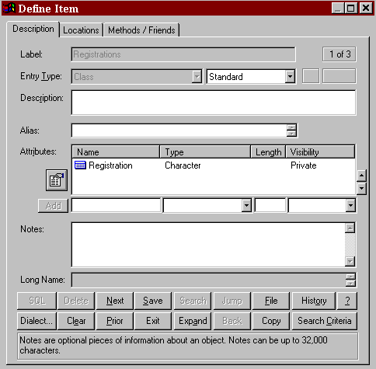Figure 17-3 Class Attributes

Methods
Methods (or Member Functions) are the operations that are defined for accessing a class. The Methods field contains a list of the functions for a class showing the name, return value, argument list, and flags to indicate its visibility. To add, change, or remove methods, click on the Methods field and click the Attributes Details button or select Add/Change from the Repository Object menu. To add a new method for a class, click the New button and type the name of method you wish to add. To search for methods that have already been defined in the repository, click the Search button. The list contains all modules that have previously been defined in the repository. If the module already belongs to a class, the class name is displayed. Note that when you select a module that already exists, the complete definition for that module is used including return value and argument list. Click OK to add the method name to the list of methods for the current class. For each method, the following information can be defined:

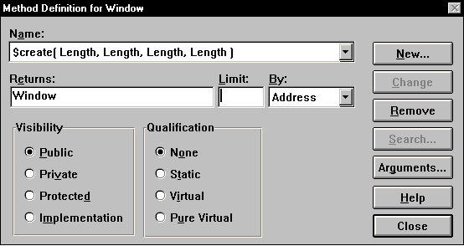Figure 17-4 Class Methods

- Returns. The return type can be a class or data element. If the type does not exist in the repository, a new class is created. The Location field of the attribute type contains a reference to the method. This is an optional field. Click the Search button to display a list of valid types.
- Limit. The number or size of the parameter. If this field is blank, it occurs once.
- By. A qualifier to indicate how the return value is passed. Value indicates a copy of the parameter is passed; Address indicates a pointer to the object is to be used; and Reference indicates a reference to an object is to be used.
- Visibility. Public methods have global visibility. Private methods are only accessible to other member functions within the same class and friends. Protected methods are accessible to derived classes and friends. Implementation methods are only accessible to the class itself. The default is Public.
- Qualification. Static indicates a method can be used without a specific instance of an object (it can only be used with static attributes (data members)). A Virtual method is one that you expect to be redefined in a derived class. A Pure Virtual method has no definition and must be defined in a derived class. A class with any pure virtual functions is an abstract (or virtual) class. The default is None.
- Arguments. A list of parameters to be used by the method. This is an optional field. If a method appears more than once with the same name within a class, it must have a different argument list for each definition. This is known as function overloading. See the next section for defining arguments.

When a method is added to a class definition, an entry of type module is created in the repository. The long name includes the class name and the argument list. The argument list is needed to differentiate between overloaded functions.

Note
 Because the same name can be used for more than one method, there may be duplicate module entries in the repository, each belonging to a different class.

Arguments for Methods
When defining methods (member functions) for a class, the parameters to the function need to be specified. To add, change, or remove arguments, click the Arguments button on the Method Definition dialog box. For each argument, the following can be defined:
  - Name. The name of the parameter. This is an optional field.
  - Type. The parameter type can be a class or data element. If the type does not exist in the repository, a new class is created. This is a mandatory field. The Search button can be used to display a list of valid types. If the parameter type is a data element or elemental class, its physical characteristics are displayed.
  - Limit. The number or size of the parameter. If this field is blank, it occurs once.
  - Pass By. A qualifier to indicate the how the parameter is passed. Value indicates a copy of the parameter is passed; Address indicates a pointer to the object is to be used; and Reference indicates a reference to an object is to be used. The default is Value.
  - Qualification. Constant indicates a parameter‘s value cannot be changed. Volatile indicates the parameter can be modified by something other than the program, either the operating system or hardware. The default is None.
  - Physical Characteristics. If the parameter type is elemental, the physical characteristics can be set.

For every item entered into the Type field, Visible Analyst creates a repository entry (if one with the same name does not already exist). These repository entries are generally created as classes unless a data element already exists with the same name or the physical characteristics are defined.

As you enter items, the dialog box automatically scrolls as necessary to allow you to enter more items until you have finished. INSERT is used to insert a new parameter into the list at the current position, while the DELETE key removes the current parameter (the current position is indicated by ➢➢). When you have completed the entries, click OK to update the method name field. Item names entered into this field may contain up to 128 characters each and may consist of any upper or lower case letters, numbers, spaces, periods, underscore characters and hyphens; but the first character must always be a letter.

Friends
The Friends field displays a list of both friend classes and methods (or functions). A friend is allowed access to the private data members of a class. To add friends, click on the Friends field and click the Search button, select Add from the Repository Object menu, or double- click on the Friends field while pressing CTRL key. A list of classes and member functions is displayed in the Search list box. Locate each repository item you want to place in the Friends field and click the Search button; the item is added to the Select list box at the bottom. When you have found all of the entries you want, click the Select button and they are entered into the Friends field.

To remove a friend, highlight the desired item and press the DELETE key or select Cut or Delete from the Repository Object menu.

Navigation Capabilities
In this section, you change the displayed repository entry using Next, Prior, and Jump.

Note
 The repository saves some internal settings for the duration of a Visible Analyst session. If these are set incorrectly, they may interfere with the smooth flow of this lesson. Therefore, we suggest that if you or another user worked in the repository during the current session, you should exit to Windows and restart Visible Analyst. In this way, you have a clean slate on which to run this lesson.

Open the Repository: | 1 | Access the repository using either Define from the Repository menu or CTRL+D. A blank Define dialog box is displayed.
Access an Entry: | 2 | Type ―Person Information‖ in the Label field and press ENTER twice. (Pressing ENTER once brings up the Search dialog box. Pressing it a second time displays the entry found. If you press ENTER twice quickly, you get the same result without displaying the search box.) The repository entry for Person Information displays with all of the information that has been entered into the repository for this entry.
Move Around: | 3 | Click Next. The next entry in alphabetical order is displayed.
 | 4 | Click Prior. Person Information is again displayed.

Jump to Other Entries: | 5 | Click the element Name in the Attributes field. (It may be necessary to scroll the contents of the field to bring Name into view.) Click Jump. (Click Yes if you are asked if you want to save Person Information.) The repository entry for the data element Name is displayed.
 | 6 | Move to page two by clicking the Physical Information tab at the top of the dialog box. (The current page number is displayed in the upper right corner of the Define window.) This displays more information about the current entry, including the Location information that indicates where the current entry is used.
 | 7 | Click the line in the Location field containing Person Information. This highlights the line.
 | 8 | Click Jump. The entry for Person Information is once again displayed. The Locations tab (page 2) is currently displayed. An alternative to selecting Jump to switch to another repository entry is to double-click the entry name in the Location field or to click the Back button.
 | 9 | Move to page one by clicking the Description tab.

Search Capabilities
Searching for entries in the repository is an easy procedure. It can also be a very useful feature because you can set the Search Criteria to display only certain entry types as you move from one repository entry to the next. To search for an entry in the repository:

Access an Entry: | 1 | Click Clear. This clears the dialog box but does not delete the entry.
 | 2 | Type ―Road Test‖ and press ENTER twice. The repository entry for Road Test is displayed with all of the information that has been entered into the repository for this entry. (This was done for you in the samples included with the TEST project.)
 | 3 | Click Clear.

Search for the | 4 | Click the Search button to open the search box to select
Entry: |  | from the repository. Type ―r‖ and entries that begin with
 |  | ―r‖ appear in the list box. If you now type an ―o,‖ you see
 |  | that the repository searches incrementally as you type,
 |  | getting closer to the entry you want.

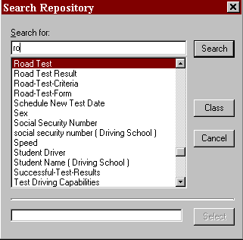Figure 17-5 Repository Search Dialog Box

5 Click Road Test and then click Search. The repository entry for Road Test is displayed.

Setting the Search Criteria
Search criteria set the scope of the entries that are displayed as you search through the repository.

Clear the Dialog Box: | 1 | Click Clear to clear the dialog box.
Set the Criteria: | 2 | Click Search Criteria. You see a dialog box  entitled Set Search Criteria, as shown in Figure 17-6.

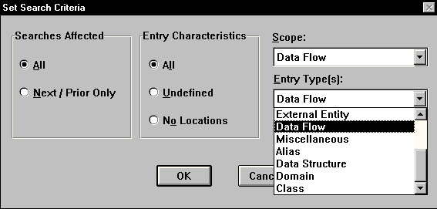Figure 17-6 Setting Repository Search Criteria

- In the box entitled Searches Affected, select All. This is the method used to limit the scope of the entries displayed when navigating the repository using Next and Prior, as well as the entries that are displayed when you select Search.

- In the box labeled Entry Characteristics, select All. This tells Visible Analyst to search all items in the repository, rather than only those entries that are Undefined or entries that have No Locations. No Location entries are typically those that have been entered directly into the repository rather than added to the repository by being placed on a diagram.

- Click the down arrow on the right side of the field marked Scope. This allows you to choose the diagram type to which you wish to limit your search. Select Data Flow.

- Click the down arrow on the right side of the field marked Entry Type(s). This allows you to be very specific about the type of entry to which you wish to limit your search. You can choose individual types and some combination types.

- Select Data Flow, then click OK.

Try Out the Criteria: | 8 | At the blank Define dialog box, click Search. Because your search criteria limits searches to data flows, the list displays only the entries in the repository of the type data flow. Select Road-Test-Criteria and then click Search.
 | 9 | Now click Next. The next entry displayed is the next data flow in alphabetical order, rather than simply the next entry in alphabetical order. If you click Next a few more times, you notice that only data flow entries are displayed.
 | 10 | Click Search Criteria again and set Scope back to Entire Repository. Be sure that Entry Type(s) is set to All.  Click OK.

Using Search to Add Items to a Field
The Search feature can also be used to add repository entries to a field without retyping them. This option is very useful for adding multiple data elements to an Attributes field. Instead of typing the name into the field, you can select it using the Search function.

Clear the Dialog Box: | 1 | Click Clear.
Find an Entry: | 2 | Type ―V‖ in the Label field and click Search.  Valid-Applicant should be the first entry on the list. Click on it and it appears in the Search For field. Click Search and the repository entry for Valid-Applicant appears.
Select Attributes: | 3 | Click on the Attributes field.
 | 4 | Click the Search button. The available data elements are displayed. Double-click on Address, Birth Date, Name, and Social Security Number. All the selected elements are displayed at the bottom of the Search dialog box as shown in Figure 17-7.

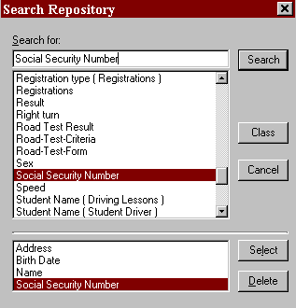Figure 17-7 Add Information with Search

Add Attributes | 5 | Click Select. All the selected elements are added to the
and Save: |  | Attributes field. Click Save and then click Exit.

ADVANCED REPOSITORY FEATURES

Adding Information to the Repository
In this unit, you add attribute information to an entity; the attributes consist of the data elements that make up the entity. You also add the primary key information, so that you can demonstrate Key Analysis and Key Synchronization to migrate foreign keys across relationships automatically. All of the key information relates to the method for accessing tables in a database. We assume that each entity corresponds to one table.

Open a Diagram: 1 Open the entity relationship diagram ―Driving School
View‖.

Display a Repository Entry: | 2  3 | Click the  button on the control bar.  With the left mouse button, double-click the entity
 |  | Student Driver. Its repository entry is displayed.
Enter Attribute Data: | 4 | Place the text entry cursor in the field immediately to the right of the Add button under the Attributes field. Type  ―Student Name‖ and click Add. Add ―Home Address‖ and ―Age‖ in the same manner. Since the data elements you just added to the Attributes field are not already in the repository, entries for each are automatically added when you click Save.
Save the Entries: | 5 | Click Save to save the attributes you entered.
Enter Key Information: | 6 | Click the key button to display the Primary Key dialog box. Select Student Name to move it from the Columns in Table box to Columns in Key box. Click OK to return to the Define dialog box.
 |  | The key notation by Student Name indicates that Student Name is the primary key for this entity.

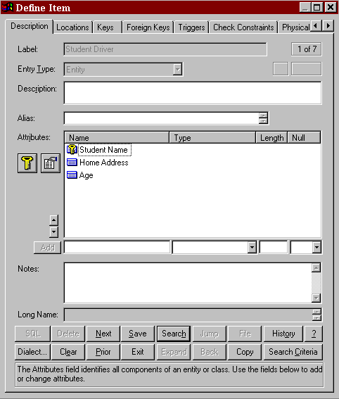Figure 17-8 Student Driver Attribute Information

Clear the Dialog Box: | 7 | Click Clear. This clears the repository dialog box but does not delete the entry from the repository.
Access Another Entry: | 8 | Type ―Driving School‖ in the Label field and press ENTER.

Add Composition: | 9 | Click the Attributes Details button and type ―Driving School Number‖ and ―Driving School Name,‖ each on a separate line. Click OK.
Create Primary Key: | 10 | Click the Key button next to the Attributes field to display the Primary Key dialog box.
 | 12 | Click Driving School Number in the Columns in Table box to move it to the Columns in Key box. Click OK to return to the Define dialog box.
Save: | 12 | Click Save to save your changes, then click Clear.
Access Another Entry: | 13 | Type ―Driving Lessons‖ in the Label field and press ENTER.
Add Attributes: | 14 | Click the Attributes Details button, place the cursor in the Type field, and then click Search.
 | 16 | Scroll the search box until Driving School Number appears. Click Driving School Number and then click Search to enter it on the Attributes dialog box. Move the cursor to Type field of the next line. Add Student Name in the same manner.
 | 17 | Move the cursor to the Type field of the next line, and type ―Lesson Number.‖ Click the cursor in the Limit field to enable the Physical Characteristics pane at the bottom of the dialog box. Select Integer as the Data Type.
 | 18 | Click OK to add the attributes to the Define dialog box.
Create Primary Key: | 19 | Click the Key button next to the Attributes field to display the Primary Key dialog box. Click Lesson Number in the Columns in Table box to move it to the Columns in Key box. Click OK to return to the Define dialog box.
Save and Exit: | 20 | Click Save and then click Exit.

Key Analysis and Key Synchronization
The Key Analysis and Key Synchronization functions, found on the Repository menu, can help you set up a consistent relational database key structure. There are three types of keys used in a data model: primary, foreign, and alternate keys. All keys are designated in the Attributes field of an entity in the project repository. A primary key is one or more attributes or data elements that uniquely identify an entity. To designate a data element as a primary key, the yellow key notation is used in the Define dialog box. On the diagram, primary keys are displayed in the area immediately under the entity name when the primary key level is selected from the control bar or the View/Entity Display Options menu. A foreign key is a non-key attribute in one relation that appears as the primary key (or part of a compound primary key) in another relation. The gray key notation in the Attributes field of an entity designates a foreign key. The FK notation is shown when the entity on the diagram is displayed at the attribute view level.

Key Analysis verifies that the key structure for your data model is complete, checking that all key information is correctly identified for the data model. Key Synchronization analyzes the key structure and migrates data elements that you designate as keys, or parts of compound keys, across relationships to their associated entities, and creates the resulting foreign keys.
Using associator element names in relationship repository entries makes this process work better. (Please check the Visible Analyst manual or online help system for an explanation of associator elements.)

Key Analysis and Key Synchronization both involve analyzing the primary key [PK] and foreign key [FK] designations in the TEST project repository. A primary key is an attribute or data element that uniquely identifies a record.

Run Key Analysis: 1 Select Key Analysis from the Repository menu. Visible
Analyst scans the entire repository and indicates any errors it finds.

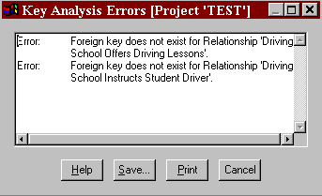Figure 17-9 Key Analysis Error Messages

View the Errors: | 2 | Click the Maximize button in the upper right corner of
 |  | the errors dialog box. Scroll through the messages. You
 |  | see that there are error messages indicating missing
 |  | foreign keys for the entities on the current diagram.

Note
 You can keep analysis error dialog boxes on the screen while you carry on various Visible Analyst activities. This is to make it easier for you to correct the errors found by Analyze. The same holds true for SQL Schema Generation, Shell Code Generation, etc.
.

- Click Cancel.

- Select Key Synchronization from the Repository menu. Visible Analyst first analyzes for key errors and then migrates the foreign keys across relationships.

- Maximize the Key Synchronization Messages dialog box. Key Analysis messages appear first, followed by Key Synchronization messages. You should notice the Key Synchronization messages, indicating the foreign keys that have been migrated.

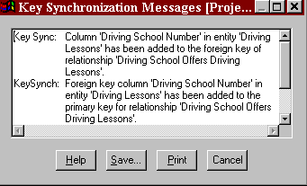Figure 17-10 Key Synchronization Messages

 | 6 | Click Cancel.
Examine the Migrated Key: | 7 | Double-click Student Driver. Notice the foreign key Driving School Number that has been added. This was done by Key Synchronization. It saves you from migrating all of the foreign keys manually.
 |  | Note also that Analyze added text describing the key. All text following an asterisk is considered a comment and is ignored by the repository. (When the object interface is enabled, comments are not displayed.)

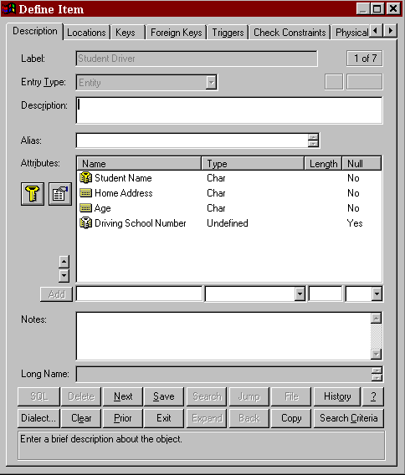Figure 17-11 New Foreign Key Information

- Click Exit.

- Deselect Student Driver on the diagram.

View Objects
Visible Analyst Corporate and Zachman Editions support the concept of an SQL view, which can be thought of as a derived or virtual entity. A view is similar to an entity in that it has a

composition, but the items that appear in the composition of a view must belong to other entities or be expressions based on data elements used by another entity.

An SQL view is made up of two major components: a list of column names and a select statement that is used to filter information from the tables in the view. The select statement can contain not only the primary select clause, but also any number of sub-selects and union selects. When view is selected as the entry type, view-specific Define dialog box pages are displayed. Using these pages, you can select tables, columns, join relationships, clauses, and other options for the view. An expression builder is available to help you create the expressions to be used in the filter, group by, having, start with, connect by, or join expression controls.

Detailed information about views can be found in the Operation Manual and in the online help system.

Note
 Views are not available in the Education Editions of Visible Analyst.

Generate Database Schema
The Corporate and Zachman Editions of Visible Analyst generates SQL DDL (Structured Query Language – Data Definition Language) schema from the information contained in the repository. In the Corporate and Zachman Editions, you can select from several different dialects of SQL, including a User Defined type, to allow the use of a dialect not currently supported by Visible Analyst. For more information on the custom feature, see the Operation Manual or the online help system. The statements that are supported include CREATE TABLE, CREATE INDEX, and COMMENT ON. More information is contained in the Operation Manual or in the online help system.

The Education Editions of Visible Analyst allow you to generate SQL for Microsoft Access and Oracle only. To generate SQL:

Choose Access Dialect: | 1 | Choose SQL Dialect from the Options menu, then choose Access.
Generate SQL Schema: | 2 | Select Generate Database Schema from the Repository menu to generate the schema. When the dialog box appears, click OK. (Refer to the Operation Manual or online help system for details of the SQL Schema Generation dialog box.) If errors are found, they along with the generated schema will be displayed.
View the Schema: | 3 | Maximize the SQL generation dialog box.

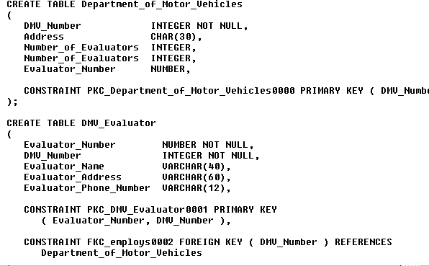4 Click the Schema button to display the generated schema. See Figure 17-12. If Visible Analyst does not have the information to generate the schema, a list of errors is displayed; but no Select box is present. Click the Errors button to view any errors. (If too many errors are generated, the Schema button is not displayed.)

Figure 17-12 Generated SQL Schema

Shell Code Generation
The Corporate and Zachman Editions can generate C and COBOL shell code. The code that is generated encompasses the sequence of functions or paragraphs that make up a program, including global definitions, descriptive comments, function call/PERFORM statements, and passed parameters. Information entered in text fields in the repository entry for a program item or a structure chart module produces comments that describe these items within the generated code. Also, actual source code can be entered in the module description field of a module or macro, and this code is placed in-line with the function calls or PERFORM statements that are generated by invocations. Couples or ITRs used with invocation lines generate parameters for C code. There is also an option to customize the code to be

generated. (See the online help for other generation options supported by Visible Analyst, such as AS/400 DDS, Visual Basic, PowerBuilder, etc.)

XML Generation
Visible Analyst can generate the XML Schema based on the W3C standard by selecting the Tools | Export | XML Schema (XSD) menu option. The XML file is generated for the entities and (optionally) classes developed in the project. The XML file is written to the Visible Analyst TRANS folder.

XML DCD code can also be generated based on the data models. This is similar to SQL schema generation. XML can be selected as the generation option when you select SQL Dialect from the Options menu. The procedure is similar to the SQL DDL generation. See the Operation Manual or the online help for more information.

Repository Reports
Now you practice generating a report on the data contained in the repository. This is a basic report containing a detailed listing of all entries contained in the repository. For detailed information about Reports and Report Queries (Custom Reports), see the Operation Manual or the online help system.

First set the font for the report you want to generate.

Set the Report Font: | 1 | From the Options menu select Text Settings.
 | 2 | Under Text Type, select Report Body.
 | 3 | Select a typeface and point size, and click OK.
Set the Report Criteria: | 4 | Select Reports from the Repository menu. The Repository Reports dialog box appears (see Figure 17-13).

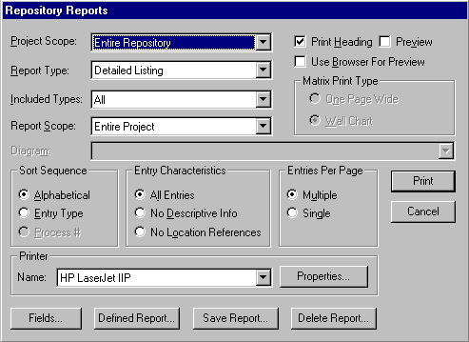Figure 17-13 Repository Reports Dialog Box

 | 5 | Under Project Scope, select Entire Repository.
 | 6 | Under Report Type, select Detailed Listing.
 | 7 | Under Included Types, select All.
 | 8 | Under Report Scope, Entire Project is selected.
 | 9 | In the box labeled Sort Sequence, select Alphabetical. This determines the entry order in your report printout.
 | 10 | In the box labeled Entry Characteristics, select All Entries.
 | 11 | In the box entitled Entries Per Page, select Multiple Entries Per Page. You can select Single Entry Per Page to reorder the pages of your report once they have been printed.
Run the Report: | 12 | Click Print; the information is sent to the printer. Select Preview to view the report first.

Note
 Reports can be generated in HTML format so that they may be viewed in a browser. When you select Preview, the Use Browser for Preview Option is enabled. If you select this option and you have a browser on your PC, the report is generated and displayed in your browser.

13 Click Cancel when printing is complete to exit the Repository Reports dialog box.

Lesson 18 Where To Go From Here

OVERVIEW
This concludes the Visible Analyst tutorial. To exit the program, select Exit from the File
menu.

You have now completed exercises in many of the major elements of planning, structured analysis and design, data modeling and object modeling:
- Drawing diagrams to model a system.
- Using methodology rules to insure against inconsistencies.
- Adding written definition to the graphic model.
- Embellishing the model following the initial layout.
- Expanding the model through definition of repository elements.
- Generating reports.

All structured software and systems engineering involve these same basic operations.

REAL WORLD APPLICATION
The example project that you created was a simple one. The real power of MDA is in the application to systems too complex to keep in your head at one time, too large to be reviewed by inspection, too widespread to have only one person working on the whole job. These types of projects include nearly every system designed today. That power shows itself in four areas:
- The assurance of accuracy and completeness, that no elements are left dangling or unaccounted for.
- The prompting and reminders that error checks and repository output provide, to focus attention in the midst of a dauntingly complex assignment.
- The word processing-like ease with which changes and modifications can be accomplished, while ripple effects are flagged and accounted for.
- The convenience of thorough documentation that is produced concurrently with the design, not as a drudgery-filled after-effort.

The power of MDA further multiplies into substantial gains in productivity, communication and quality when applied to team effort. The Corporate and Zachman Editions of Visible Analyst have significant capabilities for exporting and importing information, either through portable media or through participation in a local area network. This allows Visible Analyst to become an integral part of any development environment, sharing information and expanding the value of labor. Many groups thus can benefit from another group‘s hard work.

Finally, the application of the power of MDA productivity enhancement is not limited to software but can be applied toward analyzing and designing any system, such as:

Manufacturing | Medical Diagnostic Analysis
Planning | Command and Control Operations
Processing | Administrative Procedures
Legal/Judicial | Inventory Control
Audits

Visible Analyst is designed to be a natural extension of the way you think, create, and analyze. Our goal is to ―Put MDA Within Everybody‘s Reach‖ and to make MDA tools and the methodologies of structured analysis, design, data modeling and object modeling a natural, seamless, integrated part of your everyday work, rather than an arcane ritual to be occasionally endured by specialists. The integration and flexibility to use the components and elements that you deem necessary for your application provide you with a customizable tool set that can be adapted to support how you choose to work on the design and development of information systems.

WHAT TO DO NEXT?
There are still many things for you to do to become comfortable and committed to the use of a MDA tool. We suggest the following:
  - Study and review the logic concepts introduced in the tutorial (consider reviewing the referenced materials).
  - Review the tutorial steps and practice any areas that were unclear.
  - Select a personal real-world project to do using Visible Analyst. Make it a modest-sized effort to give you some time to explore and experiment with the tool.
  - Select the parts and components that you want to use in your software development practice.
  - Practice, practice, practice. Make adjustments where needed.
  - Make the tool a regular part of all of your projects.
  - Define standards and procedures for library components.
  - Build disciplines and skills with concepts and Visible Analyst.
  - Use technical support as needed - don‘t get stuck, don‘t become frustrated.

- Stop and evaluate what you have done, show others, review the work of others - find ways to improve the content and the processes.
- Practice reusability wherever possible.
- Stay up to date with the tool and the evolving methodologies.
- Build a library of materials for use in future projects.

CONCLUSION
We hope that these lessons have helped to make you feel comfortable with the planning, structured systems analysis and design, and data modeling tools, and their implementations in our product.

For more information or if you have any questions about MDA or structured analysis, please contact the Visible Systems technical support staff:

Telephone (617) 902-0767
FAX (508) 302-2400
Internet: http://www.visiblesystemscorp.com
E-mail: support@visiblesystemscorp.com

You can send your comments to:

Customer Comments Visible Systems Corporation 63 Fountain St. Suite 301 B
Framingham, MA 01702

Index

#
 button, 72, 73, 83, 85, 88, 90

,
, library modules, 128
, return value, 223

:
: procedure call, 185

A
a list of functions for a class, 223 a list of valid types, 149
abstract class, 224
Abstract class, 222
access diagrams, 12
access method, 221
access method for an attribute, 145 access projects, 12
Accesses repository, 10
action, 154
action verb, 58
action verbs, 56
actions, 4
activation, 177
activation bar, 185
activation symbol, 180
active object, 222 active state verbs, 56 activity, 158, 197
activity diagram, 158
activity states, 160
actor, 168
actor communicates with use case, 170 actors‘, 168
add a file, 116
add a new method for a class, 223 add activation symbol, 181
add actor, 173
add actors, 173
add arguments, 149, 225
add communicates relationship, 174 add includes relationship, 174
add message, 194
add method, 194
add methods, 223
add object deletion, 183 add object links, 194 add objects, 193
add procedure call, 185 add procedure calls, 184
add relationships to a use case diagram, 174 add return, 187
add symbol button, 139 add symbols, 82
add system boundaries, 173 add system boundary, 173 add text, 187
add text button, 187 add use case, 174 add use cases, 173 adding a line, 71
adding a start, 161, 206
adding a synchronization bar, 161 adding activities, 162
adding attributes to a class diagram, 146 adding caption text, 73
adding classes, 139
adding classes to a view, 139 adding composition, 230 adding connection lines, 85 adding decisions, 162 adding entities to a view, 96
adding items to a field using search, 230 adding labels, 164
adding lines to a diagram, 132 adding methods, 150
adding new flows, 118 adding relationship lines, 99
adding relationships to a collaboration diagram, 194
adding relationships to a state model, 156 adding relationships to a view, 140 adding states to a view, 155

adding stopping, 163
adding swimlanes, 164
adding symbols, 67
adding transitions, 163
Address, 145, 148, 149, 221, 224, 225
advanced repository features, 231 aggregation, 137
aggregations, 4, 60, 138, 140
Alias field, 214, 219
aliases, 218
Align selected symbols, 10 align symbols, 83
alternate key, 235
alternate name for the use case, 172 alternative labels, 219
analysis, 1
analysis error dialog boxes, 88 Analysis error dialog boxes, 123
Analyze, 10, 59, 80, 87, 88, 89, 101, 112, 119,
122, 123, 152
analyze for key errors, 236 analyze information process, 3 analyze process, 3
analyzing a class diagram, 152 analyzing a diagram, 101 analyzing an FDD, 88 analyzing for balance, 122 analyzing for completeness, 122 annotation, 205
Apply button, 69
argument list, 223, 225
arguments, 149, 225
Arguments, 148, 224
Arguments button, 149, 225
arrow, 58
Arrow, 96
arrow originating at the object lifeline and looping around to end at the same lifeline, 177, 202
arrow with a filled circle, 135 arrowhead terminator, 130
arrows, 60
artifacts, 204
ASCII file, 214
as-is operations, 3
assembly, 129
assigning user access, 14 association, 137
association flow, 203
Associative, 138
associative entity, 94
associator elements, 235 assurance of accuracy, 244 assurance of completeness, 244 asterisk, 237
asynchronous message, 177
asynchronous stimulus, 185, 191
attach flows, 114
attach lines, 114
attached classes field, 221 attached entities field, 221
attaching data flows to symbols, 118 attribute type, 145, 220
attributes, 60, 137, 176
Attributes, 137
Attributes Details, 217
attributes field, 219
Attributes field, 220 attributes of an object, 145 Attributive, 138
attributive entity, 94
Attributive Entity, 98
Auto Connect, 115 auto label lines, 194 Auto Label Lines, 71
Auto Label Symbols, 67, 68 automatic labeling of lines, 13 automatic labeling of symbols, 13

B
Bachman, 96
Back button, 217
Backup, 13
balancing a data model against a process model, 59
basic attributes, 60 basic MDA models, 3
basic problem statement, 107 behavior, 138, 176
bi-directional relationship, 57
black bar, 158
blank context diagram, 92 block the symbols, 83 Boilerplate, 66
Boilerplates, 116

Boldness, 69
bounding box, 70
BPEL4WS, 196
BPMN, 196
build information systems, 1 building relationships', 156
business functions, 3, 4, 79
Business Model, 4
Business Process Modeling, 196 business rules, 58
Business rules, 18, 42, 45, 46 business scenario description, 172 By, 148, 224

C
C, 240
C type components, 138 calling flows, 127
calling sequences, 127
caption text, 11, 116
caption text adding mode, 11
capture the behavior of a single use case, 176 cardinality, 56, 137, 140
Cardinality, 143
cardinality notations, 96 cardinality of classes, 138 Cascade, 14
change argument list of method, 192 change arguments, 149, 225
change arrangement of open diagrams, 14 change caption characteristics, 73
change cardinality of relationship, 101
Change Color, 76
change data flow lines, 115 change default settings, 13 change entity type, 98
change from one state to another, 154
Change Item, 98, 101, 135 Change Item dialog box, 98 change items displayed, 13 change methods, 223
change of condition, 154 change terminator, 133
change the appearance of active diagram, 13 Change Type, 98
change zoom level, 13 changing a symbol type, 97
changing caption characteristics, 73 changing conditions, 61
changing states, 61
changing text characteristics, 76 child, 81
child diagram, 111, 112, 117, 118
child diagrams, 107 choose rule set, 5
class, 138, 149, 176, 192, 224
Class, 145, 220, 225
class characteristics field, 222 class diagrams, 137
class hierarchies, 5
class inheritance, 94
class level, 190
class model, 1
class name, 225
class type, 137
classes, 4, 60
Classic User Interface, 217 classify kinds of users, 172 clause information, 220
clauses, 95
CLDs, 137
Clear, 10
clear dialog box, 227 clear display, 216
clear the dialog box, 228 click and drag, 9, 12 click and drag object, 12 Close, 77
close a diagram, 112 Close Diagram, 112 closing a diagram, 77 cluster, 94
cluster diagrams, 63
cluster view, 95
COBOL, 240
code generation, 1, 127
collaboration diagram, 190
collaboration diagram analysis questions, 191 collaboration diagrams, 190
collapse folder, 12
collection of program statements, 60 colors, 75
Colors, 13
column information, 220
columns, 95

COMMENT ON statement, 239 comment text, 237
comments, 62, 240
communicates relationship, 170
compilation, 129
completion of the actions, 158 components, 1
components of a class modeling process, 137 components of state transition modeling, 154 Composition field, 214, 230, 235
computer program, 128
concatenated entity, 94
Concurrency, 222
condition, 177
condition an object can be at rest in, 154 conditional behavior, 158
conditional flow, 201
conditional invocation relationship, 133 conditional procedure call, 185 conditional terminator, 133
conditions, 177
configuration features, 7
Connect, 10, 86
connecting symbols, 86
Connection errors, 152
connection lines, 86
connectors, 81
consider benefit, 172
consistency check, 3
Constant, 145, 149, 221, 225
context diagram, 92, 107, 112
contract button, 216 contract display size, 216 control architectures, 127
control bar, 10, 11
Control Bar, 13
control connection, 130
control couple, 130, 135
control couples, 60, 130
control flags, 60
Control menu, 8
Control menu button, 112
control relationship between activation and its callers, 177
control relationship between the activation and its callers, 177, 180
copy, 7
Copy, 10, 13
copy of parameter is passed, 225 copy of parameter is passed, 149, 224 copy of the parameter is passed, 148 Copy Project, 13
copy text to a DOS file, 217
Correct Cardinality, 101
correlation table, 94
couple, 130
couple adding mode, 11 couple cursor, 11
couple-adding cursor, 134
couples, 11
Couples, 240
Create a new diagram, 82 create a use case diagram, 173 create a view, 59
create additional views, 139 create diagrams, 12
CREATE INDEX statement, 239 create models, 3
Create new diagram, 10 Create New Diagram, 117
create new sequence diagram, 179 create projects, 12
create repository entries, 80 CREATE TABLE statement, 239 create the process view, 103 creating a child diagram, 108 creating a diagram, 66
creating a new diagram, 96, 116, 139 creating a new project, 63
creating a top-level diagram, 112 creating an FDD, 82
Crowsfoot, 65, 96
CTRL+A, 10
CTRL+C, 10
CTRL+D, 10
CTRL+E, 10
CTRL+F, 10
CTRL+L, 10
CTRL+N, 10
CTRL+O, 10
CTRL+P, 10
CTRL+Q, 10
CTRL+R, 10
CTRL+S, 10
CTRL+T, 10
CTRL+U, 10

CTRL+V, 10
CTRL+X, 10
CTRL+Y, 10
CTRL+Z, 10
Current Diagram, 101
current object, 9, 12, 68
current project, 12, 78 current zoom level, 12 custom repository report, 10 cut, 7
Cut, 10, 13, 70, 89
cutting a symbol, 70

D
dangling data flow, 122 dashed arrow, 187
dashed line, 177
dashed line with an arrow, 170 dashed vertical line, 176, 179
data and control are passed between modules, 130
data attributes, 4
data characteristics, 60
data connection, 130
data couple, 135
Data Couple, 134
data couples, 130
Data couples, 60
Data Definition Language, 239 data element, 109, 149
Data Element, 145, 220, 225
data elements, 62, 218
data entities, 3
data flow, 110
Data flow balance, 122
data flow diagram, 56, 61, 103, 107, 128 Data Flow Diagram, 4
data flow diagram objects, 108
data flow diagramming symbols, 111 data flow diagrams, 63
data flow line, 110, 115 data flow model, 1
data flow name, 111 data flow splits, 122 data flows, 58, 218
Data members, 137
data model, 1, 61
Data Model, 4
data modeling, 56
data object, 204
data only module, 129
data parameters passed between program modules, 130
data store, 58, 109
data stores, 58, 218
Data Structure, 145, 220
data transformations of the system, 61 data ture, 176
database, 58
database keys, 62
decision, 158
Decision, 133
decision diamond, 162
decision end, 158
decision logic, 127
decision start, 158
decompose, 107 decompose a process, 112 decomposed processes, 90
decomposing a diagram, 125 decomposing a process, 108, 111 decomposing data flows, 120 Decomposition, 82
decomposition hierarchy, 108
default cardinality, 65
default colors, 76
Define, 10, 13, 226 Define dialog box, 12
define information systems, 1 define models, 3
define proposed changes, 1 defining attributes, 146
Definition errors, 152 definition of object classes, 137 DEL, 10
Delete, 13, 89
delete arguments, 149, 225
Delete button, 216
delete current parameter, 225 delete current repository entry, 216 delete line, 89
Delete Project, 13
delete the current attribute, 145, 221 derivation tree of the target, 192 derived class, 143

derived classes, 148, 224
derived table, 95
Description, 64
Description field, 218 description of the use case, 172 deselect symbol, 71
deselect symbols, 83
Deselecting Objects, 9
design, 1
design information systems, 1 designating a starting point, 160 desktop colors, 7
Detail field, 143
develop changes, 3
DFD, 58, 81, 107
DFDs, 59, 63, 79
Diagram, 13
diagram Control menu button, 8 diagram created by information, 66 diagram creation date, 66
diagram heading, 66
diagram label, 68
diagram list, 12
Diagram menu, 13
Diagram Type, 66, 112
diagramming tools, 5, 63
diamond, 158
Discriminator Values & Meanings Field, 219 display context sensitive help, 217
display errors, 122
display next sequential repository entry, 216 display previous sequential repository entry,
216
displaying symbol labels, 76 document information systems, 1 double colon, 192
double-click, 9
dragged-down flows, 113 draw a top-level diagram, 107 draw data couple, 135
draw line terminator, 133 Draw lines, 10
drawing a class object, 140 drawing a data connection, 134 drawing a line, 71
drawing a process, 111 drawing a structure chart, 131 drawing couples, 134
Drawing Mode buttons, 11
duration of the action in time, 177, 180 dynamic model, 61
dynamic states, 5
dynamic view, 156

E
ease of change, 244
Edit menu, 10, 13
EDITING A DIAGRAM, 67
editing function shortcuts, 71 editing mode, 11, 73
elbow line, 99
Elemental class, 138
ending point, 159
enforce referential integrity, 57 ensure agreement, 108
ensure understanding, 108 Enter Subflows box, 121 entities, 218
entity, 56, 93
Entity, 138
Entity Attribute, 13
entity model, 62
entity relationship diagram, 56, 93 entity relationship diagrams, 63 Entity Relationship Model, 4 entity relationship modeling, 56 entity type, 93, 94
Entries Per Page, 242 Entry Characteristics, 242
Entry Characteristics box, 229 entry order, 242
Entry Type field, 218 erase button, 234
Erase button, 216, 227, 228, 230, 233 Erase partially drawn line, 10
ERD, 56, 93
ERD Notation, 65
ERDs, 59, 63
error checks, 244
error message, 88, 101
error messages, 60, 236 errors dialog box, 236
evaluate current information activities, 1 event, 93, 163, 197
event triggers, 154

events, 4
events that change state value, 156 exceptions flow, 202
existing activation, 181
Exit, 12, 244
Exit button, 216
exit the repository, 216 expand button, 216 expand display size, 216 expand folder, 12
Explode, 112, 113, 117
exploding, 112
Export, 13
exporting the repository, 214 extended attributes, 220
extends relationship, 170
external entities, 58, 107, 218
external entity, 58, 110

F
F1, 2, 217
fast track users, 2 FDD, 79
field types, 218
File button, 217
File menu, 8, 12
filled circle, 159
filled circle inside a hollow circle, 159
filled solid arrow, 191 Find, 10
finding an entry, 230 fixing errors, 123
FK, 235
flag information, 220
flags, 95, 223
flat flow of control, 185, 191
flow chart, 107
flow of events, 168, 172
fonts, 7
foreign key, 235
foreign key notation, 235 friends, 148, 224
Friends field, 226
from, 192
function, 55, 60, 81
function calls, 240
function checks, 122
function model, 1
function overloading, 224
function parameters, 225
function symbol, 82
functional decomposition diagram, 80, 90, 124 functional decomposition diagrams, 79 Functional Decomposition Model, 4 functional decomposition modeling, 56 functional models, 5
functions, 218
fundamental entity, 93, 96
future line, 133

G
Gane & Sarson, 58, 65, 80, 109, 110, 111, 122
gateway, 198
complex gateway, 200
exclusive decision, 199
Inclusive Gateway, 199
generalize relationship, 170 generate a global view, 102 generate a new view, 103 generate application shell code, 2
generate application software code, 1 generate code, 7
generate database schema, 2, 62 generate new data model views, 102 generate reports, 7
generate schema, 1 generate shell code, 62 generate SQL code, 2 generate test cases, 2 generate test plans, 2 generate test scenarios, 2 generate test sequences, 2
generating a process decomposition model, 124
generating a view, 102
generating DFDs from an FDD, 90 generating SQL, 239
generic couple, 130
generic couples, 130
gerund, 94
Global, 98
global definitions, 240
global view, 93
global visibility, 145, 148, 224

Grid, 13, 82
group of objects with the same data structure, 138
guard condition, 185, 193, 194
guarded object, 222
guarded outgoing transactions, 158

H
half-stick arrowhead, 191
hardware configurations, 7
Help, 10
help bar, 12, 68
Help Bar, 13
Help button, 217
Help menu, 2, 14
Help mode, 10
hidden interfaces, 129
Hide labels, 76
hiding symbol labels, 76 hierarchical diagram, 59
hierarchical structure, 4
hierarchical structures, 62
high-level planning, 79
History button, 217 History dialog box, 217 horizontal dimension, 176 horizontal solid arrow, 177
how a parameter is passed, 149 how groups of objects interact, 176 how parameter is passed, 225
how return value is passed, 148, 224

I
identify existing system processes, 55 identify specific business function, 55 Implementation, 145, 148, 221, 224 implementation of an operation, 138 Import, 13
Included Types, 242
includes relationship, 170
incoming transition, 158
Individual, 98
information about the way modules function, 130
information cluster, 129
information clusters, 218
inheritance, 4, 137, 138, 140, 143, 221
Inheritance, 138 initiate a search, 216 input, 60
input data flow, 110
input data flow not shown attached, 122 input data flows, 115, 118
input flows, 113
input transitions, 158
inputs, 4
insert a new attribute, 145, 221 insert a new parameter, 225 insert text from a DOS file, 217 instance, 138
instance level, 190 instance of a class, 176 integrated repository, 1
interaction diagram, 176
interaction diagrams, 190 interface table row, 130 internal data, 60
internal flows, 115 interrelationships of modules, 60 intersection, 94
invert a couple, 135 Invert Couple box, 135 invert elbow, 99
invocation line, 130
invocation lines, 240
invocation sequences, 127 invoked by name, 129 invoked module, 130
invoking module, 130 ioutput data flows, 115
iterative set of invocations, 131 ITR, 130
ITRs, 240

J
join information, 220
join relationships, 95
jump button, 217
Jump button, 227
junction, 94

K
Key Analysis, 13, 231, 235 Key Analysis messages, 236
key operational characteristics, 5 key structure, 235
Key Synchronization, 13, 231, 235, 236, 237 key synchronization messages, 237
Key Synchronization messages, 236
Key Synchronization Messages dialog box, 236
keyboard editing commands, 218 keys to using Visible Analyst, 5

L
label diagram, 68
Label field, 218
label line, 72
Label Message dialog box, 185, 192
label relationship, 99
label symbol, 68
label system boundary, 173 label use case, 174
labels, 3
LAN version of Visible Analyst, 63 left mouse button, 9
level 1 DFD, 92 level of detail, 112 library macro, 129
library macros, 128
library model, 62
Library Model, 4
library module, 129
lifeline, 176
lifelines, 176
lifetime, 179
limit, 137
Limit, 145, 148, 149, 221, 224, 225
limit the scope of the entries, 229 line adding mode, 11
line between two entities, 94 line cursor, 11
line drawing mode, 10 line entry mode, 133 line handles, 72, 89, 118
line mode, 115
line segments, 89
Line Settings, 13, 115, 132, 133, 134
Line Settings., 73
Line Type, 73, 134
line with a filled circle, 130 line with a filled in circle, 130 line with an open circle, 130 line with no circle, 130
line-adding mode, 118
line-drawing mode, 71
lines, 11
Lines, 10, 13
list, 143
list of parameters, 224
list of all entries in the repository, 241 list of all objects in the repository, 12 list of classes, 226
list of column names, 95, 239 list of data members, 220
list of friend classes, 226 list of friend methods, 226
list of member functions, 226
list of methods for the current class, 223 list of parameters, 148
list of valid types, 145, 224, 225
list of values to identify subtype entities, 219 Local change, 98
Local Data Element, 145, 222 Local Data Elements, 145 location field, 145, 220
Location field, 224, 227
logical expression, 193
logical file, 58
long name, 149, 225 Long Name field, 222 Loop, 134
loop line, 131, 134
looping, 127
Lorensen, 137

M
macro, 129
macros, 128
maintaining consistency, 59
mandatory relationships, 57
materials flow, 107
Maximize button, 82, 116, 236
maximize diagrams, 7

maximize the window, 116 Maximize the workspace, 131 MDA concepts, 3
MDA rules, 3
MDI, 7, 8
mechanics, 60
member functions, 225
Member Functions, 223
Menu Help, 10
menus, 12
message, 177
message flow, 203
message name, 177, 184
message type, 185
messages, 192
messages passed, 176
messages received, 190
messages sent, 190
method, 138
Method Definition dialog box, 149, 225 methodologies for process modeling, 58 Methods, 148, 223
methods field, 150
Methods field, 223
methods window, 150 migrate data elements, 235
migrate foreign keys, 231, 236
minimize diagrams, 7
Model Balancing, 13 model balancing rules, 13 model errors, 3
models, 1
modify user list, 12
modifying an existing view, 13 modularity, 62
module, 128
Module, 222, 225
modules, 127, 218
move backwards through repository entries, 217
move name of a line, 72 movement of items, 110 moving a symbol, 70 Multi-page, 67
multiple incoming transactions, 158 multiple open diagrams, 7
multiple views, 93
N
name, 137, 192, 223
Name, 220, 225
name couple, 135 name of message, 184
name of parent item, 220 name of the attribute, 145, 220 name of the child class, 143 name of the child entity, 143
name of the parameter, 149, 225 name of the parent, 117
name of the parent class, 143 name of the parent entity, 143 name of the repository item, 218 name of the source object, 192 name of the target object, 192 name of the use case, 172 names of data flows, 111
Names Per Relationship, 65 navigating the repository, 226 Nest, 12, 112, 116, 117, 156
nest a process, 116
nested decompositions, 122
nesting, 108, 112
network activity information, 12
New, 96
New button, 223
New Diagram, 10, 66, 82, 131, 139
new diagram dialog box, 66
New Project, 64
new project dialog box, 64 next button, 226
Next button, 216, 229, 230 No Location entries, 229 non-key attribute, 235
non-transitory storage device, 222 normal, 143
normal class, 138
normalization, 57
Normalization, 101, 102
normalization errors, 101
normalizing data, 57
note, 190
note link, 191
Notes field, 214, 219
noun, 55, 56, 58
number of attribute occurrences, 221

number of names per relationship line, 96 number of occurrences of an attribute, 145 number of parameters, 148, 149, 224, 225
numeric relationships, 138 numerical scope of associations, 56

O
object, 93, 176, 190
object browser, 12
Object Browser, 13 Object Class Model, 4 object classes, 192
object definitions, 60
object deletion, 177
object instances, 192
object link, 191
object links, 192
Object menu, 9, 98, 112, 113, 120
Object Menu, 10
object methods, 192
object model, 1, 60, 61
Object Model, 4
Object Modeling and Design, 137 object repository components, 220 Object Type, 76
objectives of structured planning, 55 object-oriented approach, 5
object-oriented concepts, 60
Object-oriented modeling, 60
objects, 3, 178
objects participating in a business scenario, 190
occurs many times flag, 185 occurs multiple times. See off-page connector, 81, 129
one-way transfer of control, 130 online help, 2
on-page connector, 129 open a parent diagram, 116 Open Diagram, 10, 112 open diagram icon, 112 Open diagrams, 7
open ellipse, 131
Open existing diagram, 10 open function icon, 112 operation, 138
operational flows, 127
operations, 138, 176
optional comments, 172
optional relationships, 57
options for generating a view, 102
Options menu, 12, 13, 115 order to perform an action, 177 ordered association, 143 ordered set of invocations, 131 Ordering, 143
Orientation, 67
output, 60
output data flow, 58 output data flows, 118 output flows, 113
output transactions,, 158
outputs, 4

P
Page, 12
page connector, 81
Page Size, 67
parallel activities, 158
parallel behavior, 158
parameter passing, 127
parameter type, 149, 225
parent, 81
Parent, 116
parent class, 137
parent class contains the child, 137 parent entry type, 220
Pass By, 225
Pass By., 149
passed parameters., 240
passing data between a module and a data only module, 130
passing of control, 59 passing of data, 60 passing of parameters, 59 passing parameters, 60
paste, 7
Paste, 10, 13, 71
pasting a symbol, 70 PERFORM statements, 240 performance of actions, 158 period of the interaction, 176 Persistent class, 222
physical characteristics, 145, 149, 221

Physical Characteristics, 225
physical model, 61
PK, 232, 234, 235
planning, 1
Planning Statement, 38, 41, 42, 48, 51, 52
pointer, 148, 149, 221, 224, 225
pool, 203
populate composition of repository entry, 217 populating a top-level diagram, 112
Position Symbol, 68
primary key, 232, 235 primary key notation, 235 primary keys, 93
primary select clause, 95 Print, 10, 12
printer drivers, 7
Prior button, 216, 226, 229
Private, 145, 148, 221, 224
private visibility, 139
procedure, 60
procedure call, 191
process, 81, 108
Process, 103
process decomposition diagram, 80, 124 process decomposition diagrams, 63 process decomposition model, 124 process model, 61, 109
Process Model, 4
Process modeling, 57
process models, 5
process numbering, 109
process symbol, 81, 83, 108 process symbol number, 112 process view, 103
processes, 1, 4, 56, 58, 79, 218
product information, 14
Product Model, 4
program, 60
programmatic modules, 154
programming modules, 127
Project Database, 4
project details, 127
Project Name field, 51, 52, 64
Project Scope, 242
properties, 60
proposed operations, 3
Protected, 145, 148, 221, 224
protected visibility, 139
provide focus for requirements analysis, 55 pseudo code, 2, 62
pseudo-code, 127
pseudo-relationships, 95
Public, 145, 148, 221, 224
public visibility, 139
Pure Virtual, 224
purpose of structured design, 127

Q
Qcomp button, 146, 150, 220, 223
Qualification, 145, 148, 149, 221, 224, 225
qualification flag, 137
qualifier, 148, 149, 221, 224, 225
qualifier names, 143

R
Real Time Model, 4
reasons for top-level diagram, 108 rectangle, 81, 155, 158, 179
rectangle with dashed lines and double lines, 129
rectangle with dashed sides, 129 rectangle with right side open, 109 rectangle with rounded convex sides, 129 rectangle with rounded lines across each
corner, 94
rectangle with solid borders, 128
rectangle with straight diagonal lines across each corner, 94
rectangles, 139
recursive call, 181
Redisplay the Labels, 76
Reference, 145, 148, 149, 221, 224, 225
reference method, 137
relational database, 56
Relations field, 222
relationship, 94, 138, 154
relationship structure, 159
relationship type, 152
relationships, 60, 218 relationships between entities, 4 relationships between states, 155 remove a friend, 226
remove methods, 223
remove partially drawn lines, 13

removes the current parameter, 149
Rename/Move, 13
repeating subgroups, 94
Report Query, 10
Report Scope, 242
Report Type, 242
Reports, 10, 13, 241
repository, 1, 5, 7, 62, 93, 95, 214
repository access, 13 repository control buttons, 215
Repository dialog box, 218, 220, 226, 230
repository entries, 80
Repository menu, 13
Repository model, 4
Repository Object menu, 146, 220, 222
repository objects, 7
repository pages, 220
repository reports, 241
Repository Reports dialog box, 241 resize object browser, 12
Restore, 13
return, 148, 177, 187, 191
return arguments, 177
return flows, 127
return from a procedure call., 191 return message from an object, 177 return type, 224
return value, 223
Returns, 224
reusability, 62
reverse engineering, 1
reverse relationship, 100 right mouse button, 9 role names, 143
roles that generalize, 170 roles user plays, 168 rounded rectangle, 81 row of buttons, 10 rubber-banding, 72
rule set, 65
Ruler, 13
rules, 5
Rules box, 65
rules methodology, 80
Rumbaugh, 137
S
SA, 5
Save, 10, 12, 77, 97
Save button, 216
save changes to an entry, 216
Save diagram, 68
SC, 127
scaling, 67
schema generation, 13
Scope, 98, 230
SD, 5, 127
Search, 144
search button, 84
Search button, 216, 224, 225, 228, 230
Search criteria, 228
Search Criteria button, 217 Search dialog box, 226, 230 search for names, 84 Search list box, 226
search mode, 10
Searches Affected box, 229 Searching for entries, 227 Security, 13
select a flow to split, 120 select a line, 118
Select box, 230
Select button, 226
select database engine, 65 select diagram type, 173
select existing flow to be a subflow, 121 Select Flows from Diagram box, 121 select function, 90
select line, 89 select line type, 63
Select line type, 156 Select list box, 226 Select point size, 241
Select Process for Views dialog box, 103 select statement, 95, 239
Select the diagram type, 155 Select typeface, 241
select workspace, 173
Select workspace, 155
selected line, 133
selected object, 9 Selecting a Block, 9
selecting a diagram object, 9

selecting caption position, 73 selecting diagram type, 96 selecting lines, 72
selecting page size, 96 selecting symbol, 70
selecting workspace, 139
selection box, 85
selection mode, 11, 69 selection mode button, 88 self call, 177
self-delegation, 191
self-destruct, 177, 183
sequence diagram, 176
sequence flow, 201
sequence number, 193, 194 sequence of output transactions, 158 sequential object, 222
set, 143
set caption text mode, 73 set of activities, 168
set of couples, 130
set of transactions, 168
set physical characteristics, 225 set report font, 241
Set Search Criteria dialog box, 228 set zoom level, 96, 116
Set zoom level, 131 setting the zoom level, 139 setting zoom level, 155 sharing of attributes, 138 sharing of operations, 138
shell code generation, 13, 240 Shell Code Generation, 214 SHIFT+F1, 10
SHIFT+F10, 10
Shortcut keys, 10
Show Line Names, 13
Show Symbol Names, 13, 76
Single Arrow, 134
size of parameter, 148, 149, 224, 225
small circle, 129
Snap Symbols, 10, 83
solid line, 170
solid line with a stick arrowhead, 159 Sort Sequence, 242
source of operations, 108 source/sink, 110
source/sink,, 58
source/sinks, 107, 218
Spawn, 12, 90, 112, 116
spawning, 79, 90
special form of a state diagram, 158 specific object from a class, 138 Specifications for testing, 127 specify hierarchical relationships, 81 specify to search repository, 217 specify values for arguments, 192 Split Data Flow, 120
splitting data flows, 120 SQL DDL, 239
SQL schema, 13
SQL view, 239
standard class, 138
standard repository report, 10 start object, 159
State, 154
state element, 155
state entity, 155
state model, 61
state transition diagram, 154 State Transition Diagram, 155 state transition model, 1, 154, 155
State Transition Model, 4, 61
Static, 145, 148, 221, 224
static model, 61
STD, 155
steps an object passes through, 154 stick arrowhead, 191
stores, 4
Strategic Planning, 20, 21, 26, 34, 45, 47, 48,
49, 50
Structure, 138
structure chart, 2, 59, 60, 61, 127, 128
Structure Chart, 4
structure chart diagramming symbols, 128 structure chart model, 1
structure charts, 81, 127
structured analysis, 57, 127
Structured Analysis, 5, 92
structured design, 127
Structured design, 59, 127
Structured Design, 5, 92
Structured Modeling, 92 structured modeling techniques, 55 structured Planning, 55
Structured Query Language, 239

Stylize, 69
stylize a symbol, 69
Stylize Symbol Dialog Box, 70 stylizing a symbol, 69 subclasses, 4, 60
subflow, 121
subflows, 120
subfunctions, 55
subroutine, 60, 128
sub-select clause, 95 subset of classes, 137 subset of data, 93
subset of data model, 96 subsystems, 55
subtype, 138
subtype entity, 94
supertype entity, 94
support information systems, 1 supported statements, 239
swimlane, 159, 203
symbol adding mode, 11, 68
symbol button, 118
Symbol Color, 76
symbol cursor, 11
symbol drawing mode, 81 symbol entry mode icon, 96 Symbol Labels, 77
symbol mode cursor, 93, 94
symbol-adding mode, 81
symbol-adding mode cursor, 108 symbols, 11, 139
Symbols, 13
synchronization bar, 158, 161
Syntax Check, 101
Syntax errors, 152
system analysis process, 120 system boundary, 168

T
T, 187
T button, 73
TAB key, 9
table information, 220
tables, 95
tall thin rectangle, 177 Terminator Type, 133, 134
test completeness, 3
test consistency, 3
test data, 62, 127
test information systems, 1 test rule compliance, 3 Text, 10, 13
text adding mode, 10 text cursor, 11
text editor, 214
Text field, 68
Text Settings, 13, 73, 76, 241 Text Settings Dialog Box, 74 Text Type, 77, 241
The base class, 143
the data flow diagram, 58
the development of physical programming modules, 2
thorough documentation, 244
Tile, 14
time, 176
time sequence, 176, 178
to, 192
to identify the data flowing into a process, 58 to insert a new parameter, 149
tools menu, 13, 14 top level diagram, 92
top-down design map, 4 top-level diagram, 107, 108
transform data, 108
transformations of data inputs and outputs by processes, 57
transition, 154
transition lines, 163
transition steps, 154
transitions, 156, 158, 159
triggers, 4
Triggers, 154
triggers that change state value, 156 Type, 145, 220, 225
Type field, 145, 225 type of message, 192 type of relationship, 143
type of relationship line notation, 65 type of visibility, 137
types of analysis, 80 types of keys, 235 types of qualifiers, 143 types of roles, 143

U
Unattached objects, 122 unconditional procedure call, 185 undefined entries, 229
Undefined entries, 229
Undo, 10, 13
undo move line, 13 undo moved line, 10 Union, 138
union select clause, 95 unnamed data flow, 122 unordered association, 143 Unselect diagram object, 10
unstructured diagram, 63, 95, 112
Unstructured diagram, 65
Update DFDs, 91
update existing DFDs, 91 use case, 168
use case diagram, 168
Use errors, 152
user goals, 168
user information, 14
user-defined attributes, 13
user-defined object definition, 13

V
validate new information processes, 1 Value, 145, 148, 149, 221, 224, 225
Values & Meanings field, 219 Values button, 192
vertical axis, 178
vertical dimension, 176
view, 93
View, 96
View menu, 13, 93
View Object, 95
View of Data Model, 102, 103
views, 4
Virtual, 148, 224
virtual class, 222, 224
virtual table, 95
Visble Analyst architecture, 5 visibility, 139
Visibility, 145, 148, 221, 224 Visible Analyst basic components, 5
Visible Analyst Control menu button, 8
Volatile, 145, 149, 221, 225

W
warning messages, 60
Window menu, 14
Windows Clipboard, 7, 70
Windows Multiple Document Interface, 7 Windows-specific features, 7
workspace, 7
Workspace, 67

X
X, 177, 183

Y
Yourdon, 80, 109, 110, 111
Yourdon/Constantine, 60
Yourdon/DeMarco, 58

Z
Zachman Framework, 1, 3, 5, 15, 16, 17, 18
zoom level, 82

[1] Clive Finkelstein is acknowledged World-Wide as the “Father” of Information Engineering (IE) developed by his Australian Company Information Engineering Services Pty Ltd (IES) and himself in Sydney from 1976-1980. He is also acknowledged as the “Father” of “Enterprise Engineering” (EE) from 1995-2000, developed by him as an enhancement to IE to deliver Enterprise Architecture (EA) projects rapidly into production as data bases and systems in 3-month increments. From 2014-2020 he developed the Automated Rapid Business Change (ARBC) methods to eliminate Redundant Data Versions and deliver changed data bases and systems in days or weeks.
[] Dr Codd was an IBM Research Fellow in the IBM Research Labs in San Jose. He died in 2003.
[] See the Reference Textbook: Clive Finkelstein, “Enterprise Architecture for Integration: Rapid Delivery Methods and Technologies”, Third Edition, IES, (2015). Chapter 6 describes “Business Data Modeling. Concepts”, while Chapter 9 describes “Business Normalization Concepts”.
[] James Martin and Clive Finkelstein, “Information Engineering”, Savant Institute, Carnforth, Lancs UK (Nov 1981).
[] Tragically, James Martin drowned in 2013, while swimming off his private island in Bermuda.

